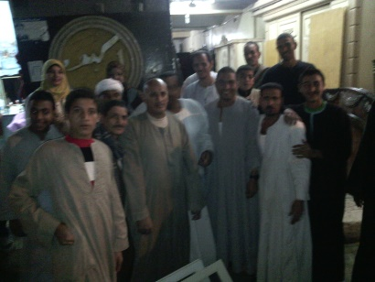 |  |  | 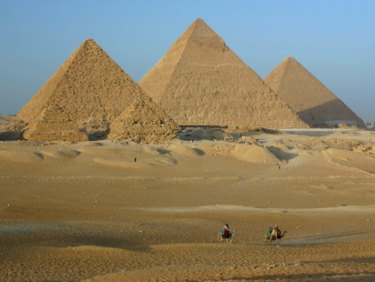
 |  |  | 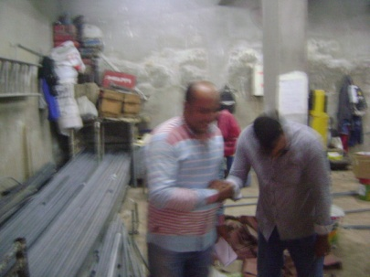
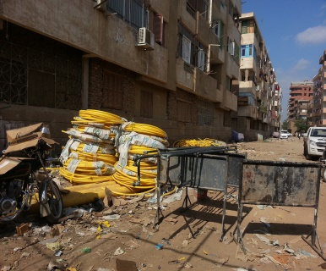 | 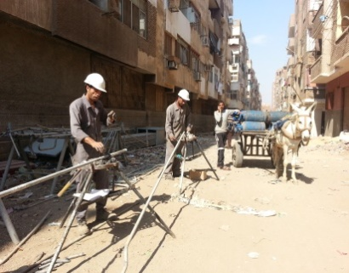 | 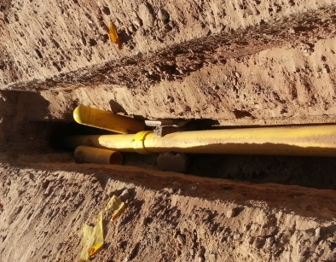
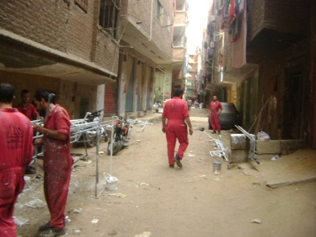 | 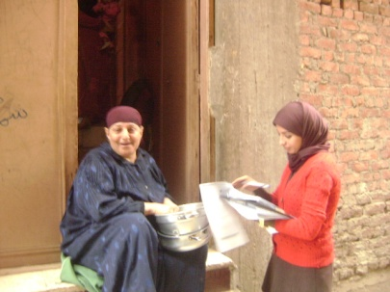 | 1.5 Million Natural Gas Connections Project in 11 Governorates  Site-Specific Environmental and Social Impact Assessment  Gerga/Sohag Governorate  28 June 2016

EGAS
Egyptian Natural Gas Holding Company
Developed by
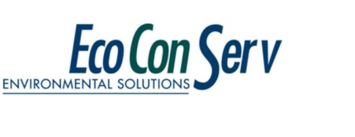 |  | 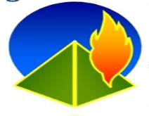
EcoConServ Environmental Solutions |  | Petrosafe  Petroleum Safety & Environmental Services Company

List of acronyms and abbreviations
AFD | Agence Française de Développement (French Agency for Development)
ALARP | As Low As Reasonably Practical
AP | Affected Persons
ARP | Abbreviated Resettlement Plan
AST | Above-ground Storage Tank
BUTAGASCO | The Egyptian Company for LPG distribution
CAA | Competent Administrative Authority
CAPMAS | Central Agency for Public Mobilization and Statistics
CDA | Community Development Association
CRN | Customer Reference Number
CULTNAT | Center for Documentation Of Cultural and Natural Heritage
EDHS | Egyptian Demographic and Health Survey
EEAA | Egyptian Environmental Affairs Agency
EGAS | Egyptian Natural Gas Holding Company
EHDR | Egyptian Human Development Report 2010
EIA | Environmental Impact Assessment
EMU | Environmental Management Unit
ENIB | Egyptian National Investment Bank
ES | Environmental and Social
ESDV | Emergency Shut Down Valve
ESIA | Environmental and Social Impact Assessment
ESMF | Environmental and Social Management framework
ESMMF | Environmental and Social Management and Monitoring
ESMP | Environmental and Social Management Plan
FGD | Focus Group Discussion
GASCO | Egyptian Natural Gas Company
GCR | Greater Cairo Region
GIS | Global Information Systems
GOPP | General Organization for Physical Planning
GPS | Global Positioning System
HDR | Human Development Report
HH | Households
HHH | Head of the Household
HP | High Pressure
HSE | Health Safety and Environment
IDSC | Information and Decision Support Center
IFC | International Finance Corporation
IGEM | Institute of Gas Engineers and Managers
IR | Involuntary Resettlement
JICA | Japan International Cooperation Agency
LDC | Local Distribution Companies
LDU | Local Development Unit
LFL | Lower Flammable Limit
LP | Low Pressure
LPG | Liquefied Petroleum Gas
mBar | milliBar
MSDS | Material Safety Data Sheet
MSEA | Ministry of State for Environmental Affairs
NG | Natural Gas
NGO | Non-Governmental Organizations
P&A | Property and Appliance Survey
PAF | Project Affected Family
PAP | Project Affected Persons
PE | Poly Ethylene
PPM | Parts Per Million
PRS | Pressure Reduction Station
PSV | Pressure Safety Valve
QRA | Quantitative Risk Assessment
RAP | Resettlement Action Plan
RPF | Resettlement Policy Framework
S HP | Steel High Pressure pipelines
SDO | Social Development Officer
SFD | Social Fund for Development
SIA | Social Impact Assessment
SRO | Social and Resettlement Officer
SSIAF | Supplementary Social Impact Assessment
SYB | Statistical Year Book 2010
TOR | Terms of Reference
Town Gas | The Egyptian Company for Natural Gas Distribution for Cities
UFL | Upper Flammable Limit
UNDP | United Nations Development Program
UST | Underground Storage Tank
WB | The World Bank
WHO | World Health Organization
$ | United States Dollars
€ | Euros
Exchange Rate: US$ = 8.83 EGP. as of March 2016
Exchange Rate: € = 9.8949 EGP as of March 2016

Contents
List of acronyms and abbreviations 2
List of Tables 6
List of Figures 7
1 Introduction 8
1.1 Preamble 8
1.2 Project Objectives 8
1.3 Environmental and Social Impact Assessment (ESIA) 8
1.4 Contributors 9
2 Project Description 10
2.1 Background 10
2.2 Project Work Packages 11
2.3 Project Execution Methodology 12
2.4 Activities of the operation phase 20
3 Legislative and Regulatory Framework 21
3.1 Applicable Environmental and Social Legislation in Egypt 21
3.2 World Bank Safeguard Policies 22
4 Environmental and Social Baseline 23
4.1 Description of the Environment 23
4.2 Socioeconomic Baseline 38
5 Environmental and Social Impacts 46
5.1 Positive Impacts 46
5.2 Anticipated Negative Impacts 48
5.3 Potential Negative Impacts during Construction 49
5.4 Potential Negative Impacts during Operation 57
5.5 Women and Vulnerable Groups 59
6 Analysis of Alternatives 60
6.1 No Project Alternative 60
6.2 Energy Alternatives 60
6.3 Installation costs 60
7 Environmental and Social Management & Monitoring Plan 61
7.1 Objectives of the ESM&MP 61
7.2 Management of Mitigation and Monitoring activities During Construction Phase 61
7.3 Environmental and Social Management Matrix during CONSTRUCTION 75
7.4 Environmental and Social Monitoring Matrix during CONSTRUCTION 84
7.5 Management of Mitigation and Monitoring activities During Operation Phase 86
7.6 Environmental and Social Management Matrix during OPERATION 89
7.7 Environmental and Social Monitoring Matrix during OPERATION 94
7.8 Reporting of Mitigation and Monitoring Activities 95
7.9 Institutional Framework for ESM&MP Implementation 96
8 Stakeholder Engagement and Public Consultation 99
8.1 Defining the stakeholder 100
8.2 Consultation Methodology and Activities 100
8.3 Summary of consultation outcomes 104

Annex 1: Contributors to the ESIA 105
Annex 2: Procedures for chance finds and ESM&MP for physical cultural resources 106
Annex 3: Site air measurements Methodology 109
Annex 4: Flora 110
Annex 5: Impact Assessment 111
Annex 6: Complaint Form 114
ANNEX 7: QUANTITATIVE RISK ASSESSMENT------------------------------------------------------------------------------------121

List of Tables
Table ‎2-1: Planned connections 12
Table ‎4-1: Location of Air and Noise measurements 23
Table ‎4-2: Eight (8) hours average ambient air pollutants’ concentrations (µg/m³) 24
Table ‎4-3: Ambient noise level measurements 25
Table ‎4-4: National and World Bank limits for ambient noise levels 25
Table ‎4-5: % Distribution of electricity bill value by expenditure category 39
Table ‎7-1 Handling of Solid Wastes during Construction Phase 67
Table ‎7-2 Wastes Common for Construction of gas pipelines 68
Table ‎7-3: Environmental and Social Management Matrix during CONSTRUCTION 75
Table ‎7-4: Environmental and Social Monitoring Matrix during CONSTRUCTION 84
Table ‎7-5: Environmental and Social Management Matrix during OPERATION 89
Table ‎7-6: Environmental and Social Monitoring Matrix during OPERATION 94
Table ‎8-1: Summary of Consultation Activities in Gerga City 101
Table ‎8-2:Sample of the main issues raised during data collection and scoping phase in Gerga 102
Table ‎0-1: Management matrix for cultural sites (if encountered) 107
Table ‎0-2: Monitoring matrix for cultural sites (if encountered) 108
Table ‎0-3: Standard reference methods followed for the collection of ambient air pollutants 109

List of Figures
Figure ‎2-1: General components of the city’s distribution network 10
Figure ‎2-2: project sectors in Gerga city 13
Figure ‎2-3: Gerga Pressure Reduction Station Layout 14
Figure ‎2-4: Location of new PRS west of Gerga City 15
Figure ‎2-5: Site of the New PRS in Gerga 15
Figure ‎4-1: Gerga Markaz in Sohag Governorate and Gerga's institutional subdivision 23
Figure ‎4-2: Average annual temperatures and maximum and minimum temperatures. 26
Figure ‎4-3: Average rainfall 26
Figure ‎4-4: Soil composition. Gerga lies in the green area.. 27
Figure ‎4-5: Cultivated land in Gerga 28
Figure ‎4-6: Section of route where projected pipeline will be installed in Gerga. 28
Figure ‎4-7: Regional roads in Gerga 29
Figure ‎4-8: Main roads distribution network connecting Gerga to cities across Sohag. 29
Figure ‎4-9: Saad Zaghlol square in Gerga 30
Figure ‎4-10: Urban road congested with Tuk Tuks-Saad Zaglol square in Gerga 31
Figure ‎4-11: Road distribution network and location of the planned PRS (red pin) 32
Figure ‎4-12: Typical landscape for a local street for household connections. 33
Figure ‎4-13: Gerga waste disposal site in the desert area west of the city 34
Figure ‎4-14: Al Emam road in Gerga city 34
Figure ‎4-15: Vegetation encountered around canal and arable lands and in proximity of roads. 35
Figure ‎4-16: Traditional vegetation encountered alongside roads in Gerga. 35
Figure ‎4-17: Typical local streets for planned connections of pipelines to households in Gerga. 36
Figure ‎4-18: Domesticated animals encountered in Gerga. 36
Figure ‎4-19: Cemeteries in Gerga 37
Figure ‎4-20: % Distribution of population by work status of the breadwinner 40
Figure ‎4-21: % Distribution of population by income & expenditure and sex 41
Figure ‎4-22: Distribution of the problems related to LPG cylinders 42
Figure ‎4-23: Perception of the NG project 42
Figure ‎4-24: Females role in the LPG system 43
Figure ‎4-25: % Distribution of sample by monthly installment and house expenditure 44
Figure ‎4-26: Willingness to pay 44
Figure ‎7-1 Proposed Grievance and Redress Mechanism 71
Figure ‎7-2: Regas ESMP organogram 96
Figure ‎8-1: % distribution of consulted households’ sample by age category 101
Figure ‎8-2: % distribution of consulted households’ sample by occupational status 102

Introduction

Preamble
The Government of Egypt (GoE) has immediate priorities to increase household use of natural gas by connecting 1.2 million households/yr to the gas distribution network to replace the highly subsidized, largely imported Liquefied Petroleum Gas (LPG).
The total installed domestic connections until 2015 reached 7.2 million customers and 14.8 thousand commercial customers and 2.3 thousand industrial clients. That was achieved in full cooperation with the local distribution companies.
The GoE is implementing an expansion program for Domestic Natural Gas connections to an additional 1.5 Million households over the next 4 years. The project presented in this study is part of a program that involves extending the network and accompanying infrastructure to connect 1.5 million Households in 11 Governorates between 2016 and 2019 with the assistance of a World Bank Loan of up to US$500 Million and the Agence Française de Développement (French Agency for Development) financing of up to €70 Million. The program is estimated to cost US$850 Million.

Project Objectives
The proposed project represents an integral component of the National energy strategy which aims for greater use of natural gas for domestic users and reduction of government subsidies of the energy sector (LPG). The project is planned for completion within 3 years. The following results are envisaged:
- Wider NG coverage and stable household energy supply
- Reduced leakage and fire risk compared to LPG
- Reduced LPG cylinder prices due to lower demand
- Reduced hardships to the physically challenged, women, and the elderly
- Reduced costs compared to butane gas (LPG) and electricity in Egypt
- Reduced strategic dependence on imported fuel (LPG)
- Rationalization of subsidies for LPG cylinders.

Environmental and Social Impact Assessment (ESIA)
World Bank Environmental and Social Safeguard policies require an Environmental & Social Impact Assessment (ESIA) of the proposed project. In 2013 an Environmental and Social impact Assessment framework (ESIAF) and a Supplementary Social Impact Assessment Framework (SSIAF) were prepared for the 11 governorates.
This ESIA has been prepared based on the Terms of Reference prepared by EGAS and cleared by the World Bank. A joint venture between Petrosafe (Petroleum Safety & Environmental Services Company and EcoConServ Environmental Solutions was contracted in November 2015 to develop the governorate-level and site-specific ESIAs.
ESIA is undertaken to assess and propose mitigations for environmental and social impacts of off-takes from the national network to the project areas, pressure reduction stations, and distribution networks serving the various project areas. Impacts of NG exploration, extraction, refining, and transmission are outside the scope of the ESIA.

The objectives of the ESIA include:
- Describing project components and activities of relevance to the environmental and social impacts assessments
- Identifying and addressing relevant national and international legal requirements and guidelines;
- Describing baseline environmental and social conditions,
- Presenting project alternatives and no project alternative,
- Assessing potential site-specific environmental and social impacts of the project;
- Developing environmental & social management and monitoring plans in compliance with the relevant environmental laws
- Documenting and addressing environmental and social concerns raised by stakeholders and the Public in consultation events and activities
As the project involves components in various areas within the 11 governorates, the parties to the project agreed that 11 governorate-level ESIAs are to be prepared and complemented by (scoped) site-specific ESIAs for each of the project sub-areas within the governorate. Guided by the 2013 ESIAF and SSIAF, this is the site specific ESIA for the connections network and Pressure Reduction Station (PRS) planned for the Gerga city in Sohag Governorate. The project in Gerga encompasses household connections and construction of a new 10,000 m³/h PRS in Gerga District. The 31,500 households are be connected over 3 years: 12,000 in year 1, 12,960 in year 2, and 6,540 in year 3.
The local distribution company responsible for project implementation in Gerga is Regions Gas Company (ReGas( orشركة غاز الاقاليم- ريجاس) ).
No major environmental or social risks could be foreseen to prevent reaching the targeted customer over the proposed 3-year timeframe. The extensive experience gained, by EGAS and affiliates, through implementation of the previous WB- and GoE-funded Natural Gas Connection project in Greater Cairo (and all over Egypt) plays a critical role in minimizing environmental and social risks and maximizing public ownership and acceptance.

Contributors
The ESIA has been prepared by a Joint Venture between Petrosafe (Petroleum Safety & Environmental Services Company and EcoConServ Environmental Solutions (Cairo, Egypt) with collaboration, and facilitation from EGAS, Egypt Gas, Regas and Town Gas HSE and Engineering Departments. The names of the Petrosafe and EcoConServ experts who have participated in the preparation of the ESIA study are listed in Annex 1 of this report.

Project Description

Background
Natural Gas is processed and injected into the high pressure lines of the national Grid (70 Bar) for transmission. Upon branching from the main lines to regional distribution networks, the pressure of the NG is lowered to 7 Bar at the Pressure Reduction Stations (PRS). An odorant is added to the NG at PRSs feeding distribution networks to residential areas in order to facilitate detection. Regulators are then used to further lower the pressure to 100 mbar in the local networks, before finally lowering the pressure to 20 mbar for domestic use within the households. In addition to excavation and pipe laying, key activities of the construction phase also include installation of pipes on buildings, internal connections in households, and conversion of appliance nozzles to accommodate the switch from LPG to NG.
The city distribution network comprises the following components:

Figure ‎2-1: General components of the city’s distribution network

Project Work Packages

Off-take & Inlet connection/Pipeline “70 bar system”
In Gerga city there will be 15-m pipeline connection between off-take from the national high-pressure grid (70 bar) and PRS (Pressure Reduction Station).

Pressure Reduction Station (PRS)
PRS consists of equipment installed for automatically reducing and regulating the pressure in the downstream pipeline or main to which it is connected. Included are piping and auxiliary devices such as valves, control instruments, control lines, the enclosure, and ventilation equipment.
PRS for Gerga city has an inlet pressure range (70-18 bar) and outlet pressure 7 bar and maximum flow rate 10,000 SCMH.

Main feeding line/network “7 bar system – PE 100”
A gas distribution piping system that operates at a pressure higher than the standard service pressure delivered to the customer. In such a system, a service regulator is required to control the pressure delivered to the customer.
Main feeding lines are manly constructed from polyethylene pipes (HDPE) with maximum operating pressure (MOP) below 7 bar.

Distributions network “Regulators, PE80 Networks”
A gas distribution piping system in which the gas pressure in the mains and service lines is substantially the same as that delivered to the customer’s Meters. In such a system, a service regulator is not required on the individual service lines.
Distribution networks are manly constructed from polyethylene pipes (MDPE) with MOP below 100 millibar.

Installations (Steel Pipes)
A gas distribution piping system consist of steel pipes which is connected from individual service line to vertical service pipe in a multistory dwelling which may have laterals connected at appropriate floor levels; in addition to service pipe connected to a riser and supplying gas to a meter and gas appliances on one floor of a building.
Internal Installation is pipe connecting the pressure reducing regulator/district Governor and meter Outlet (MOP 25 millibar) to appliances inside the customer’s premises.

Conversions
Conversions involve increasing the diameter of the nozzle of the burner of an appliance to work with natural gas as a fuel gas rather LPG or other.

Project Execution Methodology

Project area selection criteria
Preliminary project planning has applied social, economic, safety, and technical criteria to identify sub-areas (districts and villages that might be increased subject to availability of resources and compliance with technical, economic, and social criteria) as targets for connecting the customers (households). The project shall introduce the service in new areas, which have not been connected before, and shall further extend the network in areas which are partially covered.
A preliminary estimate was generated through a general survey (outlined below), followed by a Property & Appliance (P&A) survey. The outcome of the P&A survey is a detailed listing of individual households to be connected after passing safety and technical evaluations. The detailed listing is then used to finalize pipeline sizing and routing.

General survey
- Data collection on potential households to be connected from all relevant authorities
- Field visits to record road and building conditions.
- Approximation of the number of customers not meeting safety and technical criteria.
- Identifying availability of utilities in the area and their conditions (Electricity, Water, telephone lines, and sewage) through data and maps from the relevant authorities.
- Identifying the location of the nearest PRS or gas networks, if available.

Property & Appliance (P &A) survey
- Obtain the latest aerial maps of the project areas from the Egyptian Survey Authority
- Identifying Global Positioning System (GPS) coordinates of the sites
- Locating each road and building and inserting them on the corresponding map
- GPS team develops a survey map to be used by the P&A survey team to generate a unique customer reference number (C.R.N) based on building, block, and sector
- The final (C.R.N) will be associated to customer name, address, appliances, and data.
- An isometric drawing for each building, location of service, and riser routes is created, reviewed by the surveyors, and delivered to the Installations department
- Data is entered into a central database and G.I.S system for review by a design team
- Design team finalizes pipe sizing, type, regulator capacity & locations, routing, and number of appliances to be converted

Criteria for selection of structures eligible for connections
- Areas with pre-existing utilities especially underground (electricity, water, sewerage, telecommunication)
- Structures in residential areas cannot be made from clay or wood
- Structures must comply with British Standards and Egyptian Building Codes
- Residential areas must be in proximity to the gas network
Based on the above, potential connections in Gerga City are presented below:
Table ‎2-1: Planned connections
Governorate | First year  2017/2016 | Second year  2018/2017 | Third year  2019/2018 | Total  (Thousand units)
Gerga | 12 | 12.96 | 6.54 | 31.5

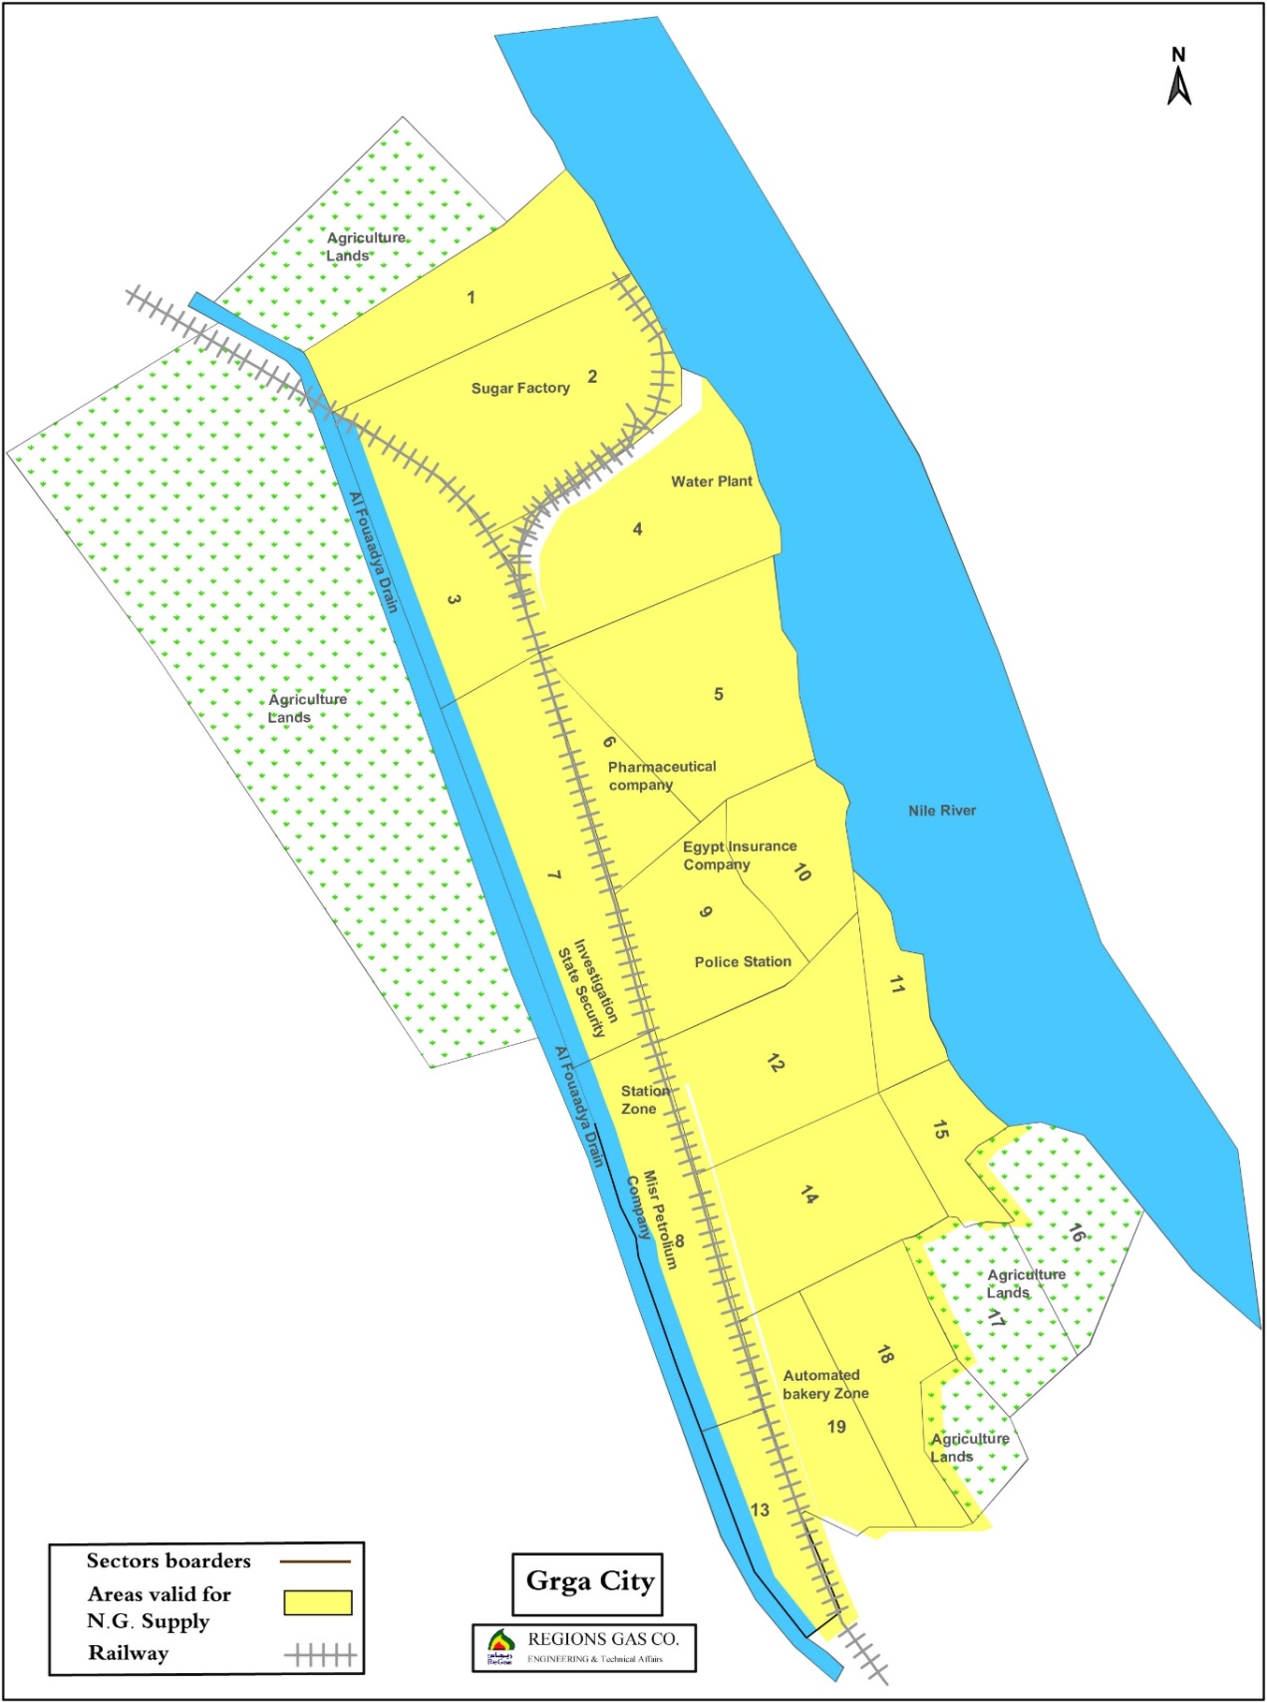
Figure ‎2-2: project sectors in Gerga city

    - Design and material take-off (MTO) including procurement
Once the final number and location of project components and households is finalized, a final design of the transmission and distribution pipelines is utilized to estimate the materials needed to implement the project. Procurement of the materials includes local and international components. Local purchases typically include PE piping for the distribution networks. The main international purchases may include critical components and PRSs, regulators, and metering stations

Construction works of Off-take & Inlet connection/Pipeline “70 bar system”
Gerga will connected to the national Natural Gas Grid (High-Pressure Steel lines). A 15m off-take will connect the 70-bar HP line to a new 10,000 m³/h Pressure Reduction Station (PRS). Diameters of the steel-HP pipelines are 8 inch, and are usually 1.2m deep inside the ground.
General features of the construction activities are also applicable to excavation and installation of the 70-bar high-pressure piping. However, HP piping is the case of Gerga is quite limited (15m). HP piping will take place in an area which is by and large uninhabited and exhibits minimal flora/fauna.

Construction works of PRS

Pressure Reduction Station Civil Works
PRS siting was guided by minimizing the possible negative impacts on surroundings: the safety of neighboring areas from possible gas release accidents and noise associated with reducers operations. There are currently no buildings around the PRS. In case buildings arise in the area around the PRS, the following buffer zones are to be respected:
- Minimum distance between high pressure line (70 bar) and buildings outside the PRS will be 90 meters from the center line.
- PRS should have free areas from each side to allow for emergency vehicle access.
- At least 20 meters between reducers and any building which may arise in the future to minimize noise impacts.
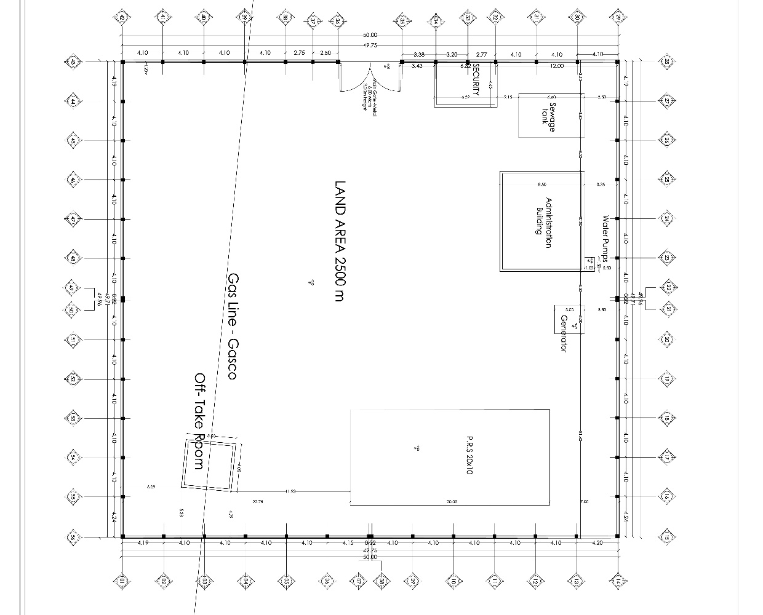
Figure ‎2-3: Gerga Pressure Reduction Station Layout
The PRSs shall be located in low-population-density areas on land plots of about 40-50m x 40-50m for each PRS. The PRSs shall be accessible by road to ensure quick response in the case repairs or emergencies. The PRS new venue is located close to Beit Dawood village about 2 km away. The closest high pressure pipeline is located 15 meter from the site.
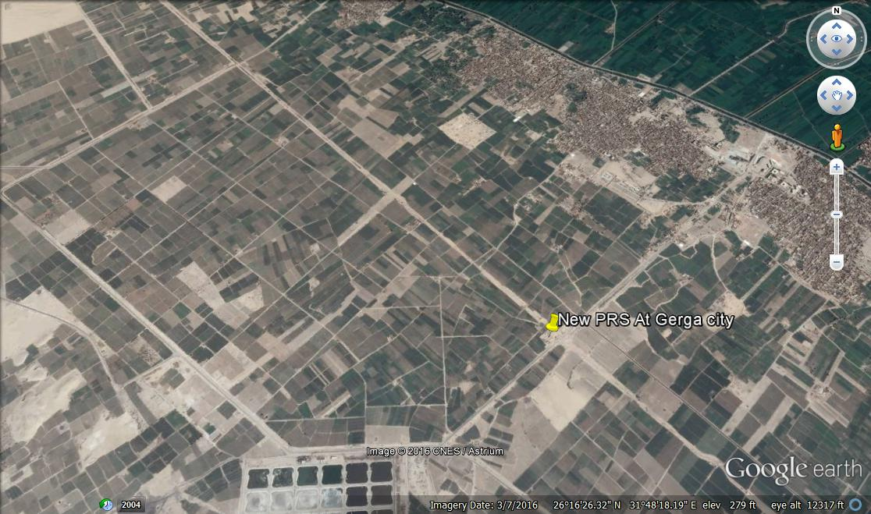
Figure ‎2-4: Location of new PRS west of Gerga City
The site was obtained by willing buyer- willing seller process. Three alternative lands were selected. The most proper site that is technically and financially acceptable was selected. The land owners (4 owners) expressed their satisfaction with the price provided as it was relatively above market price. The site was reclaimed agricultural land with no facilities inside. The investigations of EGAS reflected that the land is owned by four people. EGAS & Regas negotiated and the price was paid upon approval by land owners.

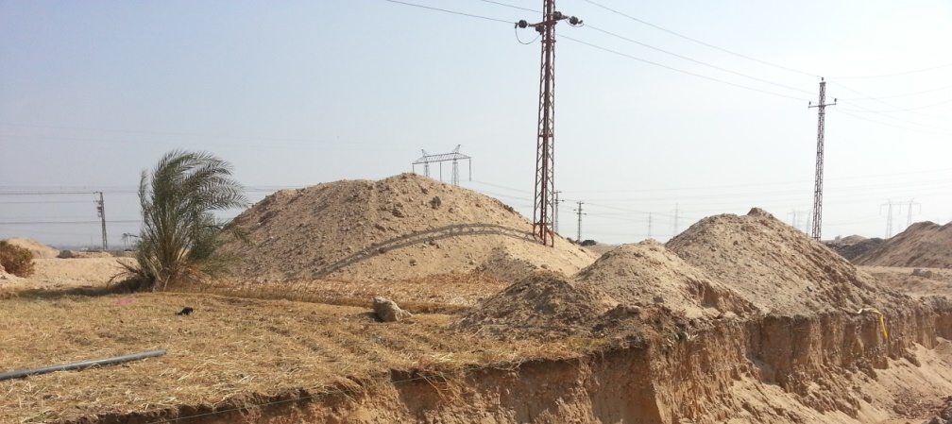
Figure ‎2-5: Site of the New PRS in Gerga

Pressure Reduction Station Mechanical Works
Constructing Pressure Reduction Stations and City gate Regulators are regular construction works in addition to connections between transmission mains and distribution mains. The PRS comprises two types of pressures, the first is the upstream pressure, which a high pressure is ranging from 30 to 70 Bar, while the second pressure is the downstream pressure, which is a low pressure (7 Bar). PRS design is in accordance with Institute of Gas Engineers/ Safety Recommendations IGE/SR/9, 10, 16, 18, 22, 23, 24, 25; Institute of Gas Engineers/ Transmission Distribution IGE/TD/13; and National Fire Protection Association NFPA 15.

Inlet stage
Inlet components of the PRS should be completely isolated from the cathodic system applied to the feeding steel pipes by installing isolating joint with protection.

Filtration stage
The aim of the filtration stage is to remove dust, rust, solid contaminants and liquid traces. Two filters and two separators are installed in parallel; each filter-separator operates with the full capacity of the PRS. Filter-separator lines are equipped with safety devices such as differential pressure gauges, relief valves, liquid indicators, etc.

Heating stage
Because the difference between the inlet and outlet pressure is relatively high, icing normally occurs around outlet pipes. This may cause blockings and accordingly reduce or stop the gas flow. To avoid such circumstances, a heater is installed to keep the temperature of outlet pipes over 7°C. Each PRS is equipped with two heaters in parallel in order to allow for a standby heater in emergencies.

Reduction stage
Each PRS includes two reduction lines in parallel, also to allow for a standby line. The lines are equipped with safety gauges, indicators and transmitters to maintain safe operation conditions. According to the IGEM standards, the reduction unit should be installed in a well-ventilated-closed area or, alternatively, in an open protected area.

Measuring stage
After adjusting the outlet pressure, gas flow and cumulative consumption are then measured to monitor NG consumption from the PRS and to adjust the dosing of the odorant as indicated below. Measuring devices are sensitive to low gas flow, which normally occurs during first stages after connecting a small portion of targeted clients.

Odorizing stage
The objective of the odorant is to enable the detection of gas leaks in residential units at low concentration, before gas concentration becomes hazardous. The normally used odorant is composed of Tertiobutylmercaptin (80%) and Methylsulphide (20%). The normal dosing rate of the odorant is 12-24 mg/cm3. The system consists of a stainless steel storage tank, which receives the odorant from 200-liter drums, injection pumps and associated safety devices.

Outlet stage
The outlet stage includes an outlet valve gauge, temperature indicators, pressure and temperature transmitters and non-return valves. The outlet pipes are also, like inlet pipes, isolated from the cathodic protection by an isolating joint.

Construction works of Main feeding line/network “7bar system – PE100”
The distribution system shall consist of 7-Bar mains extending from the PRSs through city gate regulators, which in turn feeds low pressure networks via district regulators.
Distribution mains are typically Polyethylene (PE) pipes connected to regulators. Regulators are feed by 7-Bar piping which is orange in color (referred to as PE100) with diameters between 16mm to 355mm according to GIS PL2-8.

Excavation and pipe laying:
In general, the least expensive and most commonly used excavation technique is the Open cut technique. Alternatively, borings may be excavated using hydraulic drive, and finally Horizontal Directional Drilling (HDD) technique. HDD is only utilized in the case of railway crossings, waterways, and major streets where traffic cannot be interrupted. In the case of HDD under railway crossings steel or reinforced concrete sleeves will be installed to further protect the piping from fatigue. It should be noted that intersections with waterways of the Nile or its major branches are not anticipated in this project.

Site preparation and excavation:
Prior to excavation works, pipeline routes shall be identified and marked in the field. Excavation works start by removing the asphalt layer using either a mechanical trencher or a jack hammer. The mechanical trencher also removes broken asphalt and the base stone layer. In case the jack hammer is used, road layers are then removed by excavator.
The road base soil, underneath asphalt and stones, is then excavated either by a backhoe excavator or by manual excavation. The advantage of manual excavation is that it reduces the risks of breaking water, sewerage, electric or telecommunication lines which are unmapped. Typically the trench for PE pipes is 0.4-0.6 meter wide, and about 1.5 meter deep, depending on pipe diameter. For steel pipes the trench width is 0.6-0.8 meters with the same depth, also depending on diameter.
Excavated soils, broken asphalt and other waste materials during excavation are loaded onto trucks, which transfer it to disposal areas. Because of the limited available space on most Egyptian streets, loading waste trucks shall be done upon excavation, whenever possible, in order to avoid stockpiling waste on site.
In some cases, where groundwater table is shallow, the trench should be dewatered before pipe laying. Dewatering pumps typically discharge into a drain or sewer manhole, according to arrangements with local authorities. To conserve water, if dewatered groundwater is free of perceivable pollution, it will be- to the extent possible- used on- or around the work site or discharged into the nearest irrigation channel to be used for irrigation.

Pipe laying:
During the excavation works, welding works may take place above-ground. Once the trench is excavated, the pipe stretch shall be laid down.
Welding may involve a built-in coil electrical fusion weld (fittings with heating coils installed inside) or butt welds (hot plate softening the tips of the PE pipes before joining). In both cases, adequate electrical units are needed onsite (diesel generators, cables).

Backfill and road repair:
Natural gas PE pipes should be surrounded by sand in order to absorb loads from the road. After laying and welding works, the trench is then filled with sand either by a front loader or manually.
The sand should be effectively compacted in the trench in order to avoid road settlements, and subsequent cracks. A yellow warning tape marked “Natural Gas” is placed on top of the sand layer.
In some cases, an inverted U-shaped reinforced concrete slab is constructed around the pipeline after laying in order to improve shock resistance.

Leakage testing:
Following construction activities, the piping should be tested to locate possible leaks using either hydrostatic testing or pneumatic air-gas testing. In the former, the pipe is filled with water and then pressurized to the desired level, along with pressure testing at different locations to detect leaks, then water is drained. In the second process, air, or an inert gas, is used instead of water. In both cases, pressure is increased to 1.5x the operating pressure. Pressure drop indicates leakage.
Hydrostatic testing is more complicated than the pneumatic, as it requires highly efficient water drainage. This drainage takes place by the "pigging process", which includes forcing an object, the "pig", through the pipe by liquid or air pressure to totally drain the line before NG is fed. In the case of pneumatic testing, Nitrogen gas purge to remove air after the test.
In order to prevent deformation, dislocation, and rupture of the pipes, leakage testing through pressurization must be performed AFTER backfilling the excavation under (10 cm), around (10 cm), and above the pipes (20 cm, at least).

Construction works of distribution network “regulators, PE80 networks”:
The distribution system shall consist of 100 mbar mains extending from the city gate regulators through, Distribution networks are typically Polyethylene (MDPE) pipes connected to regulators. Regulators are feed by 100 mbar piping which is yellow in color (referred to as PE80) with diameters between 16mm to 250mm according to GIS PL2-2.

Construction works of household installation
- Connections work will connect the distribution network to the households.
- Gas will be feed into the property at 100 mbar maximum, through risers and laterals for flats and an external meter box service termination for singly occupied premises.
- Sizes of risers depend on the number of dwellings in the block of flats but laterals will be normally 1 inch or 3/4 inch.
- Gas meters will be installed with a suitable regulator (governor) at internal pressures of 20 mbar.
- Internal piping inside the household will be steel pipes of 1 inch, 3/4 inch and 1/2 inch diameter and will generally supply a cooker and a water heater. Connections from steel pipes to appliances are typically flexible rubber tubing in the case of stoves and copper tubing for water heaters

After testing the piping for leakage, connections to the buildings commence. The connection starts from the main line (PE) and crosses the road to the buildings on both sides. At the edge of the building, a riser (steel) feeds different laterals which ends at the customer gas meter then to different appliances. Traffic may be affected by the connection works.
The underground portion of the riser is sleeve-protected, while above-ground pipes are painted. Risers and laterals are fixed on walls by steel clips. This will involve drilling the walls to attach the necessary bolts and rivets. The laterals enter the household through the wall. Connections are tested for leakage by increasing pressure to 2Bar and monitoring pressure drop.

Conversion of home appliances
Conversion of home appliances shall be carried out on 2 appliances (stove and water heater). The majority of appliances will be converted by drilling out existing injector nozzles to accommodate the targeted gas flow. Burner drilling is necessary to increase the flow of low-pressure NG in order to maintain the calorific value that was previously available from high-pressure LPG. Typically, injector nozzles are drilled to become 1.25 to 1.5 times larger in diameter.
The installation contract between the household owner and the implementing company includes the cost of converting 2 appliances. Conversion involves increasing the diameter of the gas injectors of the stove and water heater to accommodate the difference in operating pressures and calorific value of natural gas in comparison with LPG. Conversion works are practiced at the client's flat, by changing the injectors' properties of the appliance. Typical drill bit sizes used for conversions are either 35 or 70mm.
Conversion also involves flue gas outlet/stack installation for bathroom heaters. The stack must lead to external/ambient atmosphere outside the HH. In order to allow the installation of the conversion of the heater and installation of the stack, the bathroom volume must exceed 5.6 cubic meters. Installation of the stack may require scaffolding and breaking of the wall or ceiling.

Activities of the operation phase

Operation of the PRS
Operation of the PRS involves operation of the various components outlined in the construction phase. Risks associated with those activities are further addressed separately in a Quantitative Risk Assessment (QRA).

Filtration stage
During the operation, one filter-separator line is operated, while the other is on standby.

Heating stage
During operation, one of the two heaters in parallel is used, while the second is kept on standby and operated in case of emergencies.

Reduction stage
One of the two reduction lines in parallel is used, while the second is on standby. y line.

Measuring stage
Gas flow and cumulative consumption are measured to monitor NG consumption from the PRS and to adjust the dosing of the odorant as indicated below.

Odorizing stage
Operation of the odorant unit is controlled automatically, and could be switched to manual operation if needed.

Operation of the network
The operation of the system is undertaken by LDCs. Normal operation will include routine audits on pressures and condition of the network. Normal maintenance and monitoring works for the network include:
- Monitoring valves at selected points on the pipeline. Gas leaks are routinely monitored using gas detection sensors;
- Checking cathodic protection on "Flange Adaptors" by taking voltage readings and changing anodes whenever needed.
In case of a leak detection, or damage to part of the network, the damaged pipe is replaced. The following procedures are usually followed:
- Stopping leaking line by valves when available or by squeezing the lines before and after the damaged part.
- Excavating above the effected part (in case of distribution main or underground line)
- Venting the line
- Removing affected pipe, replacing and welding, backfilling and road repair

Repairs in households
Repairs in include appliance adjustments or piping/metering replacement.

Hotline
During construction activities, a 24-7 Hotline (129) is available for customers and the public to report leaks, damage, emergencies, and/or incidents related to gas connections, components, infrastructure, and activities (inside or outside households) and to request repairs/emergency response/assistance.
This includes possible damage to other underground utility lines (water, wastewater, electricity, phone, Internet) and to buildings and physical structures or cultural sites during excavation/construction activities.
It also includes reporting issues resulting from construction activities such as excessive/prolonged noise, vibration, waste, traffic, accessibility, visual, and other community health and safety impacts.

Legislative and Regulatory Framework

Applicable Environmental and Social Legislation in Egypt
- Law 217/1980 for Natural Gas
- Law 4 for Year 1994 for the environmental protection , amended by Law 9/2009 and law 105 for the year 2015
Executive Regulation(ER) No 338 for Year 1995 and the amended regulation No 1741 for Year 2005, amended with ministerial decree No 1095/2011, ministerial decree No 710/2012, ministerial decree No 964/2015, and ministerial decree No 26/2016
- Law 38/1967 for General Cleanliness
- Law 93/1962 for Wastewater
- Law 117/1983 for Protection of Antiquities
- Traffic planning and diversions
  - Traffic Law 66/1973, amended by Law 121/2008 traffic planning during
  - Law 140/1956 on the utilization and blockage of public roads
  - Law 84/1968 concerning public roads
- Work environment and operational health and safety
  - Articles 43 – 45 of Law 4/1994, air quality, noise, heat stress, and worker protection
  - Law 12/2003 on Labor and Workforce Safety
  - Book V on Occupational Safety and Health (OSH)
  - Minister of Labor Decree 48/1967.
  - Minister of Labor Decree 55/1983.
  - Minister of Industry Decree 91/1985
  - Minister of Labor Decree 116/1991.
- International Plant Protection Convention (Rome 1951)
- African convention on the conservation of nature and natural resources (Algeria 1968)
- UNESCO Convention for the protection of world cultural and natural heritage (Paris, 16 November 1972)
- Basel Convention on the control of trans-boundary movements of hazardous wastes and their disposal (1989)
- United Nations convention on climate change (New York 1992).
- United Nations Convention on climate change and Kyoto Protocol (Kyoto 1997)

World Bank Safeguard Policies
Three policies are triggered for the project as a whole: Environmental Assessment (OP/BP 4.01), Physical Cultural Resources (OP/BP 4.11), and Involuntary Resettlement (OP/BP 4.12).
OP/BP 4.01, OP/BP 4.12 and BP 17.50 are triggered for the project. However, OP/BP 4.12 will not be applicable to the land obtained in Gerga city as the process of obtaining the land for the pressure reduction station was based on welling buyer willing seller approach. No pipelines will cross agriculture land in Gerga and accordingly no compensation will be applied.

OP 4.01 – Environmental Assessment
According to the World Bank Operational Policy OP 4.01, the Natural Gas Connection Project is classified among Category A projects. Projects under this Category are likely to have significant adverse environmental impacts that are sensitive, diverse, or unprecedented.
Likely environmental impacts shall be analyzed and mitigation measures proposed for expected negative impacts in an Environmental Management/Monitoring Plan.

OP 4.11 – Physical Cultural Resources
Project areas may include sites, buildings and monuments that fall under the definition of Physical Cultural Resources. As the project involves excavations in many locations, which may be near sites of cultural value, there has been specific attention in this study to identify the locations of such sites, and to develop mitigation measures for controlling the effects on such sites. These mitigation measures are also reflected in the Environmental Management and Monitoring Plan.

OP/BP 4.12 – Involuntary Resettlement
According to the WB’s safeguard policy on Involuntary Resettlement, physical and economic dislocation resulting from WB funded developmental projects or sub-projects should be avoided or minimized as much as possible. Unavoidable displacement should involve the preparation and implementation of a Resettlement Action Plan (RAP) or a Resettlement Policy Framework (RPF), to address the direct economic and social impacts resulting from the project or sub-project’s activities causing involuntary resettlement.
It is not envisaged that the project will result in any physical or economic dislocation of people in Gerga City. Therefore, no safeguards instruments for OP 4.12 will be triggered for this specific Governorate.

BP 17.50 – Disclosure
The “Disclosure” of information to the public is a requirement by this policy. It reaffirms the fundamental importance of transparency and accountability to the development process. In addition, timely dissemination of information to local groups affected by the projects is essential for the effective implementation and sustainability of projects.

Environmental and Social Baseline

Description of the Environment
Gerga markaz is located in the south west of Sohag governorate. Gerga is bordered by El Monshah markaz in the north and by El Baliana markaz in the south. The Nile is on the eastern border of the markaz while the desert is at the western border.

Gerga city is the capital of Gerga markaz which covers around 151.13 km² from the total area of Sohag Governorate.
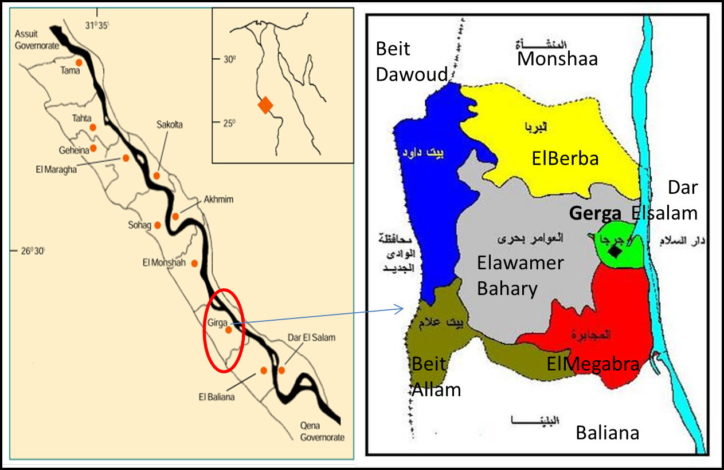
Figure ‎4-1: Gerga Markaz in Sohag Governorate (left) and Gerga's institutional subdivision (right).

Climatology and Air Quality

Site Specific Ambient Air Quality
8-hour average measurements were conducted for pollutants of primary concerns, namely, carbon monoxide (CO), nitrogen dioxide (NO₂), sulfur dioxide (SO₂), Total Suspended Particulates (T.S.P) and particulate matter (PM₁₀).
Table ‎4-1: Location of Air and Noise measurements
Location
In the vicinity of the proposed location of the New PRS West of Gerga City

Methodology for selection of analysis location and instrumentation are detailed in Annex 3.
Results
The following tables present the results for ambient air quality measurements conducted at the monitoring location. Daily average results are shown in the following table for all the measured parameters.
Table ‎4-2: Eight (8) hours average ambient air pollutants’ concentrations (µg/m³)
Time | NO | NO₂ | NO_{x} | SO₂ | CO | PM₁₀ |  | T.S.P
10:AM | 17.8 | 15.3 | 34.1 | 16.4 | 2.7 | 76.89 |  | 101.34
11:00 | 15.4 | 14.9 | 30.3 | 8.4 | 2.8
12:00 | 15.2 | 14.5 | 29.7 | 10.3 | 2.9
13:00 | 15 | 14 | 29 | 12.9 | 3.1
14:00 | 14.8 | 13.9 | 28.7 | 12.9 | 3.1
15:00 | 14.8 | 13.5 | 28.3 | 16.8 | 2.9
16:00 | 13.7 | 20.3 | 34 | 16.8 | 2.9
17:00 | 13 | 23.7 | 36.7 | 15 | 2.8
Limits
National (24 hrs) | 150 | 150 | 150 | 150 | 10  (mg/m³, 8 hrs) |  | 150 |  | 230
WB (24 hrs) | - | - | 200  (1 hr) | 125 | N/A |  | 150 |  | 230

The concentrations of measured air pollutants are below national and WB guidelines. All the measurements for the gaseous pollutants were complying with the maximum allowable limits according to law 4/1994 for Environment protection and its amendments by law No.9/2009 and the executive regulation issued in 1995 and its amendments no. 710 in 2012 and 964 in April 2015”.
Construction engines are certified, i.e., exhaust is below permissible levels. Ambient concentrations of gaseous pollutants, NOx, SOx and CO are unlikely to surpass permissible levels due to operation of construction equipment. Management and mitigation plans for ambient air pollution are further addressed in chapters 5 and 7.

During the construction phase, excavation and rehabilitation activities will likely cause dust levels to surpass permissible levels in construction areas. That said, excavation and rehabilitation are done on the same work day. Therefore, the duration of permissible levels being surpassed will be intermittent for the duration of the work day i.e., 8-10 hours. Management and mitigation plans for dust concentration beyond permissible levels are further addressed in chapters 5 and 7.

Site specific noise measurements
Noise level measurements were conducted in the same location (proposed site of the new Pressure reduction station) of the ambient air quality measurements. The duration of the measurements is 8 hours with one hour averaging intervals.
Methodology
Ambient noise levels were measured using two B & K 2238 Mediator, Integrating Sound Level Meters, Type I (precision grade), compliant with IEC 1672 Class 1 standard and a B & K 4198 Outdoor Weatherproof Microphone Kit;

Results
The tables below present the results of ambient noise measurements and their corresponding national and World Bank permissible limits.
Table ‎4-3: Ambient noise level measurements
Time | Sound Level Equivalent & Percentile Recordings in dBA for 24 Hours
Time | LAeq | LA10 | LA50 | LA90 | LA95 | LCpeak
10:00 | 48.05 | 50.44 | 45.68 | 41.78 | 40.59 | 104.6
11:00 | 55.32 | 58.6 | 53.59 | 48.08 | 46.49 | 102.61
12:00 | 57.89 | 60.94 | 53.44 | 45.95 | 43.89 | 104.93
13:00 | 59.92 | 63.46 | 56.78 | 46.62 | 43.53 | 100.8
14:00 | 48.77 | 45.49 | 35.63 | 27.24 | 24.35 | 101.92
15:00 | 45.85 | 34.01 | 24.62 | 20.09 | 19.63 | 102.89
16:00 | 50.7 | 53.91 | 47.92 | 43.36 | 42.42 | 101.65
17:00 | 49.83 | 53.52 | 45.86 | 42.27 | 41.76 | 95.45

Table ‎4-4: National and World Bank limits for ambient noise levels
 | Egyptian Law 4 Requirements |  |  |  | WB Requirements
Noise |  | Permissible noise  intensity decibel |  |  | Receptor | One hour L_{Aeq} (dBA)
Noise | TYPE OF AREA | DAY  7 a.m. to 10 p.m. | NIGHT  10 p.m. to 7 a.m. |  | Receptor | Day  07:00– 22:00 | Night  22:00 - 07:00
Noise | Sensitive Areas (Schools- hospitals- rural areas) | 50 | 40 |  | Residential;  Institutional; educational | 55 | 45
Noise | Residential with limited traffic | 55 | 45 |  | Industrial; commercial | 70 | 70
Noise | Urban residential areas with commercial activities | 60 | 50
Noise | Residential adjacent to roads less than 12m wide | 65 | 55
Noise | Residential adjacent to roads 12m wide or more, or light industrial areas. | 70 | 60
Noise | Industrial areas (heavy industries) | 70 | 70

Baseline ambient noise levels are marginally higher than the national and World Bank permissible limits for residential, educational, and institutional receptors and higher than national permissible limits for sensitive receptors.

Furthermore, excavation and construction activities may cause noise levels to further surpass permissible levels at the site.

Overall, the duration of permissible levels being further surpassed during excavation and construction activities will be intermittent for the duration of the work day i.e., 8-10 hours. Management and mitigation plans for noise levels beyond permissible levels are further addressed in chapters 5 and 7.

Climate

Temperature
The average annual temperature is 23.1°C in Gerga. The warmest month of the year is August, with an average temperature of 29.9 °C. January has the lowest average temperature of the year at 13.7 °C.
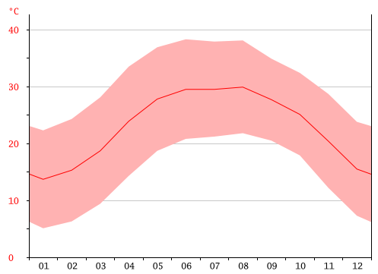
Figure ‎4-2: Average annual temperatures (red line) and maximum and minimum temperatures.

Rainfall
Gerga is considered to have a desert climate. During the year, there is virtually no rainfall except for the month of December for which 1 mm were recorded. The figure below illustrates the average annual precipitation. January is represented by 01 etc.

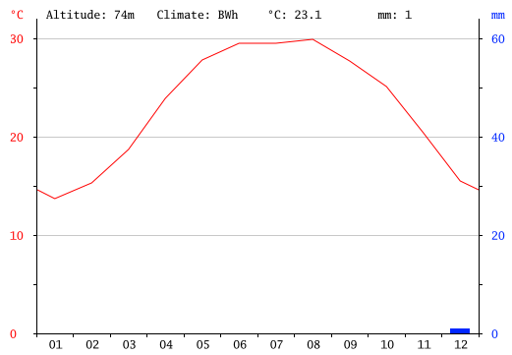
Figure ‎4-3: Average rainfall

Geology

Geomorphology
The geology of Gerga consists of the following deposits:

- Thebes formation (Eocene)
- Muneiha formations (Pliocene)
- Issawia Formation (Pliocene/Pleistocene)
- Pleistocene sands
- Dandara Formation
- Recent wadis

Soils
In Sohag area, soil falls into four sectors:
- cultivated floodplain soils (CF)
- Nile floodplain
- new reclaimed lands (NRL)
- wastewater disposal soils (WWD) at El-Dair site

Gerga is characterized by cultivated flood plains as shown in the figure below.

Figure ‎4-4: Soil composition. Gerga lies in the green area. Reference: Al Haddad and Shater, 1988.

Water resources

Surface water
Sohag is irrigated from the River Nile and the main irrigation canals. The irrigation canal supplying Gerga is El-Gergawia and is approximately 45 km long.

Groundwater
The main groundwater aquifer in Sohag Governorate is the Quaternary aquifer system. The average thickness ranges between 40 and 170 m increasing towards the course of the Nile.
Groundwater of the Nile aquifer is unlikely to be encountered as excavation depth for does not exceed 1 m.

Habitat type
The terrestrial habitats can be classified as follows:
- Agricultural/arable lands
- Desert
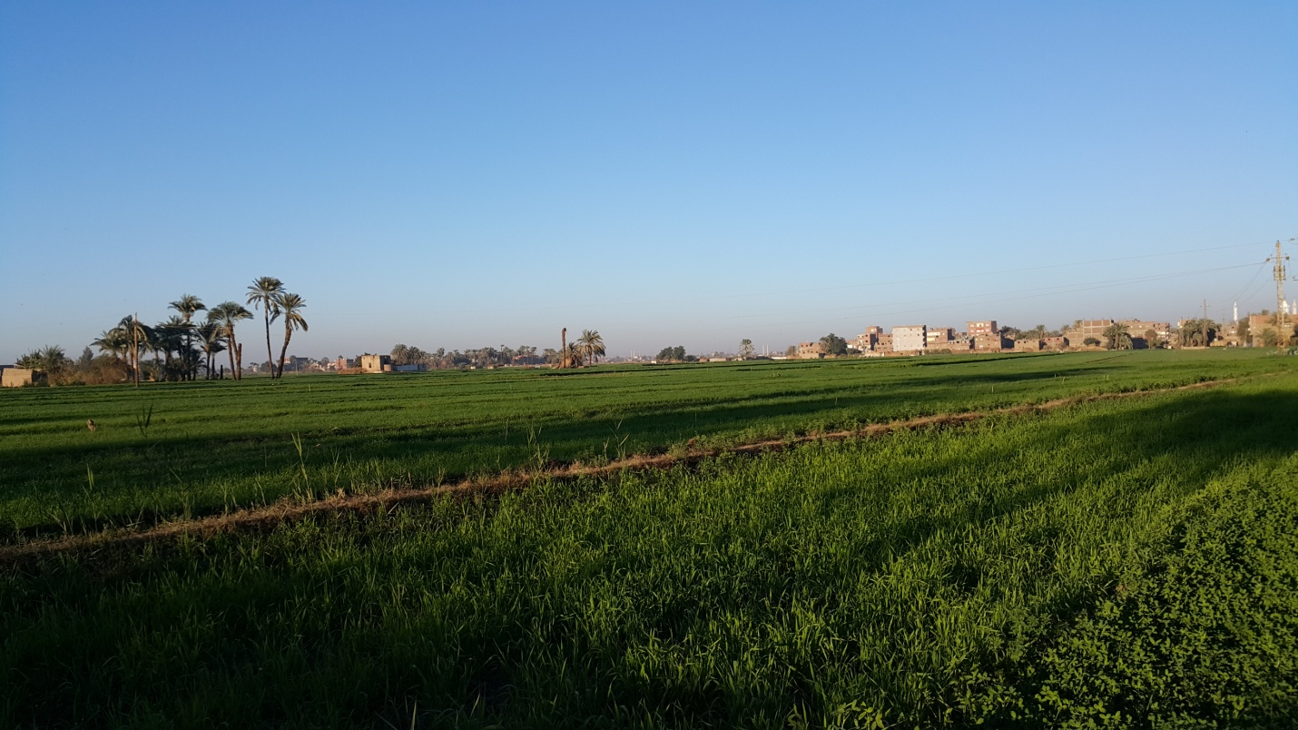
Figure ‎4-5: Cultivated land in Gerga
The projected work is planned along existing roads; no pipelines will be passing through any of the aforementioned habitats. The PRS will be in a desert area with limited land reclaimed agricultural surroundings.
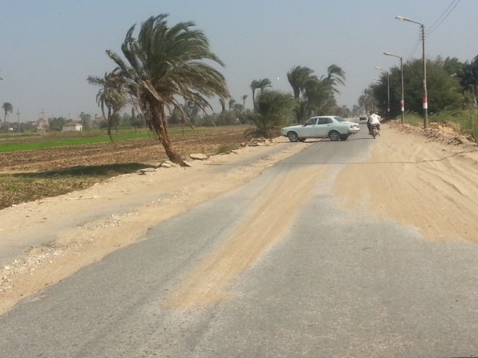
Figure ‎4-6: Section of route where projected pipeline will be installed in Gerga.

Traffic
Main roads
Six Main roads are asphalted connect Gerga to other cities.
The following figure shows the main road distribution network in Gerga.
Figure ‎4-7: Regional roads in Gerga

The following figure shows the main road distribution network.
Gerga
Figure ‎4-8: Main roads distribution network connecting Gerga to cities across Sohag.

No works are planned on main roads.

Urban primary and secondary arterial streets
Urban arterial streets are 3-4 lanes wide, partially paved with asphalt and partially dusty and rocky. Urban roads carry major portions of traffic in and out of urban areas. On-street parking is usually prohibited on primary streets and allowed on secondary streets. Urban arterial streets include:
- Sawi October street
- Ezbat EL Moaz
- Shekh Ahmed Morsy street
- Saad Zaghloul Pasha street
- Al Sayeed Street
- Barakat street
- Farouk street
- Abo Assem El Bassary
- Al Saqifa street
- Al Qisareya
- Abd El Kareem Al Maghni street
- Old Souq street
- Al Fouadeya street
- Mohamed Abd El Megeed Al Meshwady Bek
- Al Horreya (Al Mahata)
- Main roundabout: Alsahreeg

Urban streets are congested with pick-up trucks, Tuk Tuks, carriages pulled by donkeys, pedestrians, and bicycles. The figure below shows one of the primary urban roads in Gerga city: Saad Zaghloul square.

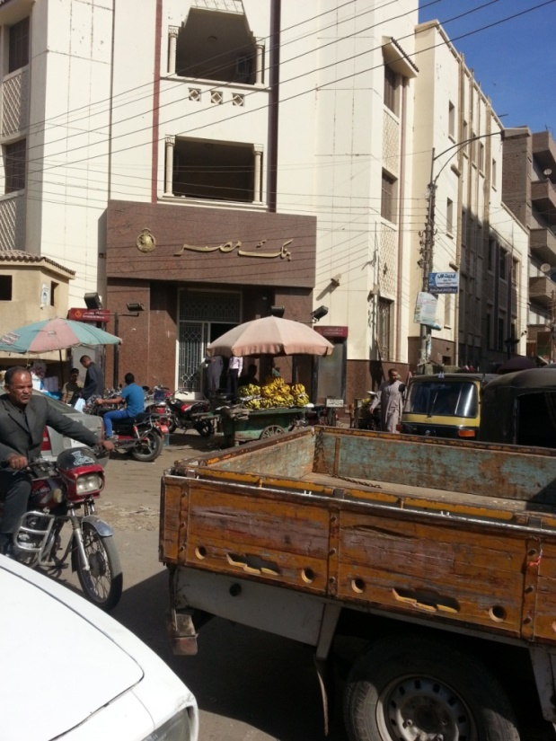
Figure ‎4-9: Saad Zaghlol square in Gerga

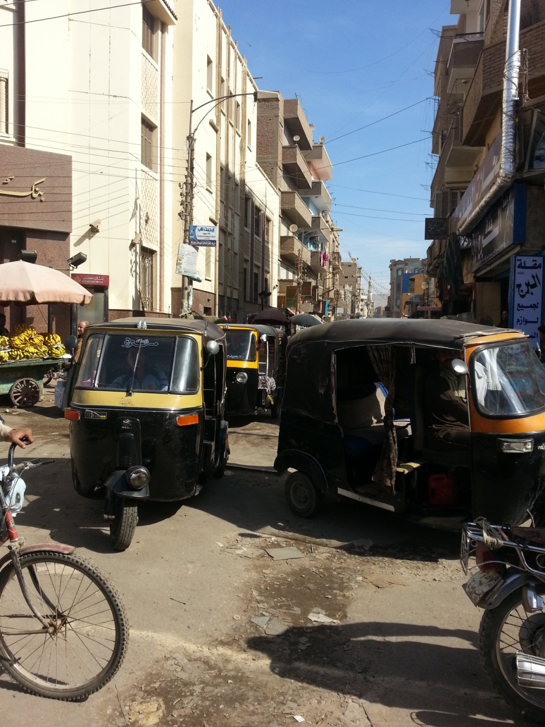
Figure ‎4-10: Urban road congested with Tuk Tuks-Saad Zaglol square in Gerga

Construction of the PRS is planned in an area outside the city of Gerga. The nearest urban road is Tariq Al Lewaa Mohsen El Noamany. The map below shows main roads in yellow, the PRS planned location (red pin)

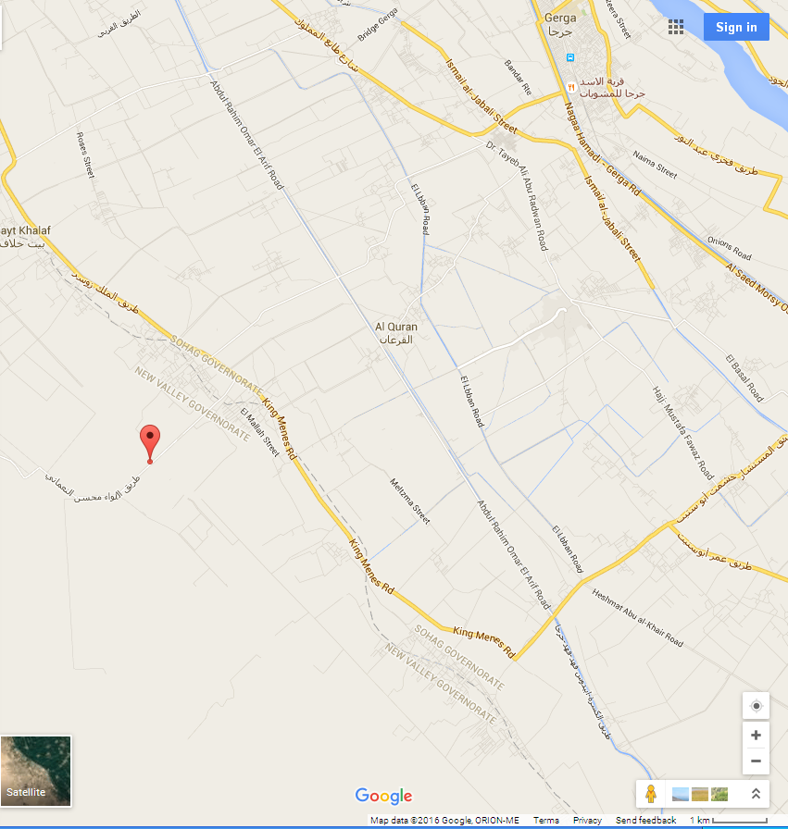
Beyt Khallaf
Gerga city
Tariq Al Lewaa Mohsen Al Noamany
Figure ‎4-11: Road distribution network and location of the planned PRS (red pin)

Local streets
Local streets are 2 lanes wide and serve residential and commercial areas. Local and distributor streets within the city of Gerga are dusty and rocky. On street parking is allowed. Those streets are not congested with vehicles, where the principal modes of transport are Tuk Tuks, carriages pulled by donkeys, walking, and bicycles. Examples of local streets are shown below.

Local streets include:
- Om Al Saad street
- Abdo Abaas
- Barkat street
- El Saha Street

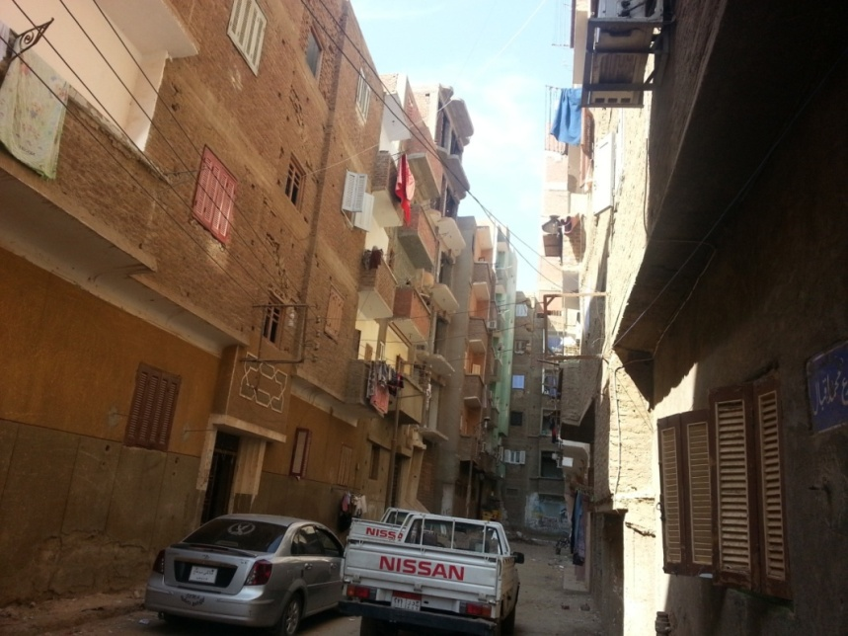
Figure ‎4-12: Typical landscape for a local street for household connections.

Physical structures
The implementing body in Gerga, EGAS/REGAS, has carried out an assessment to determine the eligibility of structures for proposed pipeline connections. The type of dwelling should be highlighted in order to identify the probability to install the NG to those houses. Poverty Mapping 2013 reported that 79.13% of the total population in Gerga city live in apartment. With regards to the sample surveyed, 80.4% of the sample surveyed live in an apartment. Whereas 16.5% of sample surveyed live in independent house.
The data collected revealed that the majority of the sample surveyed live in newly constructed buildings. The type of buildings in the selected areas is suitable to install the NG. The types of dwellings reflected that, the majority of buildings consist of 4-5 floors. However, the high buildings (6 floor +) are noticeable in the city.
The construction materials of the walls and ceilings are one of the main bases and conditions required to install the NG. It was reported that all of the sample surveyed live in buildings that are constructed of concrete and red bricks. It was obvious that some of the buildings are still under construction. The concrete columns were seen among various areas. On the basis of the investigations, 99% of households in Gerga city are eligible for gas connections. .

Waste management
The disposal site used by the local unit in Gerga is located about 15 km west of the city in a desert area (South of the Sohag International Airport- West of the Beit Daoud and Beit Khallaf villages). The site accepts municipal as well as construction and demolition waste.
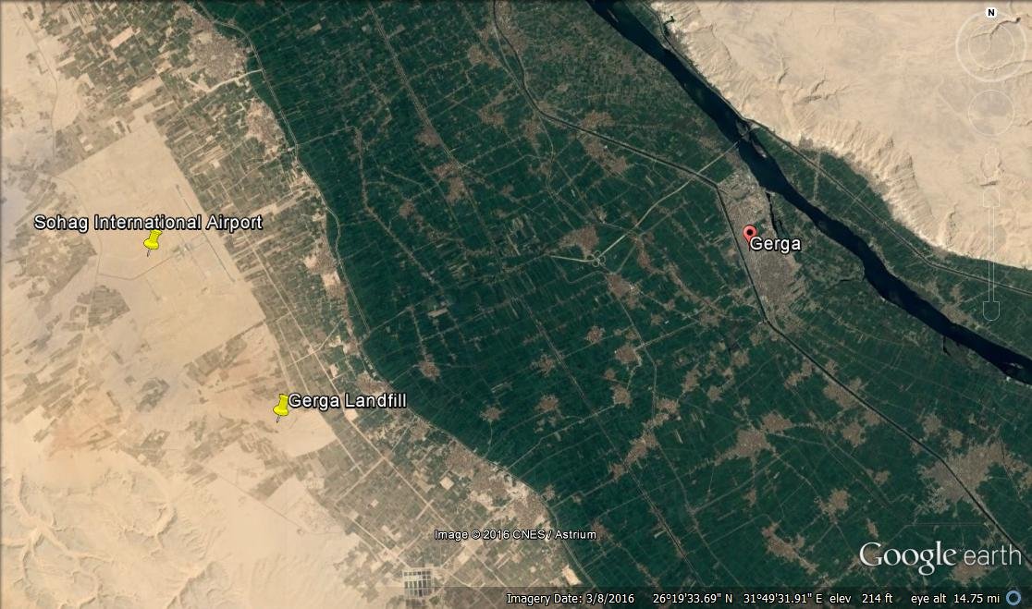
Figure ‎4-13: Gerga waste disposal site in the desert area west of the city
The Nasreya & UNICO facilities in Alexandria are the only designated entities in Egypt for disposal of non-medical hazardous waste.
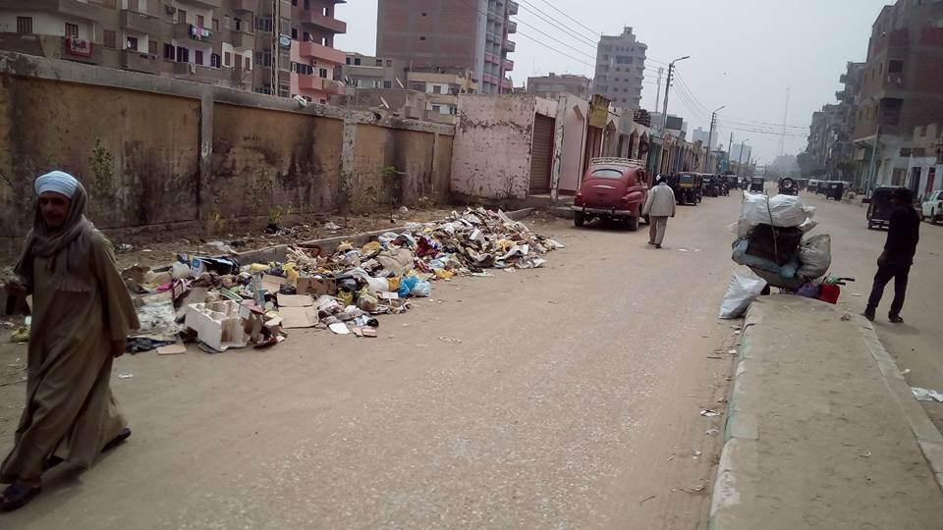
Figure ‎4-14: Al Emam road in Gerga city

Project activities in Gerga will take place in the city, where project workers will have access to public sanitary facilities. Therefore, no extra sanitary waste is anticipated.

Terrestrial Environment
The construction of the PRS and the connections of pipelines to households are planned in areas where flora and fauna of significance do not occur.

Flora
Annex 4 lists typical flora encountered in Upper Egypt. Because Gerga borders the Nile, traditional crops and vegetation such as palm trees and reed occur, as shown in the figure below.
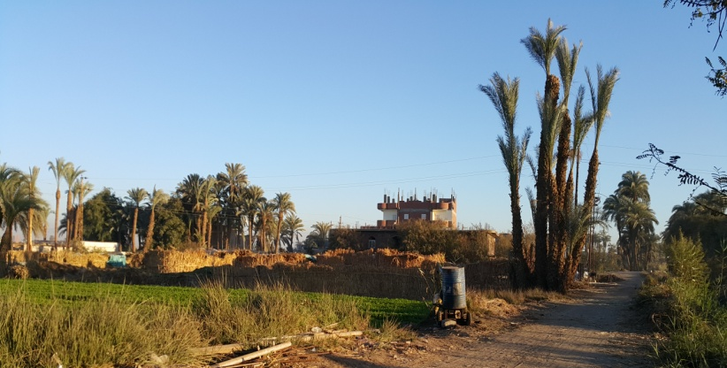
Figure ‎4-15: Vegetation encountered around the canal and arable lands and in proximity of roads.

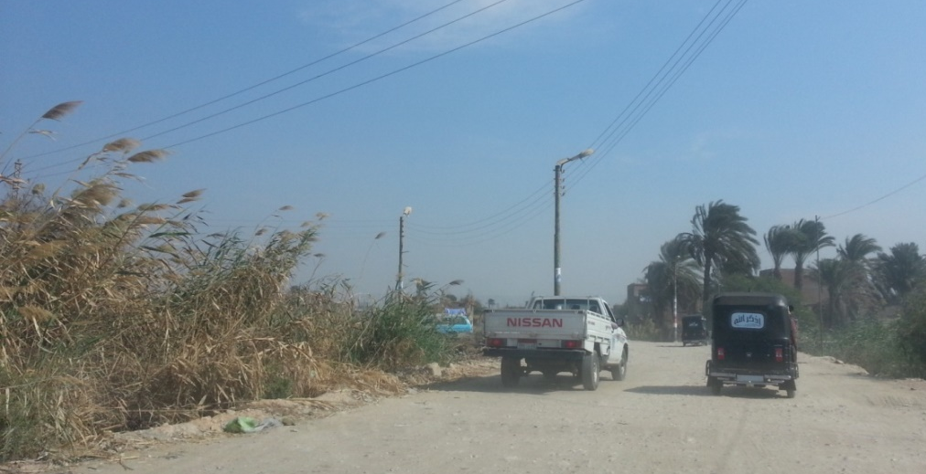
Figure ‎4-16: Traditional vegetation encountered alongside roads in Gerga.

With respect to flora of significance, none were encountered in residential areas, where household connections are planned. Typical residential areas are free of significant vegetation as shown in the figure below. Planned off-take from national grid to the PRS shall not come into contact with palm trees alongside the road.
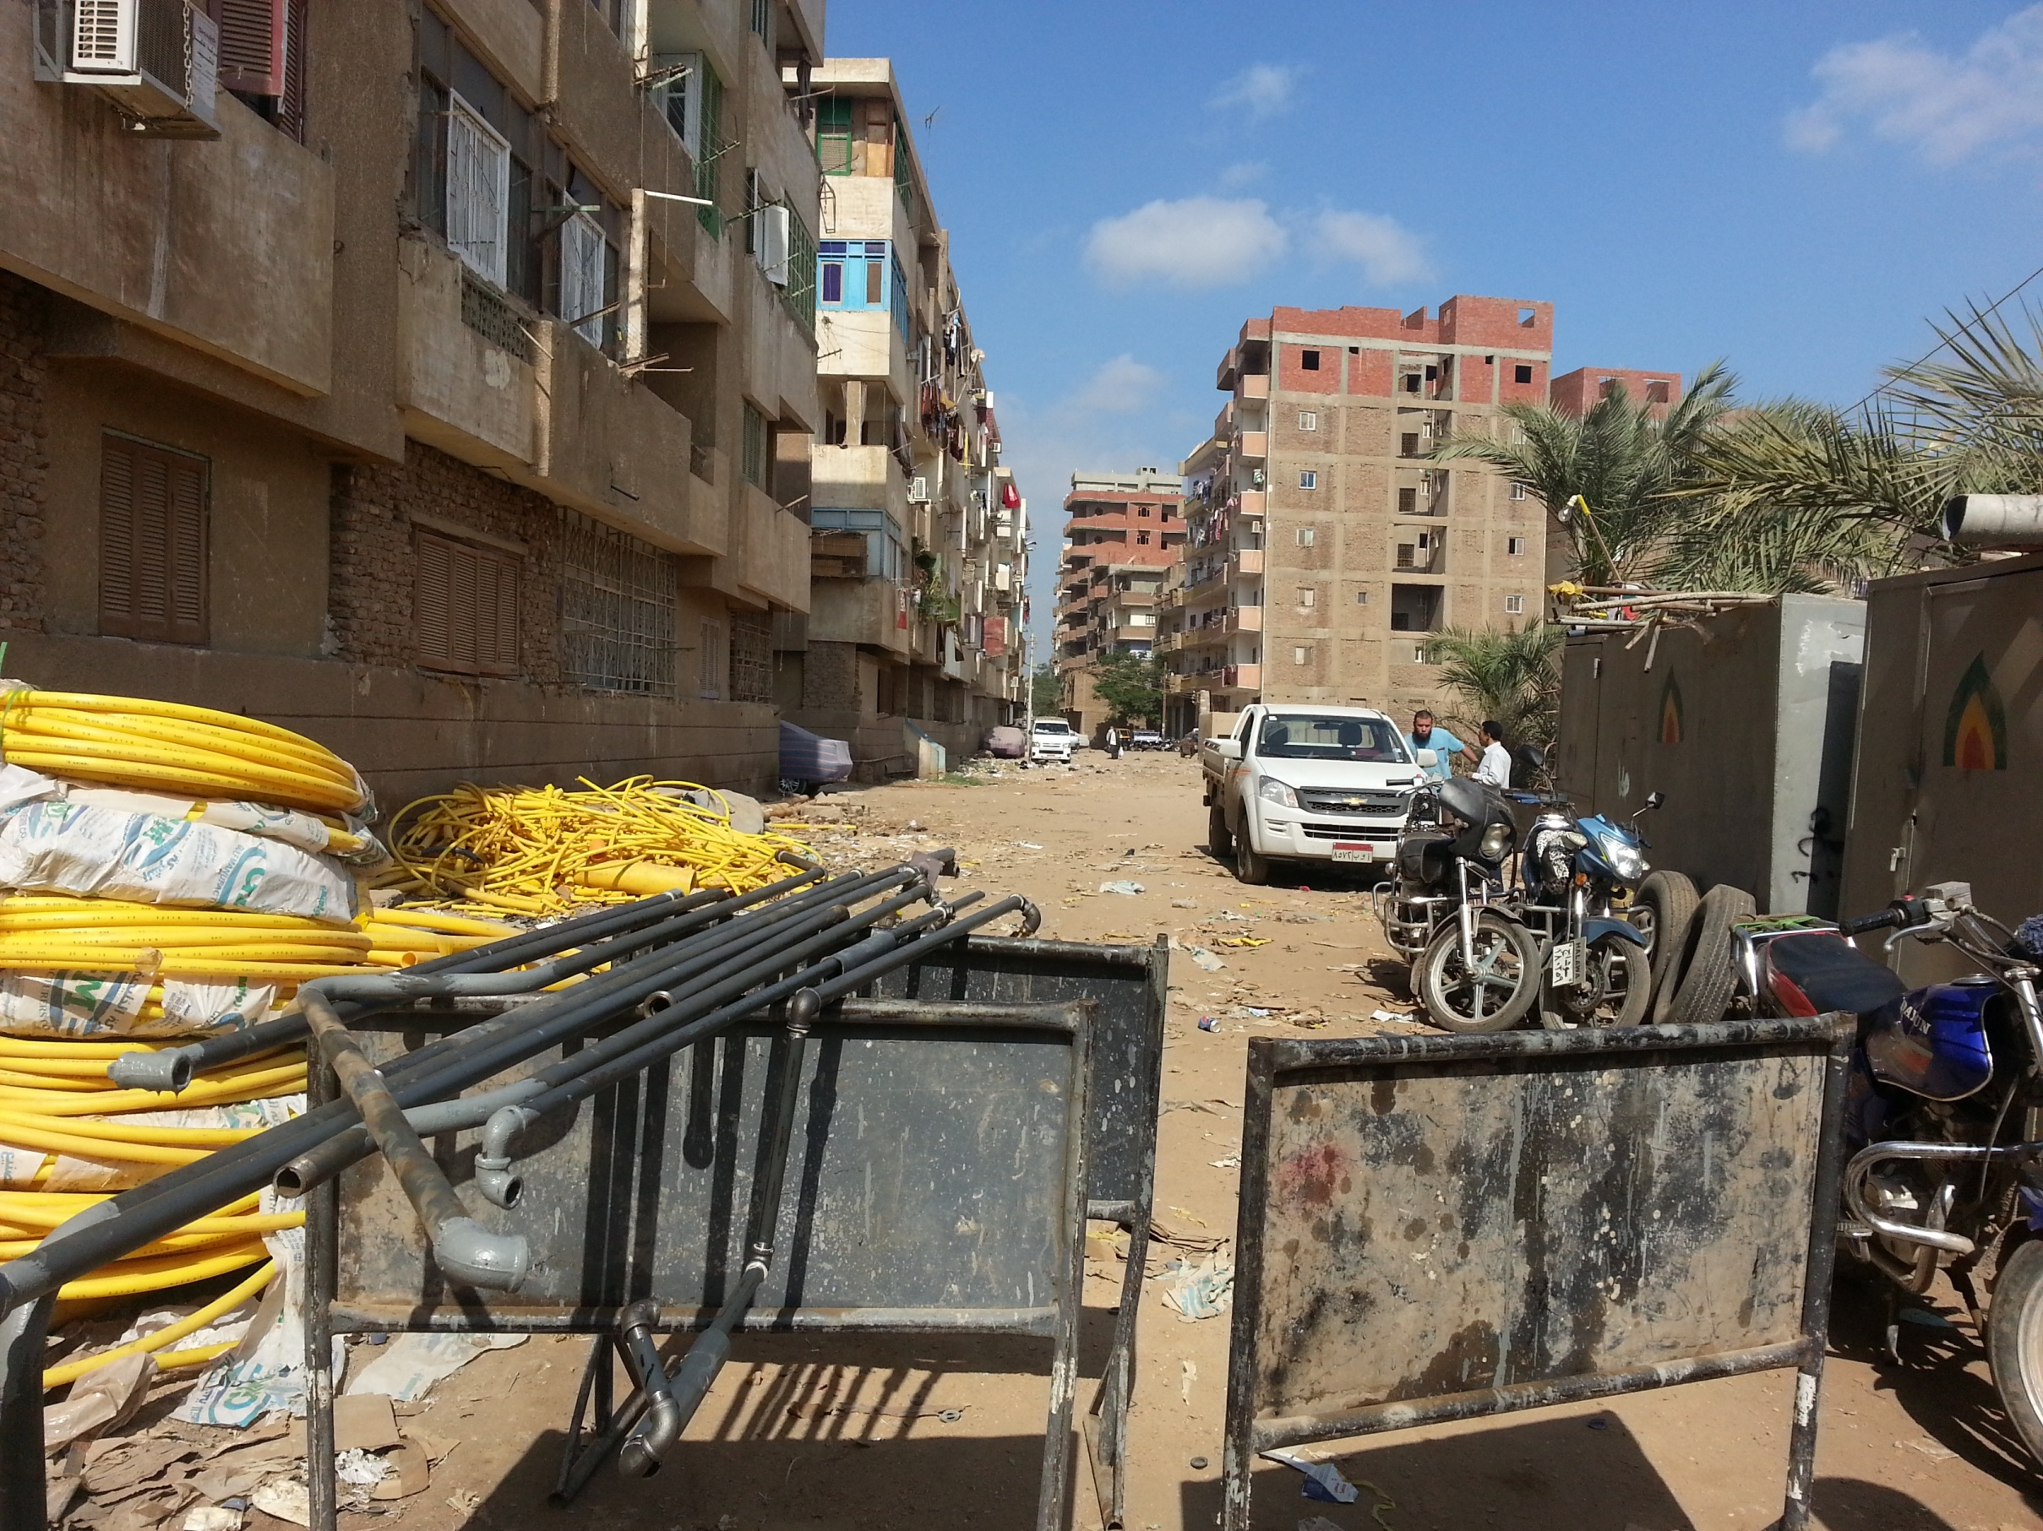
Figure ‎4-17: Typical local streets for planned connections of pipelines to households in Gerga.

Fauna
Domesticated animals such as camels, buffaloes, cows, donkeys, sheep, horses, dogs were observed and their presence dependant on human activity. Domesticated animals are not likely to be encountered roaming freely in the project area. Domesticated animals such as donkeys are typically used as a means of transportation. The figures below show domesticated donkeys encountered.
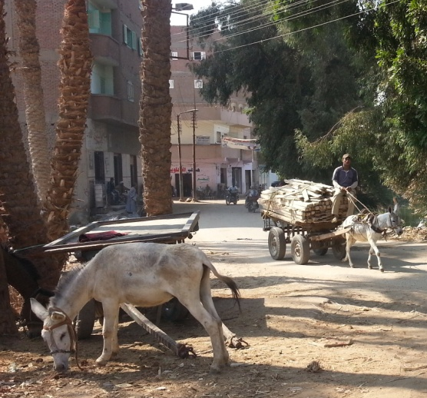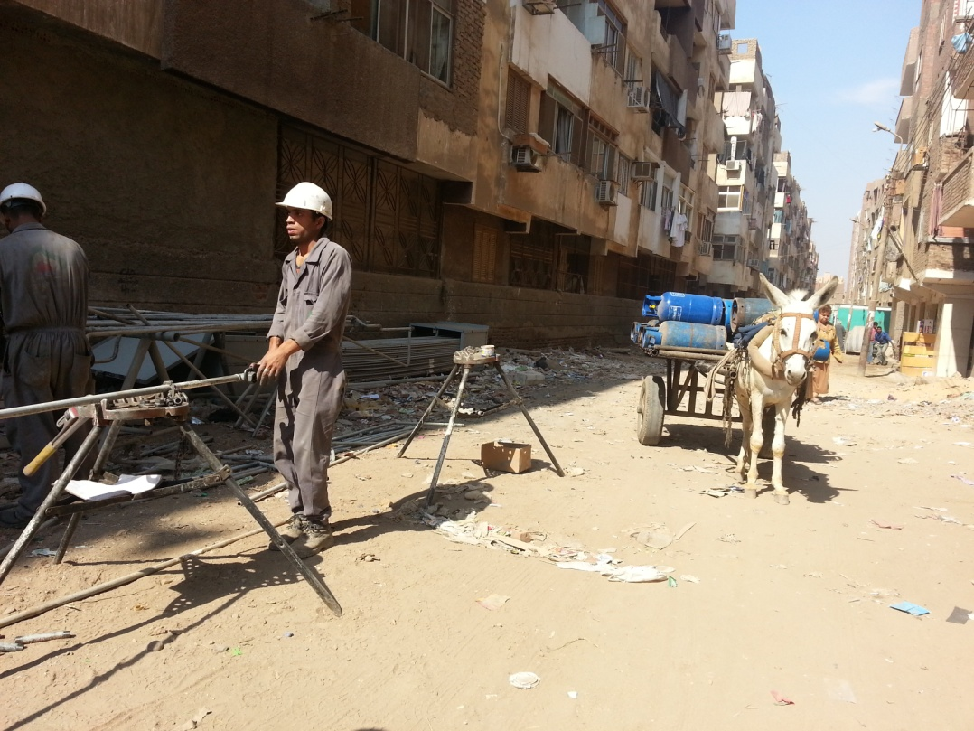
Figure ‎4-18: Domesticated animals encountered in Gerga.

Physical cultural resources
The main physical cultural resources in Gerga city are the Coptic Church of the Archangel Michael located on Mostafa Kamel Farouk Sabeqan street, Church of St. George the Great Martyr (Mar Girgis) on Saad Zaghloul Pasha street, and the El-Sini monastery also known as the Porcelain mosque located off Fakhry Abd El Nour street (26°20'12"N 31°53'45"E), the Church of prince Tadros the Great Martyr off Ahmed Abd El razeq El Gammal, and Al Zebda Mosque near El Sini Mosque off Fakhry Abel Nour.

Cemeteries are also considered physical cultural resources. Cemeteries in the city of Gerga are shown in the figure below.
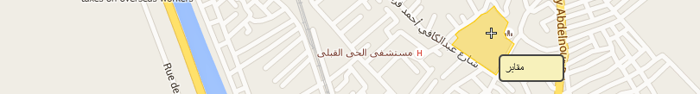
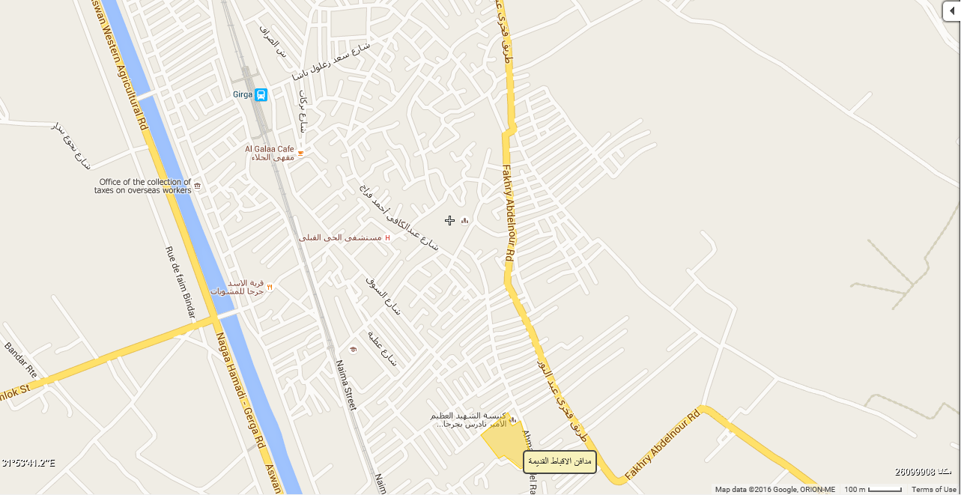
Figure ‎4-19: Cemeteries in Gerga (yellow shaded areas)

There are no physical cultural resources of significance in the vicinity of the PRS or along the pipeline route.
Concerning the household connections, the project work is planned in residential areas where physical cultural resources are unlikely to be encountered. However, considering that Sohag hosts many cultural and historical sites, should any chance finds occur, the procedure outlined in the Annex 2 titled ‘Chance Find Procedure’ will be followed.

Socioeconomic Baseline
Gerga District (Markaz) is located in the South of Sohag Governorate. In the proximity area, El Baliana city is located in the south, El Monsha’a District is situated in the northern part. In the western area, the desert border is surrounding Gerga district.
Based on the information available from the SYB 2015, the populated area of Gerga Markaz is estimated with 151.13 km2. This represent 8.73 % of the total Sohag governorate area. Total density ratio is estimated with 3352 person/ km2. It is administratively divided into one city, 1 Shiakha, 5 rural local units which consist of 27 villages and 195 hamlets. The Markaz's population reached 506,517 people.

Urbanization trends
The governorate geared towards expansion in the desert borders, thus it established new urban communities on the desert hinterland. Gerga is tend to be expanded to the vicinity desert lands in the western area.

Demographic characteristics and human development profile
The total population of Gerga Markaz is 506,517 people who reside 107,997 households. The residents of Gerga Markaz represent about 11.0% of the total population residing in Sohag Governorate.
The percentage distribution reflected that 25.2% of the total population live in urban areas in Gerga Markaz, while 74.8% of the population reside in rural areas. The average household size is estimated with 4.7. Gerga city total population is estimated with 118983 persons (CAPMAS 2013). The total number of households is 25316 household.

Age structure
The age-distribution of the population in Gerga city shows that almost 40.09% are less than 15 years old; while those between 15 to 45 years old represent about 28.57%. Female adults represent 28.2% (Poverty mapping. CAPMAS 2013). The city of Gerga tends to be a growing community.

Rate of Natural Increase
The birth rate in Sohag governorate overall is 31.7 births per 1000 persons. The adult mortality rate is relatively low; in Sohag Governorate the mortality rate is 5.6 per 1000 people. That gives a natural growth rate which of 26.1 per thousand persons in Sohag Governorate.

Living Conditions

Household Size and Density
A household is defined as “Family (and non-family) members who share residence and livelihood, and operate as one social and economic unit”. The average family size in Gerga is about 4.7 persons per household.
With regards to street conditions, the width of streets varies between 8-30 meters width. That was an indication of the high probability to get the NG installed in. Almost all streets and roads are covered with asphalt. That should be reflected on street restoration plans.

Access to Basic Services

Access to Electricity
Access to electricity in Upper Egypt governorates is 99.0% (Egyptian Human Development Report 2010). Even squatter areas have access to electricity regardless of their legality. The number of customers of the electricity utility company in Gerga Markaz is 118270 units.

In Gerga city, the number of subscribers of electricity represent 99.4% of the total residents. It is relatively crucial to mention that minor percentage of residents within the project areas in the city have no legal access to electricity.

The sample surveyed provided information about the electricity bill. They also were keen to provide electricity bills that inform about their monthly consumption ratio. The data revealed that households with high expenditure ability tend to consume more electricity.

15.4% of the sample surveyed consume less than 50 EGP per month, while 55.9% of the sample consume 50-135 EGP. The average electricity consumption in Gerga city is about 111.3 EGP.

Table ‎4-5: % Distribution of electricity bill value by expenditure category
Expenditure | Electricity bill value categories
Expenditure | 5-21 EGP | 22-49 EGP | 50- 135 EGP | 136-990 EGP
less than 500 EGP | 25.0% |  | 25.0% | 50.0%
500-999 EGP |  |  | 83.3% | 16.7%
1000-1499 EGP |  | 35.7% | 50.0% | 14.3%
1500-1999 EGP |  | 12.0% | 60.0% | 28.0%
2000-2499 EGP |  | 22.2% | 61.1% | 16.7%
2500-2999 EGP |  |  | 62.5% | 37.5%
3000-3499 EGP |  |  | 50.0% | 50.0%
3500-3999 EGP |  |  |  | 100.0%
4000 EGP |  | 33.3% | 33.3% | 33.3%
Total | 1.1% | 14.0% | 55.9% | 29.0%
Source: Data collection results

Access to potable water and sewage
The governorate depends almost entirely on Nile water for all its water needs. Occasionally, ground water is utilized in remote areas. Accessibility to potable water is high in Gerga Markaz and city. 99.77% have access to potable water in Gerga city.

With regards to access to sewage system, the Poverty Mapping reported that only 9.015% of the households in Gerga city have access to sewage system. Actually, this is an important factor that should be considered during planning phase. The data collected reflected that 99.0 of the sample have access to sewage. This is an indication that the planner of the project considered access to sanitation.

Human Development Profile

Education
Education is perceived as the first shell that can help population to withstand poverty. The review of secondary data showed that the intermediate education is prevailed among all governorates.

There was a remarkable gap between males and females’ education. 38.94% of the females are illiterate. However, 32.34% of the population are illiterate in Gerga City. The university graduates represent 14.09% of population versus only 10.43% of the females. The majority of educated population have completed vocational secondary school.

Unemployment and Work Status
Those who joined labor force in Gerga city are about 42.98% of the total labor force. The percentage of females within labor force is estimated with 16.28 %. Those who work for wage are estimated of 70.06%, whereas, those who are self-employed are 10.91% of the total employed adult.
With regards to the type of work performed by the breadwinner of the sample surveyed, 26.8% of the sample breadwinner work as skilled workers. 18.6% of the surveyed sample reported that the breadwinner work as high managerial personnel 14.4% of the total sample surveyed work as administrative staff. The unemployed, pensions and house wives represent 16.5% of the sample surveyed.
Figure ‎4-20: % Distribution of population by work status of the breadwinner
Source: Data collection results

Poverty index
Poor people are those who spend less than 2570 EGP per capita annually (Source: Poverty Mapping, CAPMAS 2013); meaning that those who spend less than 214 EGP per capita monthly are below poverty line. According to poverty mapping developed by CAPMAS in 2013, poor people in Gerga City are estimated to be 44.81%. The Income, Expenditure and Consumption study developed by CAPMAS in 2013 reported that a household of 5 persons need 1620 EGP to satisfy their basic needs. The households that spend less than 1620 EGP per month are considered as poor.
The total number of poor people, households with monthly expenditure of less than 1620 EGP, in Gerga City is 53316. The GDP per capita reported in the Human Development Report 2010 for Sohag Governorate is about 7329.7 EGP. The annual expenditure per capita is 4743.24 EGP. The ratio of female headed households is 16.6%. Female headed households tend to be of more vulnerable condition.

Income and expenditure

NG installation project necessitates a clear determination of poverty through analyzing the income and expenditure of household. Reliability of expenditure data is higher than income. The expenditure and income of households reflected that 25.1% of the sample surveyed spend less than 1500 EGP. This categories tend to be of poor economic conditions. 26.3% of the sample surveyed spend 1500- 2000 EGP. This was an indication of the economic wellbeing of the target beneficiaries. The average expenditure value is estimated with 1921.8 EGP per household whereas the average income is estimated with 2055.8 EGP

Figure ‎4-21: % Distribution of population by income & expenditure and sex

Source: Data collection results

With regards to stability of income, about 13.5% of the total sample surveyed reported their income decreased during the previous year. However, about 53.1% of the sample surveyed reported no change in their income.

Fuel currently used in households
Gerga Markaz hosts 18 outlets (storeroom to change empty LPGs). The total LPG cylinders consumed annually in Gerga is 39600 LPGs. Gerga residents consume 7.5% of the total LPG cylinders allocated to Sohag Governorate.
The sample surveyed reported that the main type of fuel used for cooking is the LPG cylinders. 53.1% of the sample obtains the LPG from vendors. 39.8% obtain it from the LPG outlet. 14.3% obtain it from supplies office. With regards to the fuel used for water heating, 71.1% of the sample surveyed use electric heaters. 1.0% use kerosene. 27% use LPG cylinders for heating,

Problems faced with the current household fuel
The majority of sample surveyed in Gerga City reported that the LPG is of high price. 44.9 % of the respondent reported the unavailability of the LPG, particularly, during the shortage period. 44.9% of the sample reported that the cost is relatively high. 12.2% were not satisfied with the LPG leakage. 11.2% of the sample reported that the LPG cylinder is empty.

Figure ‎4-22: Distribution of the problems related to LPG cylinders
Multiple responses
Source: Data collection results

52.0% of the sample surveyed reported that they are obliged to change it of higher price. 13.3% reported that they borrow the LPG from neighbors.

Electricity used in water heating fuel was of less problems. The main problematic aspect related to electric heaters is the high electricity tarrif. The sample surveyed reported that they overcome such problems by rationalization of electricity consumption.

Perception towards the project
It is very obvious that almost all of the sample surveyed have positive perception about the NG. They reported that NG has many remarkable benefits. 43.3% reported that NG saves time and effort. 37.1% of the sample reported that it is always available and reliable. Safety of the NG was reported by 35.1% of the respondents. It will also put limitation to the crisis of the LPG shortage. The high cost of the LPG fed into the positive perception towards the NG.
Figure ‎4-23: Perception of the NG project
Multiple response
Source: Data collection results

Another level of investigation was applied on the sample through asking directly about the drawbacks of the NG. 53.6% of the sample reported no drawbacks. 6.2% of the surveyed sample reported that they have concerns related to safety measures 14.4% of the sample surveyed reported that the NG might have defects. Some of the sample surveyed were reluctant to install the NG due to fears pertaining to high installation cost.

Gender dimension of the current type of fuel
Females play a role in the domestic labor relating to bringing and handling LPG. 7.1% of the households nominate women to bring the LPG cylinder from the outlet. 13.3% of the sample nominate females to bring the LPG upstairs. 29.9% of the sample nominate woman to install the LPG cylinder to the cooker.
Figure ‎4-24: Females role in the LPG system
Source: Data collection results

Willingness and affordability to pay

The majority of sample surveyed expressed their willingness to be connected to the NG regardless to the amount of money they can afford to pay. 56.1% of them were willing to pay in cash. Such attitude is attributed to the fluctuation of the LPG prices.

On average each household consumes 1.4 LPG cylinder for cooking and one for water heating. The cost of one LPG is about 22.41 EGP on average, indicating that each house pays about 31.37 EGP per month for cooking fuel. Water heaters’ fuel is divided into electricity and LPG. The average cost of water heating was about 27.18 EGP.

24.5% of the sample surveyed in Gerga pays 11-20 EGP per cylinder. However, 55.1% pay 21-30 EGP. The mentioned figures reflect two important issues. Firstly, community people pay double price of the LPG cylinder. Secondly, the subsidy dedicated to the LPG is not fully useful as the community people have to pay high prices for the LPG. During the shortage of LPG, people used to pay 50-100+ EGP in Gerga. . NG was largely perceived to be a much more useful and convenient fuel option.

Based on the results survey and by asking local communities about the appropriate payment modality for them, 55.7% of the sample in Gerga were willing to pay in cash. 44.3% of the sample reported their willingness to pay in installment. Monthly installment value was investigated among the whole sample. 23.4% of the total sample reported their willingness to pay 52 EGP for 36 months. 18.2% were willing to pay 74 EGP for 24 months. 16.9 % showed willingness to pay 138 EGP for 12 months.
The figure below reflected that poor households (those who spend less than 1500 EGP per month) were willing to pay less than 42 EGP per month.50.0% of those spend less than 1000 EGP were willing to pay less than 31 EGP per month. The poorest category were willing to pay a high installment in order to reduce bank profits and save their money.

Figure ‎4-25: % Distribution of the sample surveyed by monthly installment and house expenditure (Source: Data collection results)

The households surveyed were asked about the minimum and maximum amount of money to be paid in cash. They reported that the least amount is about 831.9 EGP and the most is about 1400 EGP on average. The average of full installation cost reported by the sample surveyed reflected that almost all surveyed sample are fully aware about the cost which is on average is 1693.8 EGP
They were asked about the most and least advance payment they afford paying. 420.22 EGP was reported as the most advance payment they can pay, while the least amount was 253.0EGP.
The monthly installment amount they can afford to pay varies between 62.48 EGP and 105.0 EGP.
Figure ‎4-26: Willingness to pay
Source: Data collection results

The poorest category of respondents reported that they can pay in installment. The FGD participants reported that the poor spend a lot of money to obtain cylinders. Thus, they will be keener to save their money by installing the NG. “The state should provide additional subsidy to all people” reported by a female FGD participant in Gerga.

The community socioeconomic characteristics and the willingness of people to convert to the NG are remarkable. Community people are much in favor to host the project. However, there is an actual need to provide clear information about the project in order to warrantee their support to the project. This information should discuss the following issues: 1) safety of the NG, 2) payment schemes, 3) project impacts and mitigations, 4) grievances mechanism

Environmental and Social Impacts
The environmental and social advantages of switching household fuel from LPG cylinders to natural gas pipelines are diverse. On the residential level, the proposed project will lead to improved safety, reduced physical/social/financial hardships, and secure home fuel supply. On the national level, it promotes the utilization of Egyptian natural resources and reduces the subsidy and import burden. Even on the global level, the project involves cleaner fuel with reduced carbon footprint.
A thorough analysis of environmental and social impacts is important to detail an effective management and monitoring plan which will minimize negative impacts and maximize positives.
The assessment of impacts distinguishes between the construction phase and the operations phase.

Positive Impacts

During the construction phase

Direct job opportunities to skilled and semi-skilled laborers
The project is expected to result in the creation of job opportunities, both directly and indirectly. Based on similar projects implemented recently by EGAS and the local distribution company, the daily average number of workers during the peak time will be about 150 workers in 6 sites across Gerga. The local community of Sohag Governorate could provide a proportion of this temporary labour force dependent on skills needed and the strategies of the individual contractors in sourcing their workforce.
    - The total number of new short term job opportunities within the project areas is estimated at 150-200 temporary jobs they are segregated as follows:
    - Up to 20% semi-skilled workers on a temporary basis
    - Up to 30% local construction workers for water heater vent installations
    - Up to 50% daily wage workers for street drilling
Additional temporary job opportunities will be provided through construction works (for 5-6 months) on the PRS site. They will be as follow:
    - 7 drilling workers
    - 2 security staff
    - 1 engineer
    - 6 plumbers
    - 5 carpenters
In order to maximize employment opportunities in the local communities it is anticipated that training will be required for currently unskilled workers. On-the-job training will also supplement opportunities for the local workforce for both temporary construction roles also for long-term operations phase position, where these are available.

Indirect opportunities
As part of the construction stage, a lot of indirect benefits are expected to be sensed in the targeted areas due to the need for more supporting services to the workers and contractors who will be working in the various locations. This could include, but will not be limited to, accommodation, food supply, transport, trade... etc.

During the operation phase
- As indicated in the Baseline Chapter, women are key players in the current domestic activities related to handling LPG and managing its shortage. Being the party affected most from the shortfalls of the use of LPG, the NG project is expected to be of special and major benefits to women. This includes, but is not limited to, clean and continuous sources of fuel that is safe and does not require any physical effort and is very reasonable in the price of consumption fees. Time saving is among the benefits to women. The use of a reliable source of energy will allow women to accomplish the domestic activities in less time and this will potentially open a space for better utilization for the saved time.
- Constantly available and reliable fuel for home use
- Reduced expenditure on LPG importation and subsidies. 28.457 thousand connections will be installed in Gerga City. Each household consumes 1.4 LPG monthly and one LPG for water heating. The total LPG that are predicted to be reduced are about 68296.8 thousand LPG per month for cooking and water heating purposes. The subsidy value is about 70 EGP per each LPG. Consequently, the total subsidy to be saved monthly will be about 4780776 EGP. That will result in total annually savings of 57369312 EGP. Additionally, significant savings in electricity will result due to replacing the electric water heater by NG heater.
- Significantly lower leakage and fire risk compared to LPG
- Improved safety due to low pressure (20 mBar) compared to cylinders
- Beneficiaries to benefit from good customer service and emergency response by qualified personnel/technicians
- Eliminate the hardships that special groups like physically challenged, women, and the elderly had to face in handling LPG.
- Limiting possible child labor in LPG cylinder distribution

Anticipated Negative Impacts

Impact Assessment Methodology
To assess the impacts of the project activities on environmental and social receptors, a semi-quantitative approach based on the Leopold Impact Assessment Methodology the Buroz Relevant Integrated Criteria was adopted.
Detailed assessment matrices shown in Annex 5. Following are the impact assessment scoring classification and results. The table below presents the classification of impact ratings and respective importance of impact values.

Importance of Impact | Impact rating
0-25 | None or irrelevant (no impact);
26-50 | Minor severity (minimal impact; restricted to the work site and immediate surroundings)
51-75 | Medium severity (larger scale impacts: local or regional; appropriate mitigation measures readily available);
76-300 | Major severity (Severe/long-term local/regional/global impacts; for negative impacts mitigation significant).

Potential Negative Impacts during Construction

Reduction of Traffic Flow (disruption of local and regional traffic)
Environmental impacts
During the mobilization, preparation phases and construction phases: Mobilization of heavy machinery, asphalt breaking, excavation, placement of piping, and backfill activities are bound to limit traffic and accessibility. The impact of works on traffic flow and local access will be dependent on the type of road accessed during project activity.
Main roads (highways)
No works are planned on main roads; therefore, the project will not directly impact circulation on main roads. An indirect impact can be increased flow of vehicles as urban roads are avoided.
Urban roads
On urban roads, mobilization, preparation and construction phases will entail narrowing roads by longitudinal and/or lateral excavation or totally blocking narrow or side roads as well as limiting or prohibiting parking along the length of the works. Access to buildings and shop entrances may be limited or constricted in cases where excavations form obstacles for pedestrians and cargo.
Coordinating with and obtaining approvals from local government and traffic police is vital to avoid delays, objections, and public inconvenience to the work program.
On urban roads, the impact on traffic flow and local accessibility are of medium severity.
Local roads
As pipeline installation will be taking place on roads, local access on select parts of the road will be ceased and will likely restrict local access to residents into and out of their households. As regular sized vehicles are not the principal mode of transport on local roads, congestion of cars is not anticipated. The inconvenience is expected to affect the flow of Tuk Tuks by slowing them down. However, considering their small size, congestion is not likely to be significant.
Inconvenience to the residents will last for the duration of the construction phase activities, namely, excavation and rehabilitation of the road, which will be done on the same day with no pits being left open overnight. Therefore, the duration of inconvenience and slowed traffic of Tuk Tuks etc. in affected areas will last for the duration of the work day i.e., 8-10 hours.
On local roads traffic congestion of regular sized vehicles will be insignificant. The main impact will be inconvenience to residents in accessing residential buildings and will likely be of minor severity.
On local roads, traffic and access limitation impacts are temporary, local, and of minor severity
Socioeconomic impacts
The project will result in inconvenience and disturbance to local communities and business and delay in the various daily activities due to the following:
Traffic congestion will result in various unfavorable socioeconomic impacts. i.e.:
- Microbuses and tuk tuks may find difficulty in maneuvering the streets that will be dug during the project construction. This will increase their oil consumption and reduce their ability to move quickly and transport less clients as each errand will take more time.
- There might be a disturbance to community people due to the traffic congestion

Air Emissions
Environmental impacts
WB requirements and Law 4/1994 (modified by laws 9/2009 & 105/2015) stipulates strict air quality standards . Air emissions (gases and particulates) during construction shall arise from:
- Particulate matter and suspended solids from excavation/backfilling operations
- Possible dispersion from stockpiles of waste or sand used for filling trenches.
- Exhaust from excavation equipment and heavy machinery (excavators, trenchers, loaders, trucks) containing SO_{x}, NO_{x}, CO, VOCs, etc.
- Traffic congestions resulting from road closure or slowing down of traffic due to excavation works.

Dust
The impact of dust generation (particulate matter) will be limited to the working hours as excavation and backfilling are carried out within the same day.
Excavation on dusty or rocky roads such as local roads and some urban roads are likely to generate more dust compared to asphalted streets due to the dusty status of those roads.
Gaseous pollutants emissions
Provided machinery used during construction is certified and maintained as per guidelines, the increase in emissions stemming from the exhaust of machinery is unlikely to increase ambient levels beyond national and WB permissible levels.
On urban roads, traffic congestion may lead to increased exhaust emissions. Traffic management with local authority will reduce the impact of works on road congestion and associated emissions.
Socioeconomic impacts
Air emission might result in health problems to allergic community members.
Air emissions impacts are expected to be temporary, local, and of minor severity.

Noise
Environmental impacts
Construction activities of the PRS and the gas distribution network will likely increase noise levels due to excavation and heavy machinery. Typical construction noise includes noise intensity due to engine operation, and intermittent impacts which may take place during demolition of asphalt, either by a trencher or by a jack hammer. As discussed previously, the WB/IFC guidelines and Law 4/1994-9/2009-105/2015 have defined standards for noise intensity and exposure periods in the work place, in addition to certain limits for ambient noise levels for different types of urban and rural areas.
Noise impacts on construction workers, technicians and engineers in direct vicinity of the excavation works and heavy machinery are considered more significant than those on residents. Traffic congestions, which could be caused by excavation works, may increase ambient average noise intensity levels.
Socioeconomic impacts
Noise might result in health problems to the workers, engineers and technicians.
Noise impacts are expected to be temporary, local, and of minor severity.

Risk on Infrastructure and underground utilities
Environmental impacts
Gas network connection
Underground utilities and infrastructure pipelines (such as water, sewerage and telecommunication) have been installed years ago without accurate documentation and maps for its routes and depths. Therefore, the risk of damage to such utilities during excavations for natural gas pipeline installation is possible.
The most significant potential environmental impact will arise in case a sewerage pipe is broken and wastewater potentially accumulating in the trench. There is also the possibility of overflowing to the streets causing nuisance to the surrounding environment.
Socioeconomic impacts
Breaking a water supply pipe may result in cutting the supply to a number of residential units, which may lead residents to use other sources of water which may be either expensive or unsafe.
Damaging sewage, electricity and water supply result in severe disturbance to community people. Yet such problem takes short time (no more than 4-8 days). Additionally, the contractor will be responsible of compensating for damaged pipes.
Impacts on underground utilities are expected to be temporary, local, and of minor severity

Possible effects on vulnerable structures
Environmental impacts
Gas network connection
Dewatering activities: Excavation for natural gas pipelines is usually shallow and does not exceed 1.0 meter depth. Groundwater is typically not encountered at shallow depths. However, if groundwater is encountered, dewatering will be applied. If dewatering activities are sustained for a long duration, differential settlement of the fine soil can jeopardize the integrity of weak structures in the surrounding area.
Drilling vibrations: Workers are accustomed to manually drill to prevent vibrations near sensitive structures.
Another possible impact on structurally-vulnerable buildings is weakening the structural system during drilling holes in the walls for riser connections on the side of the building or for internal connections to the household. The hole for the pipe usually is small compared to the wall section. Moreover, beams can easily be avoided by carefully selecting the distance of the drilling from the ceiling. For skeleton type buildings, drilling in columns or beams could have a significant effect on the structure, but this risk is well understood among connection workers and could be avoided.

PRS construction
The PRS is not located near any physical structures.

Structural impacts on vulnerable buildings are of irrelevant severity

Effect on Culturally Valuable Sites
Effects on culturally valuable sites (monuments, archaeological, paleontological, historical, architectural, religious, aesthetic or other cultural significance) may involve:
- Structural damage to a monument due to dewatering during excavation.
- Damages to monuments' foundations due to excavation works.
- Damage to the monument body by vibration of machinery.
- Reducing the aesthetic appeal of the site or building.
- Improper management of discovered antiquities during excavation (chance finds).
If dewatering is needed, may lead to differential settlement of the soil surrounding the monument foundations could result. Shallow foundations may be affected by excavation works. This may cause differential settlement and may cause cracks and stability risks to the monument body.
Vibrations caused by machinery such as a trencher and jack hammer may cause cracks and surface damage to the stones of the monument, and risks to its stability.
According to the CULTNAT classification, a site may be classified as architecturally-valuable for its artistic design, its elevation view, artistic balcony, windows, domes or other components. Fixing gas risers and connections next to such components may reduce their artistic value.
Chance finds during excavation are highly unlikely within Gerga as the streets have been previously excavated for installing underground utilities. However, Antiquities Law provides clear guidelines for action in the case of chance finds. It also states that a representative of the antiquities department must be present during excavations in areas adjacent to antiquities sites. Please see Annex 2 that outlines procedures in case of chance finds.
The projected works for the PRS and the gas distribution network are not planned nearby physical cultural resources as described in the baseline of the project area in chapter 4.
Impacts on culturally valuable sites and buildings are of irrelevant severity

Effect on ecological systems (green areas/farmland)
Environmental impacts
During construction of the PRS and the gas distribution network, excavations and pipe laying will mostly be aligned along routes previously excavated or paved.
No protected areas will be encountered in the alignment of the lines.

Impacts on ecological systems are expected to be irrelevant.

Solid and Liquid Waste Management
Environmental impacts
Wastes that are generated during the construction phase include:
- Excavated soil and excess sand; concrete and bricks waste;
- Broken asphalt in the case of paved roads;
- Cans containing paint used on steel pipes in household connections
- Containers of chemicals and lubricant oils used for construction machinery;
- Possibly damaged asbestos water pipes during excavation; and
- Dewatered product from trenches.
- Construction waste estimates are in the range of 100-120 m³/km.
Excavated soil and concrete/bricks waste are inert materials. Improper disposal of such wastes will only have aesthetic effects on the disposal site. The legal standards of Law 4/1994-9/2009-105/2015 for the Environment and Law 38/1967 stipulate that these wastes should be disposed of in licensed sites by the local authority, which minimizes any aesthetic effects of such waste.
Asphalt waste may contain hazardous components, such as tar, lubricating oils, some heavy metals, etc. However, its solid nature minimizes the transport risk of such components to the environment. Disposal of asphalt waste to a construction waste disposal site is common practice in Egypt, and is not normally associated with environmental risks because of dry weather.
Empty containers of chemicals, lubricating oils, and paint are considered hazardous waste. They should be disposed of in an approved hazardous waste handling facility. This is not a direct result of construction activities, but rather relates to maintenance of equipment. By preventing fueling/lubricating activities on construction sites no empty containers will need disposal.
Asbestos waste could result if an underground water pipe is broken during excavation. If encountered, wasted parts of the pipe must be sprayed with water, to prevent emissions of asbestos-containing dust, and transported to an approved hazardous waste landfill. Asbestos waste may pose significant health risks to workers, pedestrians and residents of neighboring areas. Therefore, efficient management of such waste, if generated, will be very important. The probability of generating asbestos waste is relatively low as the damage is usually repaired locally without the need for pipe replacement. Management and disposal of the generated waste is the responsibility of the Water Authority performing the repairs.
Improper drainage of dewatering water may result in forming stagnant water ponds around the construction site, which can develop, if not drained, infiltrated or evaporated, to form nuisance and an environment for breeding of insects. Normally dewatered product is relatively clean water, which should be drained to the sewer system. To conserve water, if dewatered groundwater is free of perceivable pollution, it will be- to the extent possible- used on- or around the work site or discharged into the nearest canal to be used for irrigation When dewatering is performed from a contaminated trench or near a source of pollution seepage to groundwater, contaminated water is collected for certified treatment/disposal according to WB/IFC guidelines and National Laws 93/1962 and 48/1982, respectively.
Socioeconomic impacts
Waste contractors and recycling/disposal sites will benefit from waste disposal contracts.
If waste is not managed properly, it will result in health problems to the surrounding communities.
Overall, waste generation impacts are of minor severity

Street condition deterioration
Environmental impacts
Streets rehabilitation or restoration following pipeline network installation: is referred to by an Egyptian legal/institutional expression (رد الشئ لإصله) that signifies the responsibility to “restore to original condition”. In the context of the project, it applies to the responsibility of the implementing company to provide the necessary resources to re-pave roads and streets to the original state after natural gas excavation and installation works. The current arrangement is that the implementing entity performs the backfilling of the excavated trenches and agrees a restoration fee with the local government unit (district) to cover the balance of the restoration and pavement cost. The local unit uses the fee to include the restoration and re-pavement of the streets in its “pavements plan”.
Socioeconomic impacts
Delays in street restoration may lead to varying degrees of damage to vehicles, loss of access and business, traffic congestions with associated delays and emissions, and a potentially significant public discontentment.
Although the restoration impact may be temporary, localized, and of minor severity, it is perceived by the public as major inconvenience.

Overconsumption of community resources
Environmental impacts
No probability of environmental impacts pertaining to overconsumption of community resources.
Socioeconomic impacts
Generally speaking having workers in small cities might result in unfavorable impact on the available resources, e.g. pressure on accommodation, food, health care and medication and potable source of water. Given the size of population in project sites and the availability of most of services; the limited number of workers (100 worker) will not result in any significant impact on the community resources.

The impact of overconsumption of community resources is of irrelevant severity given that the limited number of workers is small in comparison to the number of residents in the area.

Community health and safety
Environmental impacts
No probability of environmental impacts on community health and safety
Socioeconomic impacts
Negligent workers may cause accidents harmful to the community members, particularly children and old people, especially close to the digging sites. The workers should support children and old people in case of crossing digging areas. There should also be caution tapes to stop community people from accessing construction sites. Concerning the PRS, the location is far from populated areas as shown in the baseline section. In case of the workers and contractor adhere to such procedures the community health and safety impact will be limited.
With compliance to the health and safety measures, impact related to the community health and safety during the construction phase will be minor

Visual intrusion
Project activities will entail piling of sands and moving of vehicles in various construction sites. Moreover, the temporary storage areas will be used to store pipes, painting materials and safety equipment. That will result in significant visual intrusion impact.

Impact related to the visual intrusion during the construction phase is irrelevant

Labor conditions and occupational health and safety
Throughout this phase there will be many occupational health and safety risks to workers on the sites. These are generic risks associated with construction sites and include slips and falls; moving lorries and machinery; exposure to chemicals and other hazardous materials; exposure to electric shock and burns; weather related impacts (dehydration; heat stroke). This is short term (6-12 months) but because of the large number of unskilled workers who are reluctant to use Personal Protective Equipment, there might be some level of risk.

Impact related to Occupational health and safety during the construction phase is minor

Land acquisition
As a new PRS will be constructed in Gerga, there was a necessity to select the technically and socially acceptable land with a total area of 2500 m² (14.286 Qirate). Selection process starts by searching for land nearest or closer to the off take of the high pressure pipeline (70 bar pipeline).

Due to the unavailability of state owned lands, EGAS/Regas followed EGAS procedure for acquiring land for the construction of the PRS on Willing Buyer – Willing Seller basis and no involuntary land acquisition took place.

Four alternatives of privately owned lands were inspected. The agreed land was technically and socially acceptable, as it is lies on top of the HP pipeline and entails no further land acquisition compared to the other three alternatives that require purchasing more land.
It is worth mentioning that in cases where land is acquired for construction of High pressure pipelines, and as per the agreement between the land owners and GASCO (HP pipelines operator), land owners have no right to build or cultivate trees above the pipeline after payment of compensation cost.

The selected land is cultivated by its owners with no tenants and did not require payment to compensate tenants for crops. It was also mutually agreed that the land owners will be granted time to collect their crops (onions) before LDC (Regas) starts any construction works.

Consultation with the land owners were conducted during the committees visits also further consultation were conducted with the other neighboring land owners to determine the prevailing price (market price) of the land in the targeted area. Prevailing price ranged from 25 to 30 Thousand EGP/Qirate, considering the current situation that the land is for agricultural purposes. Consultation meetings also reflected the future expectation of the land owners in this area that the land could be used in the near future for construction of buildings that is of more value than the current land status (agricultural).

Based on the cost estimation analysis carried out by the Regas company, and after the negotiations with the land owners, the land was purchased on 11/3/2015 at a total cost of 714285 EGP (approximately 50 Thousand EGP/ Qirate) and cheques were issued and received by each of the land owners (four persons) (please see Annex 7).

The access to high pressure pipeline owned by GASCO was in the selected and purchased land. Thus, there was no need to the extension of 70 bar steel pipelines. With regards to the exit low pressure pipeline was close to the main roads. Additionally, the grid penetrate the main roads. Therefore, no lands were needed for both the access to high pressure pipeline nor the exit of low pressure pipeline. Thus OP 4.12 is not be applicable to Gerga PRS, pipeline extensions lands and the NG grid. Hence, no RAPs are needed

Potential Negative Impacts during Operation

Community health and safety
In addition to a full array of safety and emergency precautions taken by EGAS and the implementing entities, user safety is prioritized by stating emergency precautions on the household gas meter and by setting up emergency response centers. Impacts on user health and safety may occur through improper handling of piping and valves by the user. This may be due to a lack of awareness, illiteracy, or failures in piping or sealants.

Considering the low probability of occurrence and the lower density of natural gas (compared with current practice of LPG), impacts on community health and safety due to gas leaks is of minor severity.

Integrity of natural gas piping
Environmental impacts
Low-probability events may impact the integrity and safety of the NG network and components during the years of the operation phase.
- Geological and geotechnical events: earthquakes may result in geotechnical instabilities that lead to network breakage or leakage in multiple locations simultaneously. The geological and geotechnical history of the area may also lead to possible events.
- Sabotage: pipelines and other components may be targeted for sabotage.
Socioeconomic impacts
Adverse impact is expected in raising the fear of disruption of Gas supply
Leak impacts may be permanent and highly severe, however, considering the extremely low probability of occurrence, the impact is of minor severity.

Improper handling of the Odorant
Environmental impacts
Odorant handling is part of the operation of the PRS and is addressed in a Quantitative Risk Assessment attached as a separate study.

An odorant is added to the NG in order to enable detection upon leakage. The odorant containing Tertiobutylmercaptin (80%) and Methylehylsulphide (20%) is classified as a hazardous substance. The MSDS of the odorant identifies the following hazardous properties: Highly flammable, flammable and toxic products upon thermal decomposition, irritant, and toxic to aquatic flora and fauna.
It will also be required to keep a register for management practices followed in PRSs.
Odorant leak can result from improper handling of the odorant includes:
- Storage in unsafe conditions, in terms of occupational health and safety.
- Discharge of remaining odorants in containers, after use, in land or sewers;
- Disposal of used containers with domestic waste, or by open disposal; and
- Recycling of used containers for other materials.

Noise of PRS
Environmental impacts
The pressure reducers normally cause noise generated from the reducers' pipes. Maximum noise level expected from the reducers is 80db. The generated noise is constant (not intermittent). Assuming ambient noise levels are complying with WB/IFC requirements and Law 4/1994-9/2009- 105/2015 standards for low noise residential areas, a 20-meter buffer distance kept between the reducers and the PRS fences should lead to minimal impact outside the PRS borders.
Impacts of PRS noise may be permanent and of minor severity.

Safety Aspects of PRS Operation
The safety risks associated with PRS’ operation (leakage, fire hazard, explosion, suffocation) are assessed for the workers and the public at large, in a separate Quantitative Risk Assessment (QRA) modeling and comparing the results with international risk management guidelines as a reference.

Visual intrusion impacts
The installation of house connection and the chimney will affect the building There is a probability to affect the building, particularly, unique old buildings. Under certain technical and safety conditions it is not possible to avoid visually impacting the entrance of the apartment and dwellings with installed pipes.
Visual intrusion Impacts will be of irrelevant severity

Economic disturbance to the LPG distributors
There could be a Minor negative economic impact on LPG cylinders distributors. (Governmental sector- private sector who have license to distribute LPG cylinders- non official distributors). The LPG distributors will lose their income. However, their ability to move to other areas or change their business is high. Various previous NG projects have not influenced the informal LPG vendors.
The probability of such impact is minor as LPG distributors manage to perform alternative job.

Women and Vulnerable Groups
Vulnerable groups are more exposed to the implications of various impacts and are more likely threatened to get in more impoverishment. The level of vulnerability of a certain group and the severity of the impact on these groups has been assessed. It is believed that certain groups are more vulnerable than others due to higher level of exposure to these impacts or lack of alternatives or survival methods that allow for coping with these impacts.
It is expected that poor women and female headed households will be able to access the project benefits through the installment schemes that EGAS is making available to encourage citizens to get connected to the project. The same benefits that women will gain from this project apply also to other vulnerable groups of elderlies and people with disabilities.
It is foreseen that the project will not have any unfavorable impacts on women and vulnerable groups.

Analysis of Alternatives

No Project Alternative
This Natural Gas Connections to Households Project is expected to yield many economic and social benefits in terms of providing a more stable, energy source, achieve savings in LPG consumption and enhance safety in utilizing energy.
The No-Project alternative is not favored as it simply deprives the Egyptian Public and Government of the social, economic, and environmental advantages detailed in section 5.1.

Energy Alternatives
- Maintain LPG use: Introduction of piped natural gas to replace LPG will help to remove subsidies and reduce imports. The proposed project would also improve the safety of gas utilization as appliance standards are strictly controlled and only qualified personnel carry out installations and respond to emergencies. In the case of LPG, installations are not carried out by trained personnel resulting in possible unsafe installations and unsafe use of LPG.

- Covert to Electricity: The second alternative is to convert all homes to use electricity for all energy supply applications. Additional power stations would be needed to cope with the additional demand created by utilization of electricity in homes, which most probably would operate also by natural gas. Power losses in transmission and distribution are also significantly higher than their natural gas equivalents which would add to the overall inefficiency.

- Use Renewables: the renewables market does not present feasible, practical, and affordable alternatives to connecting 1.5 million households at this point in time in Egypt. Biogas requires large amounts of agricultural and domestic waste, while solar panels and heaters remain in pilot phase.
Energy alternatives do not provide favorable options to the proposed NG networking

Installation costs
The average natural gas connection installation cost is about 5600 EGP and consumers contribute a part of 1700 LE because the connection is heavily subsidized by the Government. This payment can be made either upfront or in installments over a period of time. Installment schemes are available to all community people.
The government of Egypt is negotiating with the project’s financing organizations in order to secure additional subsidy to poor and marginalized groups. They also provide facilitation payments strategies through offering various installment schemes. The following are the main types of installments: 138 EGP/Month for 12 months,74 EGP/Month for 24 months, 52 EGP/Month for 36 months, 42 EGP/Month for 48 months, 35 EGP/Month for 60 months, 31 EGP/Month for 72 months and 28 EGP/Month for 84 months.

Environmental and Social Management & Monitoring Plan

Objectives of the ESM&MP
The objective of the Environmental and Social Management and Monitoring Plan (ESMMP), is to outline actions for minimizing or eliminating potential negative impacts and for monitoring the application and performance of mitigation measures. The ESMMP identifies roles and responsibilities for different stakeholders for implementation and monitoring of mitigations. This section also presents an assessment of the institutional capacity and institutional responsibilities for implementing the ESMMP.
Wherever applicable, the ESMMP is designed to accommodate alternative context-specific mitigations and monitoring measures.
Overall, the following Environmental and Social measures are complementary to and do not substitute compliance to the detailed HSE guidelines, procedures, and actions adopted by EGAS and its subsidiary LDCs.
In the following Management and Monitoring measures the term Local Distribution Company (LDC) refers to the gas company in charge of project implementation: ReGas.

Management of Mitigation and Monitoring activities During Construction Phase

Hotline
During construction activities, a 24-7 Hotline (129) is available for customers and the public to report leaks, damage, emergencies, and/or incidents related to gas connections, components, infrastructure, and activities (inside or outside households) and to request repairs/emergency response/assistance.
This includes possible damage to other underground utility lines (water, wastewater, electricity, phone, Internet) and to buildings and physical structures or cultural sites during excavation/construction activities. It also includes reporting issues resulting from construction activities such as excessive/prolonged noise, vibration, waste, traffic, accessibility, visual, and other community health and safety impacts.

Management of Traffic Impacts
The following mitigation measures are proposed to minimize traffic disruptions:
- Construction During Off-peak Periods: Times of construction are identified by the local Traffic Department in a conditional excavation permit issued to the implementing company, based on the Traffic Department operational experience in the area,
- Signage and Markings: Construction works require proper information disseminated to motorists. This can be done by provision of informational and directional signs posted prior to the construction. Pedestrian crossings can be also provided at proper locations.
- Traffic Detour: To maintain traffic in critical streets at a reasonable level of service, the Traffic Department may implement traffic detouring
- Re-structuring the Road Right-of-Way: The arterial road network generally exhibits a wide right-of-way. Normally, it would be possible to re-structure the road’s cross section to accommodate the construction works and maintain traffic movements along the road.
Coordination between Regas/Egas and the local traffic authority is imperative as the above mentioned mitigation measures will be implemented by, or in coordination with, the local Traffic Department. Monitoring will be carried out by the local Traffic Department to make sure that flow reduction is within acceptable levels. Coordination should be established between the Traffic Department and the HSE Departments of the implementing gas companies (Local Distribution Companies- LDCs) to ensure compliance and adequate implementation of the identified mitigation measures. LDC HSE should record any comments by the Traffic Department regarding violation of excavation permits by the contractor.

Management of Air Emissions
The following mitigation measures are considered minimum standards:
- Excavated soil stockpiles and stored sand should be located in sheltered areas. Stored fine sand should be covered with appropriate covering material, such as polyethylene or textile sheets to avoid soil dispersion.
- Transportation of excavation/construction waste should be through licensed and sufficiently equipped vehicles with a suitable special box or provided with a cover to prevent loose particles of waste and debris from escaping into the air or dropping on the road.
- Disposal of excavation/construction waste should be in locations licensed by the local authority.
Air emissions of excavation machinery and diesel-powered electrical units should be within allowable legal limits. Because dust emissions from construction works include non-point sources such as excavation, direct emission levels cannot be measured. On the other hand, monitoring ambient total suspended particles or PM₁₀ could be misleading because of the interference of other sources. Therefore, monitoring activities should ensure point sources, i.e., exhaust of excavation machinery, are within the standards stipulated by the Law. Mitigation measures must be documented. Documentation should consist of standard operating procedures and monitoring reports for emission tests and complaints.
Leaks of natural gas
A natural gas leak can result if integrity of pipes is jeopardized. The Local Distribution Company must coordinate with the local municipality to safely evacuate the area and deploy trained personnel to repair broken pipe based on an Emergency Response Plan.

Management of Noise
Mitigation measures for avoiding unacceptable, and illegal, noise levels include:
- Prevent exposure of construction workers to different noise levels and noise impacts according to the Egyptian legal standards. This could be achieved through adjusting working hours, breaks, and exposure duration to be within permissible limits.
- Provide construction workers with ear muffs.
- Minimize construction through nighttime whenever possible. Implementing this measure should be balanced with avoiding peak hours of heavy traffic. If construction works are to take place on important traffic roads, avoiding traffic disturbance in day time may outweigh reducing noise levels in afternoon or night times and vice versa.

Monitoring of noise levels during construction shall include:
- Measurements of noise intensity at the locations of construction, where workers are exposed to the noise.
- At locations where mechanical hammers are used, measurements of noise intensity of impacts, and the corresponding number of impacts at the construction location.
- Recording complaints of the neighboring areas regarding the noise levels.
Documentation should consist of standard operating procedures and monitoring reports for noise measurement tests and complaints. Mitigation of noise impacts during construction of the PRSs should follow the same measures outlined in this section.

Management of Excavation Activities Posing Risk on Utilities
LDCs follow established procedures to deal with emergency situations related to breaking underground utility and infrastructure lines. The company supervisor calls the Police Department and emergency department in the relevant utilities company for immediate repair of the damage, which the contractor is invoiced for. The mitigation measures below focus on preventive measures and documentation.
Mitigation measures for avoiding breaking underground utilities and infrastructure pipes:
- Collecting most accurate maps for underground utilities and infrastructure routes from Information Centers in the various Governorates and asking them for site markings, whenever available, and making such data available to the contractor prior to commencing the works.
- Boreholes to locate underground utilities before using mechanical excavation.
- Once underground utilities are mapped or uncovered, horizontal and vertical clearances between natural gas lines and electricity lines must be respected for safety considerations.
- In case an underground utility and infrastructure pipe has been damaged, standard procedures should be followed, as described before, in addition to preparing a documentation report for the accident. The documentation report should include:
  - Time and place of accident;
  - Name of contractor;
  - Type of underground utilities and infrastructure line;
  - Description of accident circumstances and causes;
  - Actions taken and responses of different parties, such as infrastructure company;
  - Duration of fixing the damage; and
  - Damage caused (description shall be according to observation, expertise judgment, reports of infrastructure company).
Monitoring activities for such risks, are basically documenting, analyzing reasons that led to the accident and updating procedures to avoid future accidents. Monitoring environmental consequences of such accidents, such as depth of effected soils, volumes of effected groundwater, and other social effects are believed to be unnecessary actions by the implementing company, though it might be recommended for the authority owning the infrastructure line (Water and Sewage Authority or Telecommunication Authority) for their research activities.

Management of Activities Posing Risk on Structures Stability
- Screening by a technical committee from the Design, Projects and Operations Departments of LDCs to identify areas/sectors including buildings with potential structural problems. Areas with potential problems should be excluded from the project.
- In areas of high groundwater level, dewatering activities would be needed. Dewatering activities should follow a tight excavation/dewatering schedule through preplanning and supervision of implementation to avoid lengthy dewatering activities. If water resulting from dewatering is contaminated, it should be transferred to an adequate facility.

In Gerga, the PRS is planned at a site that is far from the Nile as described in the baseline chapter and groundwater is not likely to be encountered.

- Minimize excavation intensity and vibrations from heavy equipment in the vicinity of vulnerable structures, if any. In case vulnerable structures are identified, excavation should be done manually.

Monitoring activities will be mainly performed through supervision of the work of LDCs, and reviewing site reports by the HSE supervisor.

Management of Culturally Valuable Sites
Law 117/1983 for the Protection of antiquities has set certain standards that should be followed during excavation works near a registered antiquity site. Proposed mitigation measures include:
- Identifying a comprehensive list of all registered antiquities falling within the domain of the project and possibly at risk from construction activities.
- Provide supervision by the Supreme Council of Antiquities on implementation of construction works at identified locations.
- If dewatering activities are to take place, the process should be undertaken under the supervision of foundation engineers who shall perform necessary soil investigations.
- Reduce vibration, in identified locations of antiquities:
  - using manual tools whenever possible;
  - phasing work to eliminate vibrations from several machinery; and
  - Establish cutoff barrier through a vertical trench to absorb vibrations.
- Fixing gas risers on the back of architecturally valuable structures.
- Chance find process, in case an antiquity is found during excavation, includes stopping excavation works, and contacting the Supreme Council of Antiquities to handle the site.
Monitoring activities will be site specific according to the requirements and conditional permits granted by the Supreme Council for Antiquities.
- Monitor vibration levels at the monument location during excavation.
- Undertake geophysical survey for some locations prior to construction, according to the instructions of the Supreme Council of Antiquities.
The LDC site supervisor will be responsible for documenting the monitoring activities in monthly reports delivered to EGAS.
These mitigation measures, if required, shall be implemented by the Council, while the costs will be covered by LDCs.

Management of Waste Disposal
In Gerga, the local unit is responsible for the pick-up and disposal of solid waste. Construction waste such as soil waste is disposed of. .Domestic waste is collected from domiciles and collection sites and disposed.

Solid Waste
- Allocating certain areas, in each Sector, for stockpiling waste soil and construction waste, in coordination with the local authority.

- No soil stockpiling is allowed on banks of waterways.

- Maximize re-use of excavation waste as backfill for natural gas pipeline trenches.

- Normally asphalt waste could be disposed of with other excavation waste/aggregates in the local non-hazardous waste site.

- Solid waste from unlikely scenarios such as worker camps should be addressed in specific waste management plans, as appropriate

Liquid and hazardous waste
- Empty cans of oil-based paint resulting from painting the steel connection pipes to households are to be collected and sent back to nearest LDC depots for temporary storage until disposal at a hazardous waste facility (Nasreya or UNICO in Alexandria).

- As an important pollution prevention measure, fueling, lubricating or adding chemicals for excavation should not take place at the construction site. Accordingly, no empty chemicals/oils containers will be generated by direct project activities.

- Further to the above measure, in case waste containers of hazardous materials are generated in the construction site due to unusual circumstances, the LDC is responsible for ensuring that contractor should collect these containers and transfer it to the hazardous waste landfill in Nasreya or UNICO in Alexandria. This measure should be specified in the construction contract and supervised by LDCs site supervisor.

- If hazardous waste quantities generated are too small for isolated transport to the Nassreya landfill, a temporary storage site can be created. Coordination with waste authority will be imperative to secure a location and implement adequate procedures for storage depending on quantities and type of wastes until collection and shipping to Nassreya landfill. .

- In case of damaging of asbestos pipes during excavation, the Water Authority, which will carry out the repairs, will be responsible for handling the waste asbestos according to their procedures.

- Preplanning drainage of dewatering water and taking necessary permits from the sewage authority, or irrigation authority. No land disposal should be accepted for the water

- If dewatering is taking place from a contaminated trench, or contains hydrocarbons that could be observed or smelled, contaminated water should be collected in barrels and transported to a wastewater treatment facility.

- Asphalt waste may contain hazardous components, such as tar, lubricating oils, heavy metals, etc. However, its solid nature minimizes the transport risk of such components to the environment. Disposal of asphalt waste to the municipal waste disposal site is common practice in Egypt as this is normally not associated with significant environmental risks because of the dry weather nature of the country.

In order to minimize risk of spillage of hazardous liquid wastes, the following general precautions should be taken:
- Pre-Plan the anticipated amounts of hazardous liquid materials (such as paint, oils, lubricants, fuel) to be used in the various activities in order to minimize leftovers and residuals.
- To the extent practical, seek to combine leftovers or residuals of the same liquid material/waste in order to minimize the number of containers containing hazardous residuals
- Ensure hazardous liquid material/waste containers are always sealed properly and secured from tipping/falling/damage/direct sunlight during transportation and storage (temporary and long-term)
- In case of spillage:
  - avoid inhalation and sources of ignition
  - cover and mix with sufficient amounts of sand using PPE and tools
  - collect contaminated sand in clearly marked secure containers/bags
  - Add sand to inventory of hazardous waste

Solid wastes generated during the construction phase are classified as non-hazardous (which includes inert wastes) and hazardous wastes. They are summarized in the tables below where the waste type, description, classification and method of treatment or disposal is explained.
Medical or healthcare wastes containing pathologic, contagious, or radioactive constituents as per the definitions of Ministry of Health decree 192 for the year 2001 should be collected, stored and transported separately from any other wastes. Several certified incinerators are available across Egyptian governorates in designated healthcare facilities. In the unlikely case of medical waste, arrangements should be made immediately with the local office of the ministry of health for safe handling and disposal.
The tables below present other solid wastes that are generated during the construction phase during the proposed gas connection project. It worth mentioning Construction wastes will be generated only during a relatively short period.

Table ‎7-1 Handling of Solid Wastes during Construction Phase
Waste Type | Description | Classification | Treatment and Disposal
Excavated soil and excess sand | Excess sand not used in construction, and excavated soil other than broken asphalt. | Non-Hazardous | Dispose to an approved non-hazardous waste disposal facility: Municipal disposal site west of Gerga city (to be agreed with local unit)
Metal - Scrap | Includes sheet metal, piping, tubing, wire, cable, , welding residue, valves, fittings, and vehicle and equipment parts. | Non-Hazardous | Disposal:  - Preferred: Sell to scrap yard for recycling.  - Alternative: Dispose to an approved non-hazardous waste disposal facility: Municipal disposal site west of Gerga city (to be agreed with local unit)
Paint Containers – Water Based | Pails used for latex paint and paint related solvent containers. | Non-Hazardous | Dispose to an approved non-hazardous waste disposal facility. Which in is the Municipal disposal site west of Gerga city (to be agreed with local unit)
Paint Containers – Oil Based | Pails used for oil based paints, solvents and paints that contain lead, silver, chromium or other toxic heavy metals. | Hazardous | Dispose to an approved hazardous waste disposal facility, Nasreya Hazardous Waste disposal Centre.
Welding Rods | Generated from piping welding. Remaining portions of used rods or unused but opened packaged. | Non-Hazardous | Dispose to an approved non-hazardous waste disposal facility. Which in this case Municipal disposal site west of Gerga city (to be agreed with local unit)
Concrete and bricks waste | Excess liquid cement that not used in cementing operations, loose fragments of solidified cement , concrete debris from construction, and bricks waste | Non-Hazardous | Dispose to an approved non-hazardous waste disposal facility: Municipal disposal site west of Gerga city (to be agreed with local unit)
Broken asphalt | Streets excavation will produce broken asphalt | Non-Hazardous | Dispose to an approved non-hazardous waste disposal facility: Municipal disposal site west of Gerga city (to be agreed with local unit)

Table ‎7-2 Wastes Common for Construction of gas pipelines
Waste Type | Description | Classification | Treatment and Disposal
Possibly damaged asbestos water pipes during excavation | Any waste material containing more than 1 wt% asbestos including piping/equipment/vehicle gaskets, pump packing brake pads, etc. | Hazardous | Dispose to an approved hazardous waste disposal facility: Nasreya Hazardous Waste Treatment Centre
Batteries | Scrap wet and dry cell batteries from vehicles and equipment. | Hazardous | - Preferred: Recycle  - Alternative: Dispose to an approved hazardous waste disposal facility, Nasreya Hazardous Waste Treatment Centre.
Contaminated Soil – Refined Fuel and Oil | Contaminated soil from routine activities and minor accidental releases spills or leaks. | Hazardous | Dispose to an approved hazardous waste disposal facility Nasreya Hazardous Waste Treatment Centre.
Domestic Waste | Food waste, paper and packaging discarded from kitchens, living quarters, bathrooms, laundries, warehouses and offices. | Non-Hazardous | Dispose to an approved non-hazardous waste disposal facility. Which in this case Municipal disposal site west of Gerga city (to be agreed with local unit)
Filters – Lube Oil (Drained) | Lube oil filters used to remove solids and impurities originating from vehicles, machinery and equipment maintenance and repair. | Hazardous | Disposal:  - Filters - Dispose to an approved hazardous waste disposal facility Nasreya Hazardous Waste Treatment Centre. - Drained liquids - Manage same as Lubricating Oil
Oil Containers – (Including Drums and Barrels) | Drums and barrels used for bulk oils and lubricants. | Hazardous | Dispose to an approved hazardous waste disposal facility, Nasreya Hazardous Waste Treatment Centre.
Shop Towels (Not Laundered - Contaminated) | Shop towels, rags, Nomex, and other cloth wipers that are contaminated with a hazardous waste or that exhibit a hazardous characteristic and are not commercially dry cleaned or laundered | Hazardous | Dispose to an approved hazardous waste disposal facility, Nasreya Hazardous Waste Treatment Centre.

Monitoring activities shall depend mainly upon observation of waste stockpiles of soil and construction waste to ensure the frequency of removal from site, and whether they contain hazardous components.

Management of Street Restoration after asphalt breaking
Standard protocols adhering to national/local administrative requirements are to be followed:
- Close and early coordination between the LDC (and the excavation contractor, if applicable), the local unit, and any other relevant authorities (in the case of public roads, the Roads and Bridges Directorate may become the counterpart to the LDC)
- Agreement on the restoration arrangements, schedules, fees, and payment schedules
- Coordination with the General Utilities before starting work especially the Traffic Department, sewerage, water, telephones and electricity departments.
- Payment of restoration fees by the LDC before works commencement
- Documentation of the agreement and adoption by all involved parties
- Communication with the Public and relevant authorities (such as the security and the traffic departments) regarding excavation and restoration plans
As mentioned in the impacts section of the study, restoration and re-pavement of streets post-construction and excavation is one of the impacts which are highly perceived by the public. The implementing entity agrees a restoration fee with the local administration unit in charge of the area. The fee is used by the local unit to include the restoration in their re-pavement plans. In some cases, the restoration and re-pavement job is carried out by the Roads and bridges directorate who, in turn, schedule the re-pavements in their own plans. A key to minimize public discontentment and socioeconomic impacts of excavated streets is quick restoration and effective communication with regarding work and restoration schedules.

Management of Community health and safety
In addition to all the environmental and social management and monitoring measures in this section which aim for health and safety, awareness-raising actions and signs should be provided to workers and community members to promote safety and health, safety supervisors should be hired by the LDCs to oversee work sites and they will be largely responsible for children and their safety around the construction site.

Management of occupational health and safety (OH&S)
A comprehensive and practical occupational health and safety management system must be enforced. The OH&S measures are to comply with all relevant national legal requirements well as international Best Practice such as the IFC EHS General Guidelines. Practical and administrative measures should be taken by EGAS and the LDC to ensure adherence of site crews to OH&S procedures and measures; especially:
- Use of relevant Personal Protective Equipment at all times
- Special procedures for working at heights and working in confined spaces
- Earthing to prevent electric shock and fire hazards
- Defensive driving and operation of machinery, equipment, and vehicles
- Diligent reporting of incidents and “near-incidents” in order to take corrective steps
- Other OH&S measures, as applicable

Management of grievances (E&S Grievance Redress Mechanism)
EGAS and the LDCs aim to be recognized as a responsible operator exemplary in the management of the impacts of its activities. As such, EGAS and the LDCs are committed to preventing, limiting and, if necessary, remedying any adverse impacts caused by its activities on local populations and their social and physical environment.

Identifying, preventing and managing unanticipated impacts are facilitated by a grievance redress mechanism (GRM). As the World Bank’s governance and anticorruption (GAC) agenda moves forward, grievance redress mechanisms (GRMs) are likely to play an increasingly prominent role in Bank-supported projects .Well-designed and -implemented GRMs can help project management significantly enhance operational efficiency in a variety of ways, including generating public awareness about the project and its objectives; deterring fraud and corruption; mitigating risk; providing project staff with practical suggestions/feedback that allows them to be more accountable, transparent, and responsive to beneficiaries; assessing the effectiveness of internal organizational processes; and increasing stakeholder involvement in the project. For task teams more specifically, an effective GRM can help catch problems before they become more serious or widespread, thereby preserving the project’s funds and its reputation.

Effective grievance management helps to:
- Build trust through having a dialogue with stakeholders.
- Detect weak signal and propose solution.
- Reduce risk of conflict between the affiliate and local communities.
- Reduce risk of litigation by seeking fair solutions through mediation in the event of an established impact.
- Identify and manage unanticipated impacts of operation.
- Avoid delays to operations and additional costs.
- Avoid future impacts through analysis of weak signals.

The detailed grievance mechanism (GRM) below is to be shared with the community beneficiaries. Posters will be prepared and made available to the beneficiaries in the contracting office. Additionally, they will be availed in the customer services office. Thus, sufficient and appropriate information about the GRM will be disseminated to the communities prior to the construction phase. Information dissemination about the GRM should be shared with the beneficiaries during the process of contracting and disclosed in the contracting office and other publically accessible venues. Following are the various stages of grievances.
The proposed mechanism is built on three tiers of grievances:
- On the level of site engineer and the regional branch of REGAS in Gerga
- On the level of LDC headquarter
- On the level of EGAS
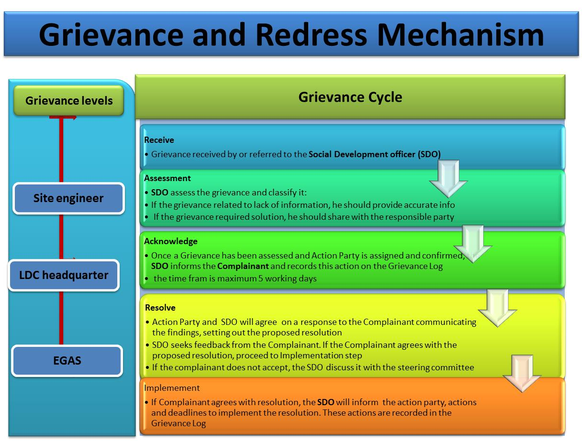
Figure ‎7-1 Proposed Grievance and Redress Mechanism

First tier of grievances

In order to ensure high level of responsiveness to the local communities, it is essential to ensure that a local grievance mechanism is functioning and that the communities are aware of it. ReGas will assign a Social Development Officer (SDO) (can be more than one) who will be working closely with the assigned SDO of EGAS. It is the responsibility of ReGas SDO to ensure that the GRM system is widely known and well explained on the local level. Moreover, s/he will follow up on the complaint until a solution is reached. The turnaround time for the response/resolution should be 10 days and the complainant should know that he/she should receive response by then.
The grievances should be presented to the following:
- The foreman working on the ground in Gerga,
- The project manager in Gerga,
- The regional department of ReGas in Sohag Governorate
It is worth noting that most of the previous experience of EGAS is suggesting that complaints are usually handled efficiently and resolved on the local level. However, the management of the complaints including level of responsiveness, providing feedback and the documentation of the complaints needs to be significantly strengthened. In case the problem is not solved, the complainant may reach out to the second level of grievance.

Second tier of grievances:
If the aggrieved person is not satisfied with the decision of the first tier, they can present the case to ReGas headquarter. Complaint form is attached in Annex 6. SDO where they should provide resolution within 15 days, following is the second level of grievances:
  - The Social Development Officer in ReGas headquarter will handle technical, environmental and land acquisition complaints. ReGas headquarter SDO should receive the unsolved problems. Thereafter, the SDO gets in contact with the petitioner for more information and forwards the complaint to the implementing entities for a solution.
  - The SDO should follow the complaints and document how they were solved within 15 days.
  - The SDO should update the complainant on the outcome of his/her complaint.

Third tier of grievances:
If the aggrieved person is not satisfied with the decision of the SDOs of ReGas at Stage 2, they can present the case to EGAS SDO where they should provide resolution within 15 days. The following section presents the third level of grievances:
- The Social Development Officer in EGAS will handle technical, environmental and land acquisition complaints. He should receive the unsolved problems. Thereafter, they get in contact with the petitioner for more information and forwards the complaint to the implementing entities for a solution.
- The SDO should follow the complaints and document how they were solved within 15 days.
- The SDO should update the complainant on the outcome of his/her complaint.

Grievance channels
Due to the diversity of the context in different Governorates and the socioeconomic characteristics of the beneficiaries, the communication channels to receive grievances were locally tailored to address all petitioners concerns and complaints. The following are the main channels through which grievances will be received:
- Foremen act as the main channel for complaints. They are always available on the construction sites. However, complaints raised to him/her are mostly verbal. Thus, s/he should document all received grievances in writing form using a fixed serial number that the complainant should be informed about to be able to follow up on the complaint
- Hotline: 129 is the hotline in ReGas.
- Trustworthy people, community leaders and NGOs/CDAs will be an appropriate channel to guide petitioner about the various tiers of grievances, particularly, in rural areas.

Response to grievances
Response to grievance will be through the following channels
- The response to grievances should be through an official recognized form to ensure proper delivery to the complainant. It is the responsibility of the SDOs to ensure that complainants were informed about the results of handling their complaints.
- Response to grievances should be handled in timely manner as mentioned above, thereby conveying a genuine interest in and understanding of the worries put forward by the community.
- EGAS and ReGas should maintain record of complaints and results.

Monitoring of grievances
All grievances activities should be monitored in order to verify the process. The monitoring process should be implemented on the level of EGAS and the LDC. The following indicators will be monitored:
Monitoring dimnesions | Means of verification and indicators
GRM is fully operational | - Number of received grievances monthly (Channel, gender, age, basic economic status of the complainants should be mentioned)  - Type of grievance received (according to the topic of the complaint  - Documentation efficiency
Efficiency of responses and corrective procedures | - Number of grievances solved and closed  - Feedback offered to the grievances  - Number of unsolved grievances and the reasons behind not solving them  - Time consumed to solve the problem
Efficiency of information sharing about GRM | - Dissemination activities undertaken  - Total number of brochures distributed (if any)  - Total number of awareness meetings conducted (if any)

Institutional Responsibility for the Grievances
The entity responsible for handling grievances will mainly be the Environmental Affair Department within the implementing agency (EGAS). The Social Development Officer (SDO) working within EGAS in cooperation with the ReGas will address all grievances raised by community members. The main tasks related to grievances of the SDOs on the various levels are:
  - Raise awareness about channels and procedures of grievance redress mechanisms
  - Collect the grievances received through different communication channels
  - Document all received grievances
  - Transfer the grievance to the responsible entity
  - Follow up on how the problem was addressed and solved
  - Document, report and disseminate the outcome of received grievances
  - Ensure that each legitimate complaint and grievance is satisfactorily resolved by the responsible entity
  - Identify specific community leaders, organizations and citizen groups required to enhance the dialogue and communication through a public liaison office to avoid or limit friction and respond effectively to general concerns of the community
  - Monitoring grievance redress activities

Environmental and Social Management Matrix during CONSTRUCTION
Table ‎7-3: Environmental and Social Management Matrix during CONSTRUCTION
Receptor | Impact | Mitigation measures | Responsibility |  | Direct supervision | Means of supervision
Receptor | Impact | Mitigation measures | Mitigation | Supervision | Direct supervision | Means of supervision
Local traffic and accessibility | Traffic congestion (and associated noise/air emissions) | Excavation during off-peak periods  Time limited excavation permits granted by local unit & traffic department | Excavation contractors | - LDC +  - Traffic department | Contractor has valid conditional permit + Field supervision | Contractor costs  LDC management costs
Local traffic and accessibility | Traffic congestion (and associated noise/air emissions) | Announcements + Signage indicating location/duration of works prior to commencement of work | - LDC  - Excavation contractors | - LDC HSE  - Local Unit  - Traffic department | Ensure inclusion in contract + Field supervision | Contractor costs  LDC management costs
Local traffic and accessibility | Traffic congestion (and associated noise/air emissions) | Apply Horizontal Directional Drilling under critical intersections whenever possible to avoid heavy traffic delays | Contractor | LDC HSE | Field supervision | Contractor costs  LDC management costs
Local traffic and accessibility | Traffic congestion (and associated noise/air emissions) | Traffic detours and diversion | Traffic Department | Traffic Department | Field supervision for detouring efficiency  Complaints received from traffic department | Additional budget not required
Local traffic and accessibility | Traffic congestion (and associated noise/air emissions) | Road restructuring and closing of lanes | Traffic Department | Traffic Department | Fluidity of traffic flow | Additional budget not required
Ambient air quality | Increased emissions of dust and gaseous pollutants | Controlled wetting and compaction of excavation/backfilling surrounding area | Excavation Contractor | LDC HSE | Contractual clauses + Field supervision | - Contractor costs  - LDC management costs
Ambient air quality | Increased emissions of dust and gaseous pollutants | Isolation, covering, transportation in equipped vehicles and disposal of stockpiles | Excavation Contractor | LDC HSE | Contractual clauses + Field supervision | - Contractor costs  - LDC management costs
Ambient air quality | Increased emissions of dust and gaseous pollutants | Compliance to legal limits of air emissions from all relevant equipment | Excavation Contractor | LDC HSE | Measure and document emissions of machinery by regular audits request emission measurements | - Contractor costs  - LDC management costs
Ambient air quality | Increased emissions of dust and gaseous pollutants | - Availability of 24-7 hotline service (129) to all beneficiaries and the public for reporting possible leaks, damages or emergencies  - Quick response to gas leaks by evacuation of the affected area  - Repair or replacement of failed component | LDC | LDC HSE | Field Supervision | - Contractor costs  - LDC management costs
- Ambient noise levels  - Local community  - Workers | Increased noise levels beyond WB/National permissible levels | Ear muffs, ear plugs, certified noise PPE for workers | - LDC  - Excavation Contractor | LDC HSE | Contractual clauses + Field supervision (audits) | - Contractor costs  - LDC management costs
- Ambient noise levels  - Local community  - Workers | Increased noise levels beyond WB/National permissible levels | Avoid noisy works at night whenever possible | - LDC  - Excavation Contractor | LDC HSE | Field supervision  Complaints receipt from local administration | - Contractor costs  - LDC management costs
- Ground utilities’ integrity  - Local community | Damage to underground utilities resulting in water/wastewater leaks, telecommunication and electricity interruptions | Coordination with departments of potable water, wastewater, electricity, and telecom authorities to obtain maps/ data on underground utilities, whenever available | Excavation Contractor | LDC HSE | Official coordination proceedings signed by representatives of utility authorities  - Examination of site-specific reports and records  - Field supervision | - Contractor management costs  - LDC management costs
- Ground utilities’ integrity  - Local community |  | If maps/data are unavailable:  Perform limited trial pits or boreholes to explore and identify underground utility lines using non-intrusive equipment | Excavation Contractor | LDC HSE Supervisor | - Contractual clauses + Field supervision | - Contractor management costs  - LDC management costs
- Ground utilities’ integrity  - Local community |  | Preparation and analysis of accidental damage reports | Excavation Contractor | LDC HSE | - Review periodic HSE reports | - Contractor management costs  - LDC management costs
- Ground utilities’ integrity  - Local community |  | Repair and rehabilitation of damaged components | Excavation Contractor | LDC HSE  Local Government Unit  Local Police | - Contractual clauses + Field supervision | - Contractor management costs  - LDC management costs
- Streets (physical status)  - local community and workers (health and safety) | Hazardous waste accumulation | - Temporary storage in areas with impervious floor  - Safe handling using PPE and safety precautions  - Transfer to LDC depots for temporary storage  - Disposal at licensed Alexandria hazardous waste facilities (Nasreya or UNICO)  - Hand-over selected oils and lubricants and their containers to Petrotrade for recycling | - LDC  - Excavation Contractor | LDC HSE | Field supervision and review of certified waste handling, transportation, and disposal chain of custody | Indicative cost items included in contractor bid:  Chemical analysis of hazardous waste  Trucks from licensed handler  Pre-treatment (if needed)  Disposal cost at Nasreya  Approximate cost of the above (to be revised upon project execution): 8,000-10,000 LE per ton
 | Hazardous waste accumulation | - Adequate management of asbestos and any possible hazardous waste | Water Authority + contractor | LDC HSE | Field supervision + review of Water Authority manifests | - Contractor costs  - LDC management costs
 | Hazardous waste accumulation | - Minimize fueling, lubricating and any activity onsite that would entail production of hazardous materials empty containers  - Pre-Plan the anticipated amounts of hazardous liquid materials (such as paint, oils, lubricants, fuel) to be used in the various activities in order to minimize leftovers and residuals.  - To the extent practical, seek to combine leftovers or residuals of the same liquid material/waste in order to minimize the number of containers containing hazardous residuals  - Ensure hazardous liquid material/waste containers are always sealed properly and secured from tipping/falling/damage/direct sunlight during transportation and storage  - In case of spillage:  - avoid inhalation and sources of ignition  - cover and mix with sufficient amounts of sand using PPE  - collect contaminated sand in clearly marked secure containers/bags  - Add sand to inventory of hazardous waste | - LDC  - Excavation Contractor | LDC HSE | Field supervision | - Contractor costs  - LDC management costs
- Local community | Non-hazardous waste accumulation | - Designate adequate areas on-site for temporary storage of backfill and non-hazardous waste  - Segregate waste streams to the extent possible to facilitate re-use/recycling, if applicable  - Reuse non-hazardous waste to the extent possible  - Estimate size of fleet required to transport wastes.  - Transfer waste to Gerga disposal facility west of the city (near beit daoud and beit khallaf villages) | - LDC  - Excavation Contractor | LDC HSE | - Contractual clauses  - Monitoring of waste management plan  - Field supervision | - Contractor costs  - LDC management costs
Local community | Destruction of streets and pavement | - Arrange Restoration and re-pavement (رد الشئ لأصله) with local unit  - Communication with local community on excavation and restoration schedules. | - LDC | EGAS | - Field supervision  - Coordination with LGUs as needed | Included in re-pavement budget agreed by LDC with local units or Roads and Bridges Directorate
Occupational health and safety | Health and safety | - Full compliance to EGAS and LDC HSE requirements, manuals, and actions as per detailed manuals developed by Egypt Gas  - Ensure the provision of the appropriate personal protective Equipment and other equipment needed to ensure compliance to HSE manuals | Excavation Contractor | LDC HSE | Field supervision | - Contractor costs  - LDC management costs
Local communities and businesses | Lack of accessibility to businesses due to delay in street rehabilitation | Compliance with the Environmental management plan concerning timely implementation of the construction schedule to minimize impact on local business  - Follow up the procedure of Grievance Redress Mechanism  - Ensure transparent information sharing | During digging process  LDC  The sub-contractors | LDC  EGAS (SDO) | - Ensure the implementation of GRM  - Supervision on Contractors performance | No cost
Local community  Health and safety | Threat to Safety of users and houses (due to limited level of awareness and misconceptions) | Prepare Citizen engagement and stakeholder plan  Awareness raising campaigns should be tailored in cooperation with the community-based organizations | During the construction  LDC | LDC  EGAS (SDO) | - List of awareness activities applied  - Lists of participants  - Documentation with photos  - Awareness reports | - 2250 $ per awareness raising campaign  - 2250 $ for brochure and leaflets to be distributed (material available by EGAS-$ spent)

Environmental and Social Monitoring Matrix during CONSTRUCTION
Table ‎7-4: Environmental and Social Monitoring Matrix during CONSTRUCTION
Receptor | Impact | Monitoring indicators | Responsibility of monitoring | Frequency of monitoring | Location of monitoring | Methods of monitoring | Estimated Cost of monitoring
Local traffic and accessibility | Reduction of traffic flow and accessibility to local community | Comments and notifications from Traffic Department | LDC HSE | Monthly during construction. | Construction site | Documentation in HSE monthly reports Complaints log | LDC management costs
Ambient air quality | Increased air emissions | HC, CO% and opacity | LDC HSE | Once before construction + once every six months for each vehicle | Vehicles licensing Department | Measurements and reporting of exhaust emissions of construction activities machinery  Complaints log | LDC management costs
Ambient noise levels | Increased noise levels | Noise intensity, exposure durations and noise impacts | LDC HSE | Regularly during site inspections and once during the night in every residential area or near sensitive receptors such as hospitals | Construction site | Measurements of noise levels Complaints log | LDC management costs
Ambient noise levels | Increased noise levels | Complaints from residents | LDC HSE | Monthly during construction. | Construction site | Documentation in HSE monthly reports | LDC management costs
Underground utilities | Damages to underground utilities and infrastructure | Official coordination reports with relevant authorities  Accidents documentation | LDC HSE | Monthly during construction. | Construction site | Documentation in HSE monthly reports | LDC management costs
Physical state of street | Waste generation | Observation of accumulated waste piles | LDC HSE | During construction. Monthly reports | Construction site | Observation and documentation | LDC management costs
Physical state of street | Waste generation | Observation of water accumulations resulting from dewatering (if encountered) | LDC HSE | During construction. Monthly reports | Around construction site | Observation and documentation | LDC management costs
Physical state of street | Waste generation | Chain-of-custody and implementation of waste management plans | LDC HSE | Zonal reports | Construction site and document examination | Site inspection and document inspection | LDC management costs
Local community | Damaging to the streets | - Streets quality after finishing digging  - Number of complaints due to street damage | LDC, EGAS | Four times per year, each three months | Site and Desk work | Checklists  and complaints log | No cost
Local community | Threat to Safety of users and houses (due to limited level of awareness and misconceptions) | - Number of awareness raising implemented  - Number of participants in information dissemination | LDC, EGAS | Quarterly monitoring | Office | Reports  Photos  Lists of participants | No cost

Management of Mitigation and Monitoring activities During Operation Phase

Hotline
As mentioned previously, odorant is added to odorless natural gas to facilitate leakage detection by smell/odor.
A 24-7 Hotline (129) is available for customers and the public to report leaks, damage, emergencies, and/or incidents related to gas connections, components, infrastructure, and activities (inside or outside households) and to request repairs/emergency response/assistance.

Community health and safety
Several measures are suggested to overcome obstacles to full understanding and adoption of safety measures by the clients in the social management plan. Examples include using drawings instead of written instructions to improve communication with illiterate customers, coordinating with women of local NGOs who are interested in cooperating with the project to explain safety precautions to women in the households to be connected, and constantly monitoring the performance of emergency response units.
During all consultation activities conducted, participating NGOs offered to host awareness activities related to the NG project. In Sohag, various NGOs were interviewed. They expressed their willingness to act actively as awareness centers for the project. Consequently, such activities will not necessitate additional cost
The LDC must communicate clear instructions to clients in order to ensure that NG piping and components (both inside the household and outside) are not be altered, violated, or intruded upon in any way without written approval from, or implementation of the alteration by, the LDC.

Management of Repairs and Maintenance
The same mitigation and monitoring measures discussed for the construction phase shall also apply to the repair and maintenance works that will require excavation.

Management of network integrity
Rare events may threaten the integrity of the network and cause multiple failures/leaks/fires/explosions simultaneously should be addressed, despite their low occurrence probability. Such events may include the unlikely impacts from earthquakes, unexpected geotechnical settlements, and pipeline sabotage. Mitigation should involves review of geological/geotechnical history and vulnerabilities. Other measures include an emergency action plan and training drills to deal with such events with minimal damage and risk to the public.

Management of Odorant Handling
The MSDS of the odorant provides information on the required storage conditions and procedures to be followed in emergencies. For the disposal of empty containers, the MSDS indicates that the remaining product could be either destroyed by oxidation using dilute solutions of hydrogen peroxide or sodium hypochlorite, or alternatively through incineration.
LDCs are currently practicing the oxidation of the containers. After evacuation of odorant containers (metal barrels) in the PRS holding stainless steel tank, the PRS staff adds hydrogen peroxide or sodium hypochlorite and sodium hydroxide and detergents to the remaining odorant in the container, with continuous rolling to ensure that all sides of the container have been exposed to the oxidation solution. These treatment procedures are documented in the instructions of the HSE department and followed by PRSs’ staff. This process destroys the hazardous properties of the remaining odorant product; however, arrangements must be made for disposal of the treatment solution remaining in the containers. Although the oxidation process is environmentally acceptable, the accumulation of treated containers in PRSs will cause area limitations inside PRSs and could affect their efficient operation. Alternatively, some PRSs may have standby odorant tanks which are taken to the company depot to be filled and replace tanks in operation upon return to PRS.
In order to minimize risk of spillage of hazardous odorant, the following general precautions should be taken:
- Pre-Plan the anticipated amounts of odorants to be used in order to minimize leftovers and residuals.
- Handle with extreme care and always perform visual checks on the integrity of the odorant container
- Avoid rough handling rolling or dropping of odorant containers
- Avoid exposure to direct sunlight during storage or transportation
- Ensure odorant containers are always sealed properly and secured from tipping/falling/damage during transportation and storage (temporary and long-term)
- Always have sufficient amounts of sand, sodium hypochlorite and detergent on standby during usage of odorant
- ALWAYS handle containers or spills with care and full PPE compliance
- Never release or empty residual odorant from its container to any receptor or for any reason other than filling the odorant tank at the PRS
- NEVER use empty odorant containers for any other purpose
- In case of odorant spillage:
  - avoid inhalation and sources of ignition
  - immediately cover and mix with sufficient amounts of sand and sodium hypochlorite using necessary PPE and tools
  - collect contaminated sand in clearly marked secure containers/bags
  - Add sand to inventory of hazardous waste

LDCs should arrange for regular transfer of empty containers to its nearest storage depot (مخزن الراكد) for temporary storage until collected by licensed hazardous waste handlers for disposal to the hazardous waste facility in Alexandria. Licensed waste handlers should produce official chain-of-custody documents to the LDC proving that the empty containers have been delivered to the certified facility. LDCs should verify and keep these records with their Environmental Register.
Trained HSE technicians should accompany drivers transporting the odorant barrels/tanks whether full or empty and treated.

Management of PRS noise
It is not expected that noise levels caused by the reducers will affect areas outside the PRS fences if the reducers are located in the middle of the location (at least 20 meters away from all fences). Therefore the following mitigation measures are recommended:
- Location of reducers should be at least 20 meters away from the PRS fences.
- The reducers should be either in a well-ventilated closed area, or in a protected open area according to IGEM standards. If the reducers are in an open area there should be wall barriers to dissipate the noise from the PRS staff offices and the neighboring areas.
LDCs are currently undertaking periodical monitoring of noise levels at each existing PRS bi-annually. It is expected that the noise monitoring of the new PRSs will take the same pattern. For PRSs in residential areas, it is recommended to increase noise monitoring at different locations especially at the southern border on a monthly basis, along with recording complaints from neighboring sites.

Management of PRS Safety Aspects
- Remote actuation of isolation and slam-shut valves by LDCs
- Hazardous Area Classification drawings for all Pressure Reduction Stations.
- Planned preventive maintenance policy should be in place for the new PRS. Also there is a need to produce a 'Station Manual' for the PRS, this manual should include formalized procedures, including precautions and a site scenario specific emergency plan, which should take wind direction, stability and interfaces with others, e.g. GASCO as well as the public living nearby, into account.
- Control room inlet door should be located in the upwind direction away from the station (Inlet door should not face the PRS station). Alternatively, the control room should be provided by a secondary means of escape at the back side of the room, which shall be used in case of blockage of the main escape route by jet.
- Self-contained breathing apparatus (2 units at least) to be provided at each PRS for handling odorant releases.
- Jet fire rated passive fire protection system to be applied to all safety critical shutdown valves ESDVs or Solenoid valves in order to maintain small isolatable inventories. (As applicable)
- Pipeline marking signs should be added indicating in Arabic and in English "Do Not Dig" and "High Pressure Pipeline Underneath" in order to prevent such extreme hazards.
- Install an elevated wind sock in the PRS site, which can be seen - from distance and from outside the fence - to determine the direction of gas migration in case of major gas leak, in addition to provision of portable gas detectors.
- The design should fully comply with IGE TD/3 code requirements.
Note: A Quantitative Risk Assessment QRA detailing such risks and mitigation measures has been prepared (Annex 7).

Management of financial disturbance
The average natural gas connection installation cost is about 5,600 EGP and consumers contribute a part of 1700 EGP. The remaining amount is subsidized by the government of Egypt. The 1700 EGP can be made either upfront or in installments over a period of time.
Typically, the households opt for flexible monthly payment plans facilitated by the LDCs and local banks. Limited number of NGOs also provided financial assistance for installing gas connections for households in very low income neighborhoods.
The government of Egypt does not provide additional subsidy to the poorer groups, However, they provide number of payments strategies through offering the various installments schemes: It is worth mentioning that the Government of Egypt try to negotiate with funding agencies to provide extra support to poor.

Environmental and Social Management Matrix during OPERATION
Table ‎7-5: Environmental and Social Management Matrix during OPERATION
Receptor | Impact | Mitigation measures | Responsibility |  | Means of supervision | Estimated Cost
Receptor | Impact | Mitigation measures | Mitigation | Supervision | Means of supervision | Estimated Cost
- Ambient air quality  - Community health and safety | Network integrity | - Detailed review of the geotechnical and geological history of the project area  - Development of a full emergency response plan  - Random inspections and awareness campaigns to ensure that NG piping and components (both inside the household and outside) are not be altered, violated, or intruded upon in any way without written approval from, or implementation of the alteration by, the LDC.  - Availability of 24-7 hotline service (129) to all beneficiaries and the public for reporting possible leaks, damages or emergencies  - Quick response to gas leaks by evacuation of the affected area  - Repair or replacement of failed component | LDC | - LDC HSE. | - Map and local geotechnical report review  - Site inspections  - Awareness actions  - Periodical trainings and drills | - LDC management costs
- Ambient air quality  - Community health and safety | Repairs and maintenance (network and households) | - As with construction phase activities | - LDC  - Excavation Contractor | - LDC HSE | - As relevant from construction phase | - LDC management costs
- Ambient air quality  - Occupational health and safety  - Community health and safety | Management of odorant and its containers | - Strict use of chemical-resistant suits and PPE when handling odorant barrels, tanks, or spills  - Evacuation of odorant from barrels into holding tank with utmost care and full PPE  - Covering possible odorant spills immediately with sand and treatment with sodium hypochlorite as per EGAS and LDC practices  - On-site treatment of empty containers with sodium hypochlorite and detergent as Per EGAS and LDC practice  - Ship empty containers to a certified hazardous waste facility via company depot using certified handling and transportation contractors  - Ensure full and empty (treated) odorant containers are accompanied by a trained HSE specialist during transportation to and from the depot and to/from the hazardous waste disposal facility (UNICO and/or Nasreya)  - Others measures as per QRA | PRS staff | LDC HSE | Quarterly auditing for each PRS | Cost to be included in PRS running budget:
- Ambient noise  - Occupational health and safety  - Community health and safety | Noise of PRS operation | - Locate noisy pressure reducers away from PRS borders in residential areas  - Others measures as per QRA | LDC Design Department | LDC HSE | Review of PRS layout | LDC management costs
- Ambient air quality  - Occupational health and safety  - Community health and safety | Leakage and fire | - Mitigations based on Quantitative Risk Assessments | Independent consultant | LDC HSE | QRA Document review | LDC management costs & PRS cost
- Ambient air quality  - Occupational health and safety  - Community health and safety | Potential risks due to PRS Operation | - Remote actuation of isolation and slam-shut valves by LDC for PRS and pipelines. | Designer | LDC Project Dept. | PRS design Document Review | Additional budget not required
 | Potential risks due to PRS Operation | - Produce Hazardous Area Classification drawings  - Control room exit design | Designer | - Eng. / Elect. Dept.  Projects Dept. | Drawing and design Document Review | Additional budget not required
 | Potential risks due to PRS Operation | - Preventive maintenance policy and station manual | contractor + LDC | Engineering Dept. | Policy and manual review | Included in PRS cost
 | Potential risks due to PRS Operation | - Provision of self-contained breathing apparatus (2 pieces for each station) for handling odorant leaks | LDC | HSE Dept. | Inspection by operators | Included in PRS cost
 | Potential risks due to PRS Operation | - Apply jet fire rated passive fire protection system to all critical safety shutdown valves ESDVs or Solenoid valves (As applicable) | Designer | LDC Projects Dept. | Component inspection and design document review | Included in PRS cost
 | Potential risks due to PRS Operation | - Place signs in Arabic and English "Do Not Dig" and "High Pressure Pipeline Underneath" | LDC | Engineering Dept. | Signage inspection and site visits | Additional budget not required
 | Potential risks due to PRS Operation | - Install an elevated wind sock and provision of portable gas detectors | LDC | HSE Dept. | Design and implementation review | Included in PRS cost
 | Potential risks due to PRS Operation | - The design should fully comply with IGE TD/3 code requirements | Designer | Project Dept. | Design document review | LDC management costs
 | Potential risks due to PRS Operation | - Any other measures as per QRA | LDC | EGAS | As per QRA | As per QRA
Economically disadvantaged Community members | Financial burden on economically disadvantaged due to the installments | - Petro Trade should collect the installment immediately after the installation of NG  - The installments should be collected on monthly basis in order not to add burden to the poor, as it will be easier for them to pay on monthly basis  - The installment should not be high | Petro trade (Company responsible for collecting the consumption fees and the installments | EGAS | Banks loans log  Complaints raised by poor people due to the frequency of collecting the installments | No cost
Informal  LPG distributors | Loss of revenue for LPG distributors | - LPG distributors should be informed about the NG potential areas in order to enable them to find alternative areas  - They should be informed about the GRM in order to enable them to voice any hardship | Butagasco | EGAS | Information sharing activities with the LPG vendors  Grievances received from them | No cost
Community health and safety | Possibility of Gas leakage | - Information should be provided to people in order to be fully aware about safety procedures  - The hotline should be operating appropriately  - People should be informed of the Emergency Numbers | LDC | LDC | Complaints raised due to Gas leakage | No cost

Environmental and Social Monitoring Matrix during OPERATION
Table ‎7-6: Environmental and Social Monitoring Matrix during OPERATION
Impact | Monitoring indicators | Responsibility of monitoring | Monitoring Frequency | Location of monitoring | Methods of monitoring | Monitoring Estimated Cost
Network integrity | - Earthquakes or geotechnical settlements  - Emergency response time and corrective actions during emergency drills  - Reports of alteration or tampering with ANY gas components | LDC HSE | Bi-annual inspections and annual emergency response drills | Along the network and inside and outside households | - Inspection, leakage detection, running the drills | LDC management costs
Improper management of odorant during operation | - Log of spillage incidents  - Number of treated containers  - Odorant delivery forms | LDC HSE | Quarterly for each PRS | PRSs | - Compare Environmental Register with odorant delivery forms, observation of site | LDC management costs
Noise of PRS operation | - Noise intensity | LDC HSE | Quarterly for each PRS | PRSs | - Noise meter | LDC management costs
Financial burden on economically disadvantaged due to the installments | - Number of economically disadvantaged people who complained  - Number of those who can't pay the installment | LDC and Petro Trade, EGAS | Quarterly | Desk work | - Complaints log  - Bank reports  - Petro trade reports | No cost
Impact on the informal  LPG distributors | - Grievance received from the informal LPG distributors  - Information shared with them | EGAS, LDC | Quarterly | Desk work | - Complaints log | No cost
Possibility of Gas leakage | - Complaints raised by the community people  - Number of leakage accidents reported/raised | LDC, EGAS | Four times per year, each three months | Site and Desk work | Complaints log  LDC | No cost

Reporting of Mitigation and Monitoring Activities
LDC HSE Departments are to prepare monthly and quarterly reports to be submitted to EGAS Environment Department during the construction phase.

During construction phase monthly reports should include as a minimum:
- Conditional permits and any comments or recommendations by Traffic Department and Supreme Council for Antiquities
- Number and date of paint cans shipped to company depot or returned to supplier
- Evaluation of LDC and contractor's performance on applying his relevant mitigation measures
- Any accidents or breaking of utility pipes
- Monitoring results of excavation machinery exhaust emission, noise and vibrations

During Operation phase monthly reports should include as a minimum:
- Undertaken treatment and temporary storage and/or disposal activities of empty odorant containers in PRSs
- Monitoring results of PRSs noise
- Evaluation of the adherence of staff to safety measures
- Pipeline leakage or damage incidents

Institutional Framework for ESM&MP Implementation

Environmental Management Structures
EGAS is the supervisory body. Regas is the implementing body. Below is the management structure of Regas.

Being the implementing body of the natural gas network in project areas, Regas has a direct involvement with the environmental management and monitoring of the natural gas network. Regas has limited environmental and social background. They will be in need to upgrade their capacity regarding the environmental and social aspects. EGAS will provide Regas staff with the needed information.

One of the standard tasks of the HSE Departments of Regas, supervised by EGAS, is to ensure that the Environmental and Social Management Plan of the project is implemented in all the phases of the Project, through establishing an Environmental Register for Pressure Reduction Stations, with frequent auditing of this register.

Figure ‎7-2: Regas ESMP organogram

In the structure above, designated site engineers perform daily implementation, monitoring and reporting of activities as per the ESMP with special attention to:

- Worker and contractor compliance to EGAS HSE manuals and procedures
- Occurrence of HSE incidents and suggestions for incident avoidance
- Management of broken asphalt (if any), unused backfill, solid waste, metal scrap
- Management of paint cans, refueling & lubrication, soil contamination
- Management of liquid waste such as leaked condensate hydrocarbons (if any) or chemicals used in heaters; and
- Checking that handling of hazardous waste is done according to the requirements of the Environmental Law, where a permit for handling hazardous material and Hazardous wastes is issued from EGAS Environment Department
- Using analyzers to measure noise, SO₂, CO, CH₄ and NO₂ in ambient air, and detect possible natural gas leaks
- Ensure and log compliant handling of odorant/odorant containers, odorant-contaminated-soils (in case of spillage)
- Measure noise at different locations of the PRS
- Other tasks as outlined in ESM&MP

Daily reports are to be compiled and sent to the governorate HSE officer for preparation of monthly summary reports.

Monthly reports are sent to HSE officer at ReGas head office for compilation into quarterly reports to EGAS.

Roles and responsibilities of EGAS and LDCs Social Development Officers
EGAS, its subsidiary Local Distribution Companies (LDCs), and the contractors will be responsible for adopting the following procedures:

Compliance with Bank safeguards
- Preparing internal guidelines for the preparation, implementation, monitoring and reporting of social documents required by various safeguard instruments;
- Reviewing, as applicable, ESMP and other social safeguard documents prepared by consultants to ensure compliance with relevant safeguard policies of the government and the World Bank;
- Providing recommendations to EGAS/LDC management and other subsidiary companies accordingly and make necessary changes prior to submission of relevant social documents to the World Bank – ensure consistency in the level of proficiency and presentation of the documentation;
- Carrying out documentation review pertaining to social compliance (including bidding documents, reviews on-site, reports from contractors etc.) throughout project implementation;
- Coordinating and facilitating the work of consultants engaged to carry out environmental and social impact assessments and resettlement planning and external monitoring of safeguard instruments implementation;
- Organizing the technical aspects of workshops and meetings as required, as outlined in the ESMF/RPF training and capacity building section;
- Preparing training materials, and conducting technical training workshops to EGAS/LDC staff and project implementation agencies on social safeguards requirements.

Monitoring and reporting
- Conducting internal monitoring of the implementation of the RAP and the social component of the ESMP in matters pertaining to timely payments and the provision of temporary measures to affected persons;
- Contributing to project progress reports pertaining to overall implementation of social requirements of the project;

Communication with and responsiveness to targeted communities
- Design community friendly grievance redress mechanism with clear and timely bound tiers and responsibilities and ensure dissemination on the local level.
- Conducting field visits to ensure that the established grievance redress mechanisms are functioning properly and that the individual projects are implemented in a socially sustainable manner;
- Participate in the process of disbursing compensations and keep track record of the compensation process documentation
- Reach out to local communities, including PAPs, to raise awareness about the project and the implementation schedule.
- Build the capacity and provide support to the field staff as needed.

Required Actions
Existing Environmental and social guidelines & practices of EGAS and its LDCs are following sound environmental procedures in the operation phase. EGAS is also working to institutionalize the social management in their practices and day to day business. A ministerial decree was issued in November 2015 with the effect of establishing a social unit to affiliate to the Environmental Management Unit. The social unit currently has 3 staff mapped officially to the unit (although support is also provided by other team members). EGAS assigned team is benefiting from number of capacity building activities to enable them to carry out their social management mandates in an efficient manner.
- Deeper involvement of environmental and social officers during the design, costing, tendering, and construction phases would be advantageous.
- Detailed HSE manuals covering each activity must be developed and institutionalized in ReGas. Several versions of such manuals have been developed by Egypt Gas and should be mainstreamed immediately to other LDCs, accompanied by the appropriate capacity-building.
- Specifically, ReGas should take steps to develop capacity of site engineers and HSE officers with specific courses focused on implementation of the ESMP detailed in this ESIA.

Stakeholder Engagement and Public Consultation
The public consultation chapter aims to highlight the key consultation and community engagement activities that took place as part of the preparation of the ESIAs and their outcomes.
The consultation activities used multiple tools and mechanisms (scoping, interviews, focus group discussions, public hearings/consultations) with various stakeholders and community people in the host communities were held for the proposed 1.5 million household NG connections project in compliance with:
- WB policies related to disclosure and public consultation, namely,
  - World Bank Procedure (BP 17.50)
  - World Bank Operational Policy (OP 4.01)
- Egyptian regulations related to the public consultation
  - The environmental law No 4/1994 modified by Law 9/2009 modified with ministerial decrees no. 1095/2011 and no. 710/2012
Objectives of various consultation activities are summarized as follows:
- Define potential project stakeholders and suggest their possible project roles
- Disseminate comprehensive information about the project to enable stakeholders to identify their concerns, needs, and recommendations.
- Document stakeholder feedback on the defined impacts as well as the social and environmental management plan and enhance the ESIA accordingly
- Identify the most effective outreach channels that support continuous dialogue with the community
- Discuss potential resettlement plans and impacts of involuntary resettlement (in the places where this is applicable).

Defining the stakeholder
In order to ensure an inclusive and meaningful consultation process, a stakeholders analysis was conducted to get better understanding of the various groups and their roles, interests and influence on the project. Full list of the stakeholders on the governorate level is included in the Consultation Chapter of the Governorate level ESIA. For the purpose of this site specific ESIA, a focused stakeholders’ identification was conducted to identify the key groups of relevance to the project in this specific location. The main identified groups are very similar to those identified on the governorate level but on a smaller scale (elaborated details on that are include in the Governorate level ESIA). In the meantime, local communities of both men and women of projects beneficiaries as well as the PAPs, local NGOs/CDAs were among the key stakeholders on the local level.
The abovementioned stakeholders were consulted using various tools (i.e. individual interviews, group meetings and public consultation). Most of them have attended the public consultation hearings conducted during December 2013 in the 11 governorates. However, some of them were interviewed in their premises in order to enable them to spell out their concerns and worries freely.

Consultation Methodology and Activities
The consultation process was a dynamic and evolving process which adapted multiple qualitative and quantitative tools and was tailored to the local culture and context of the communities. The consultation was also a good chance for the team of EGAS and the LDCs to have direct interaction with the local communities and helped in establishing channel of communication and trust.
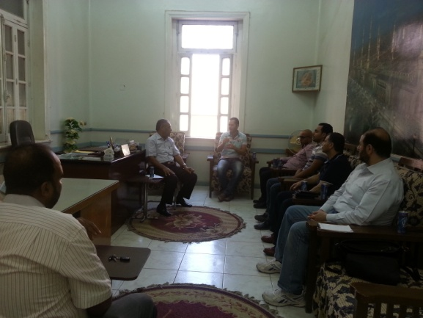 | 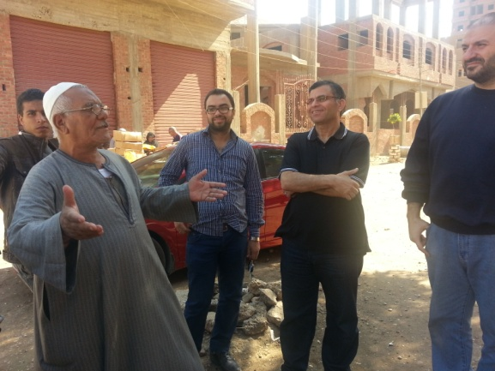
Photo ‎8-1: Consultation with the local municipality | Photo ‎8-2: Consultation with a resident

The team applied various consultation activities. This included, but was not limited to, public consultation on the governorate level as well as scoping meetings, in-depth and household interviews and focus groups discussions on Gerga city level. It is worth noting that intense consultation were conducted during the process of preparing the ESIAF and the RPF in December 2013 (please see the ESIAF report and the Governorate ESIA report)). All those activities helped to ensure that the consultation went as an ongoing process that aimed to set a foundation for future community engagement activities as part of the project.

Table ‎8-1: Summary of Consultation Activities in Gerga City
Participants | Number |  | Methods | Date
During the ESIAF and RPF study | Male | Female
Government officials | 3 |  | In-depth | December 2013
Governmental and NGOs | 1 |  | In-depth | December 2013
Community people | 32 | 17 | Structured questionnaire | December 2013
Community people | 8 | 8 | FGD | December 2013
Total | 44 | 25
During the site specific study | Male | Female
Government officials | 5 |  | In-depth | September and October 2015
Governmental and NGOs | 1 |  | In-depth | September and October 2015
Community people | 10 | 9 | FGD | September and October 2015
Community people | 62 | 36 | Structured questionnaire | September and October 2015
Public hearing for the ESIA of the governorate level. Potential beneficiaries, government officials, NGO representatives, (20 people have attended from Gerga) | 89 | 33 | Public consultation | 14th of February 2016
Total | 167 | 78
The study team exerted efforts to engage various age categories from males and females. Additionally, they were consulted in their own houses. This enabled them to talk freely.
40.8% of the sample were at the age category 30-49 y. The younger groups represented about 10.0% of the total sample. 24.5% were at the age category 60+. This was an indicator of proper presentation of elder and young categories.

Figure ‎8-1: % distribution of consulted households’ sample by age category

With regards to the occupational status of the sample, about 75.0% of the female sample were unemployed. 17.7% of male sample consulted were working as administrative staff. 19.4% were working as skilled laborers. High legislators and mangers represented 11.3% of male sample.

Figure ‎8-2: % distribution of consulted households’ sample by occupational status

Main results of consultation during the data collection phase

The majority of sample surveyed expressed very high demand on the project. They also indicted their willingness to be connected to the NG regardless to the amount of money they can afford to pay. 56.1% of them were willing to pay the installation cost in cash. This high level of enthusiasm from the local communities towards the project is attributed to the high level of awareness of the benefits of the natural gas and the current hardships that the households are facing to secure LPG
Following is the main issues of discussion raised during data collection and scoping phase

Table ‎8-2:Sample of the main issues of discussion raised during data collection and scoping phase in Gerga
Subject | Questions and comments | Responses
Safety measures of the NG | What are the safety procedures of the NG? Is it risky to the community? What about the explosions of GAS cylinders? | It is essential to say that EGAS and the LDCs (Regas) follow and apply the maximum safety standards. They adhere to provision of instructions about safety and they provide a hotline.  The use of natural gas is much safer than LPG
Reasons for not installing some areas | Why EGAS don’t provide NG to all residents in Gerga city? | There is a set of technical and economic criteria for the selection of the locations and the buildings to be connected to natural gas. It is a top priority for the Government to get as many areas as possible connected but this is usually done based on time-bound and phased plan.
Sewage problem in Sohag and the reasons to have sewage installed prior to the NG | Almost all participants were keen to inform about the problems associated with the sewage.  Lack of proper sewage should not prohibit the installation of NG | Sewage connections is crucial to the NG. Natural Gas should be the last utility as the sewage pipeline is below the NG pipeline
Lack of connection cost | 1700 EGP is too much to be paid by the community in Gerga | Each one can pay in installment. You can pay 35 EGP as installment per month. This is equivalent to the cost of 2 LPG cylinders  EGAS try to support disadvantaged people through provision various installation schemes
Contracting place | Where to go to sign a contract to install the NG? | The applicant should go to contracting caravan that will be defined and informed about in Gerga city.  The requirements of contracting will be disclosed to community people.  A technical investigation will be applied to be sure that your house is technically eligible to have the NG installed in.
Role of the municipality | What is the expected role from the municipality ? | The municipality is responsible of sharing information about facilities available. Facilitate any problems with the local units i.e. roads and Local Governmental units. It is essential also to provide information about contracting procedures and encourage the community to install the NG during the project.
Temporary closed apartments problem | In case of having a closed apartment during the project, will it be able to connect to the NG later on? | During construction phase, the apartment can be connected to the NG for 1700 EGP. After the construction phase the closed apartments can be connected but they will have to pay the full amount of money
Role of the NGOs | What is the role of the NGOs? | They will play a major role in information sharing process and mobilizing the community to have the NG installed
Illegal constructions | Some illegal construction were built in Sohag. They closed the entrance of streets how such problem can be solved | It falls under the responsibility of the local governmental units. Such constructions are demolished and penalized

Comprehensive documentation and presentation for the results of the public consultation conducted in Sohag City on the 14th of February is presented in the ESIA allocated for Sohag Governorate.

Summary of consultation outcomes
The key message from the consultation events carried out for this project is that Public and government acceptance for and support to the project are very strong. Aside from limited concerns regarding the lack of sewage, the main public and governmental requirement was the speedy implementation of the project and expansion to additional areas
Site specific consultation activities, as mentioned in details above, included wide range of concerned stakeholders. This included but was not limited to, persons/households affected by the project activities, civil society organizations representing the interest of the community, or regulatory and governmental bodies who will play a role in facilitating or regulating the implementation of site-specific project activities.
While WB safeguards and regulations state that a minimum of two large-scale, well-publicized public consultation sessions are a must for projects classified as category ‘A’ projects like the one at hand, additional consultation activities (for example through focus group discussions, in-depth meetings, and interviews) were implemented to reach the most vulnerable and difficult to reach community members. Additionally, in order to obtain larger scale and more quantifiable information, the consultant should assess conducting surveys in the different sites.

Annex 1: Contributors to the ESIA

 | Team Member | Role
 | Dr. Tarek Genena | Senior ESIA expert and team leader (EcoConServ)
 | Dr. Khaled Gamal | Senior ESIA expert and team leader (Petrosafe)
 | Ms. Zainab Hafez | Senior SIA expert and project coordinator (EcoConServ)
 | Dr Amr Sobhy | Senior EIA specialist (EcoConServ)
 | Eng. Khaled El Sahy | Senior ESIA expert (Petrosafe)
 | Eng. Fakhry Abd el Khalek | Senior EIA specialist (EcoConServ)
 | Eng. Maysara Shams | EIA specialist (EcoConServ)
 | Ms. Dalia Ashour | SIA specialist
 | Dr Nermin Eltouny | EIA specialist
 | Mr. Mohamed Hassan | Data analyst Expert (EcoConServ)
 | Ms. Shaimaa Mostafa | SIA specialist
 | Ms. Zeinab Aly | Data management manager (EcoConServ)
 | Mr. Sohy El Grouf | Field manager
 | Mr. Sameh Mahrous | Senior administrative coordinator
 | Mr. Mohamed Abd El Hady | Community engagement manager
 | Ms. Hana Mostafa | Field supervisor
Acknowledgement
The EcoConServ consultant teams would like to express their deep gratitude to the scores of support staff, drivers, NGOs, collaborators and organizations who logistically supported the completion of this project under tight time limitations.
EcoConServ also acknowledges the invaluable knowledge and support provided by the technical, environmental, and social teams of EGAS and LDCs who accompanied the consultant teams.

Annex 2: Procedures for chance finds and ESM&MP for physical cultural resources
Cultural property include monuments, structures, works of art, or sites of significance points of view, and are defined as sites and structures having archaeological, paleontological, historical, architectural, religious, aesthetic, or other cultural significance. This includes cemeteries, graveyards and graves.
Antiquities Law 117/1983: Article 24 states that everyone who finds by chance the part or parts of a fixed monument in its place must promptly inform the nearest administrative authority within forty-eight hours.
Prior to the construction phase, the approval shall be obtained from the antiquities department and surveying department

Chance Find Procedures

- Stop the construction activities in the area of the chance find;
- Delineate the discovered site or area;
- Secure the site to prevent any damage or loss of removable objects. In cases of removable antiquities or sensitive remains, a night guard shall be present until the responsible local authorities and Ministry take over;
- Notify the site manager and HSE supervisor who in turn will notify the responsible local authorities and the Antiquities Authority immediately (within 24 hours or less);
- Responsible local authorities and the Antiquities Authority would be in charge of protecting and preserving the site before deciding on subsequent appropriate procedures;
- Decisions on how to handle the finding shall be taken by the responsible authorities from the Antiquities Authority;
- Construction work could resume only after permission is given from the responsible local authorities and the Antiquities Authority concerning safeguard of the heritage.
These procedures must be referred to as standard provisions in construction contracts, where applicable. During project supervision, the site manager and HSE supervisor shall monitor the above regulations relating to the treatment of any chance find encountered are observed.
Relevant findings will be recorded in Monitoring Reports and Implementation Completion Reports (ICRs) submitted to the World Bank.

Table ‎0-1: Management matrix for cultural sites (if encountered)
Impact | Mitigation measures | Responsibility of mitigation | Responsibility of direct supervision | Means of supervision | Estimated Cost of mitigation / supervision
Effects on cultural sites | Identify areas of antiquities, monument repair zones | Contactor & Supreme Council for Antiquities and Local Council | LDC HSE | Review permitting procedures and ensure review of Council | LDC costs
Effects on cultural sites | Supervise intensity and locations of construction activities | Expert from Supreme Council of Antiquities | LDC HSE | Review field reports + field supervision | Indicative cost to be revised and included in contractor bid $715 / site for supervision and measurement of vibration for locations identified as “monument-critical”  LDC costs
Effects on cultural sites | Control dewatering process | Contractor | Supreme Council Expert + LDC HSE | Field supervision | Indicative cost to be revised and included in contractor bid $2,850 /site  LDC costs
Effects on cultural sites | Reduce vibrations | Contractor | Supreme council Expert + LDC HSE | Contractual clauses + Field supervision | Indicative cost to be revised and included in contractor bid $2,150/site  LDC costs
Effects on cultural sites | Preserve architecturally valuable sites | Contractor | LDC HSE | Field supervision | Contractor costs (included in bid price) +  LDC costs
Effects on cultural sites | Preserve any found antiquity | Contractor + LDC HSE supervisor | LDC HSE | Field inspection throughout works and review field reports | Contractor costs (included in bid price) +  LDC costs

Table ‎0-2: Monitoring matrix for cultural sites (if encountered)
Impact | Monitoring indicators | Responsibility of monitoring | Frequency of monitoring | Location of monitoring | Methods of monitoring | Estimated Cost of monitoring
Effects on monuments and vulnerable buildings | Vibration test results | LDC HSE | During construction near sites identified by the Council | Construction site | Calibrated vibration test meter | ($750/meter + $160 maintenance and calibration) x 11 vibration meters = $10,000
Effects on monuments and vulnerable buildings | Investigate possible buried antiquities | LDC HSE + Supreme Council for Antiquities | Once before construction if required by the council | Streets and areas identified by the Council | Geophysical survey | Contractor costs (included in bid price)  in areas designated as antiquities or monument repair zones (to be covered by LDC)

Annex 3: Site air measurements Methodology

Site selection
The selection of the site for the active air measurements is based on the prevailing wind direction, the future layout of the proposed project components.

Collection of air measurement

Instrumentation for measurements of ambient air pollutants
Ambient air concentrations of sulfur dioxide were measured using an SO₂ analyzer (Thermo Scientific SO₂ Analyzer model 43i-USA) with a detection limit of ≤ 1 ppb and a precision of ≤ 0.5%. Nitrogen oxides were measured using a NO_{x} analyzer (Thermo Scientific NO_{x} Analyzer - Model 42i- USA) with a detection limit of ≤ 0.4 ppb and a precision of ≤ 0.5%. Carbon monoxide concentrations were measured using a CO Analyzer (Thermo Scientific Carbon Monoxide CO Analyzer model 48i-USA) with a detection limit of ≤ 0.04 ppm and a precision of ≤ 0.5%. Particulate matter, PM₁₀, and total suspended particles, T.S.P, were measured using a Sequential Particulate sampler equipped with a Beta Ray Source. The detection limit is ≤ 1.5 µg/ m³ and the precision is ≤ 0.4 µg/ m³ for 24 hour cycle time at a 2.3 m³/h operating flow rate.

Protocols for measurements of ambient air pollutants
Concentrations of ambient pollutants were measured according to the standard reference methods presented in the table below.

Table ‎0-3: Standard reference methods followed for the collection of ambient air pollutants
Pollutant | Standard reference procedure
NO_{x} | ISO 7996 equivalent to(U.S.A EPA Reference method – RFNA-1289-74)
SO₂ | ISO 10498 equivalent to( U.S.A EPA Reference method – EQSA-0486-60)
CO | ISO 4224 equivalent to U.S.A EPA Reference method – RFCA-0981-54)
PM₁₀  T.S.P | EPA method, Appendix J-Reference method FR

Annex 4: Flora
The table below lists typical flora encountered in Upper Egypt, which includes Gerga. 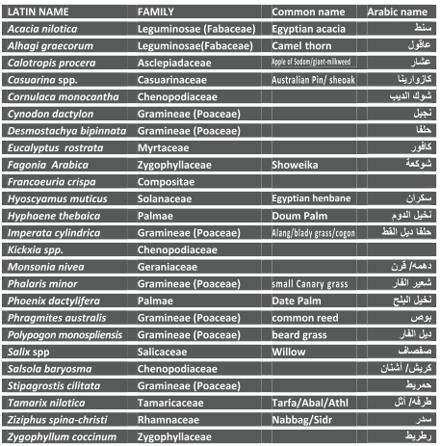

Annex 5: Impact Assessment
The impact of each activity on each receptor was assessed according to magnitude on a scale of -10 to 10, where negative values indicate a negative influence on the receptor, and importance on a scale of 0 to 10, which encompasses the probability of occurrence, frequency of the impact etc. The numbering system is used as a relative measure, where more negative numbers correspond to impacts having a higher negative magnitude. Susceptible receptors and corresponding activity are deduced and addressed if both magnitude and importance are of minor severity.

Further, the Buroz Relevant Integrated Criteria and is used to determine the total importance, I, of the impact for each activity on all receptors and of the project overall.

On the basis of the value of the importance of impact, I, obtained, the severity of the impact of an activity is assessed.

Criterium | Definition | Scoring Scale
Intensity (IN) | Degree of destruction of activity on receptor | 1 (lowest)-12 (highest)
Extension (EX) | Theoretical area of influence of the impact | 1 (localized) – 8 (widespread)
Momentum (MO) | Period of time for manifestation of the impact | 4 (immediate: <1 year) – 2 (medium: 1-5 years)- 1 (long term: > 5 years)
Persistence (PE) | Duration of the effect of the impact | 1 (fleeting, < 1 year), 2 (temporary, 1-5 years), 4 (permanent, >5 years)
Reversibility (RV) | Possibility of returning to pre-activity initial conditions by rebuilding or natural means | 1 (short term, < 1 year)- 2 (medium term, 1-5 years) – 4 ( long term, > 5 years or irreversible)
Recoverability (MC) | Possibility of reconstruction with corrective measures | 1 -2 (full and immediate recovery)- 4 (partial recovery and medium term)- 8 (unrecoverable)
Synergy (SI) | Reinforcement ability of manifested effects | 1(No synergy of actions on a receptor) -2 (moderate synergism)-4 (high synergy)
Accumulation (Ac) | Progressive increase of the effect | 1 (no cumulative effect)-4(cumulative effect)
Effect (EF) | Directionality of impact-the cause (action)-effect (impact) | 4 (direct)- 1 (indirect)
Frequency (PR) | Regularity of manifestation of the effect | 4 (continuous) – 2 (irregular)-1 (periodic)
Importance of Impact (I) | I = ± (3$×$IN + 2$×$EX + MO+ PE + RV + SI + AC + EF + PR + MC)
The table below is based on the Buroz’s Relevant Integrated Criteria

Annex 6: Complaint Form
Local Distribution Company:-------------------------------------------------
English Complaint Form
Date:---/----/------ Time: ---:----
Aggrieved person information
Name of the customer:------------------------------ ID Number:------------------------------------------
Address:------------------------------------------------------------------------------------------------------------------------------------------------------------------------------------------------------------------------------------

CRN:-----------------------------------------------------
Name of aggrieved person:----------------------------
Relation to the customer:-----------------------------
Cell phone:-----------------------------------------------
Summary of the complaint:
------------------------------------------------------------------------------------------------------------------------------------------------------------------------------------------------------------------------------------------------------------------------------------------------------------------------------------------------------------------------------------------------------------------------------------------------------------------------------------------------

Name of aggrieved person Signature
------------------------------- -----------------------

Complaint recipient
Name of the person received the complaint------------------------------------- Signature:------------
The entity caused the complaint-------------------------------------------------- Zone:------------------

Analysis of complaint reason:
------------------------------------------------------------------------------------------------------------------------------------------------------------------------------------------------------------------------------------------------------------------------------------------------------------------------------------------------------------------------------------------------------------------------------------------------------------------------------------------------
Proposed corrective procedures:
------------------------------------------------------------------------------------------------------------------------------------------------------------------------------------------------------------------------------------------------------------------------------------------------------------------------------------------------------------------------------------------------------------------------------------------------------------------------------------------------

Person responsible of the corrective procedures:------------------ Signature:-------------------

شركة ……………….
شكوى عميل
التاريخ :- ……………………/…………/……… الوقت :- : ………………………
بيـــــــــــــانـــــــــــــــــات الشاكى
اسم العميل : …………………………………… رقم قومي …………………………………………
العنوان:- …………………………………………………… CRN : …………………………
اسم مقدم الشكوي: …………………………………صفتة: ………………تليفون: …………………………
ملخص الشكوى :
…………………………………………………………………………………………………………………………………………………………………………………………………………………………………………………………………………………………………………………………………………………………………………………………
مقدم الشكوي
الاسم: …………………………………………………………… التوقيع : ………………………………

بيــــانـــــــــــات متلقي الشكوي
اسم متلقى الشكوى : …………………………………… التوقيع: ………………………
الجهة المشكوي منها : ………………..………… المنطقة : ………………………
تحليل أسباب الشكوى:
………………………………………………………………………………………………………………………………………………………………………………………………………………………………………………………………………………………………………………………………………………………………………………………………
الإجراءات التصحيحية:
………………………………………………………………………………………………………………………………………………………………………………………………………………………………………………………………………………………………………………………………………………………………………………………

اسم متخذ الاجراء التصحيحي : …………………………… التوقيع : …………………

Annex 7: Quantitative Risk Assessment

Because natural gas is odorless, odorants facilitate leak detection for inhabitants of residential areas.
A potential impact is considered “sensitive” if it may be irreversible (e.g., lead to loss of a major natural habitat) or raise issues covered by OP 4.10, Indigenous Peoples; OP 4.04, Natural Habitats; OP 4.11, Physical Cultural Resources; or OP 4.12, Involuntary Resettlement.
Physical Cultural Resources are defined as movable or immovable objects, sites, structures, groups of structures, and natural features, and landscapes that have archeological, paleontological, historical, architectural, religious, aesthetic, or other cultural significance.
Sohag Statistical Year Book 2015
Shortage period occurs during Ramadan (the fasting month for Muslims in Egypt) and the feasts
If encountered within project areas.
If encountered within project areas.
According to World Bank definition, a vulnerable group is a population that has some specific characteristics that make it at higher risk of falling into poverty than others living in areas targeted by a project. Vulnerable groups include the elderly, the mentally and physically disabled, at-risk children and youth, ex-combatants, internally displaced people and returning refugees, HIV/AIDS- affected individuals and households, religious and ethnic minorities and, in some societies, women.
In case of any change of the value of NG installation cost, the installment value might be changed
Sufficient sheets should accompany work groups during the construction phase. Cost of sheets should be included in ESMP budget
If encountered within project areas.
If encountered within project areas.
The Nasserya hazardous waste facility is currently being operated under supervision of Alexandria Governorate while UNICO (also in Alexandria) is approved by EEAA to treat and dispose of petroleum wastes.
http://siteresources.worldbank.org/
Falls under the budget of the LDCs
Converting Households from LPG to Natural Gas- Social Impact Assessment Study- 2013
In case of any change of the value of NG installation those installment might be changed
Clause 14 of OP 4.01 states that: “For Category A projects, the borrower consults these groups at least twice: (a) shortly after environmental screening and before the terms of reference for the EA are finalized; and (b) once a draft EA report is prepared. In addition, the borrower consults with such groups throughout project implementation as necessary to address EA-related issues that affect them.”
In the highly unlikely event that such finds are encountered in the project areas which are have been previously excavated for all underground utilities.

