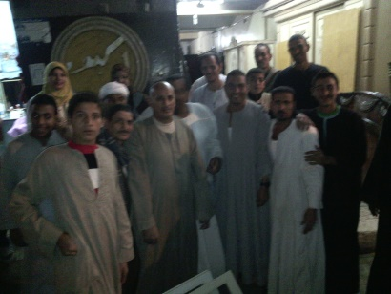 |  |  | 
 |  |  | 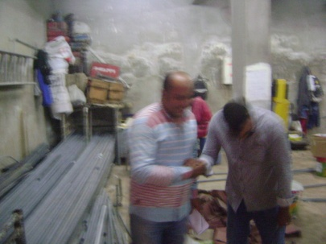
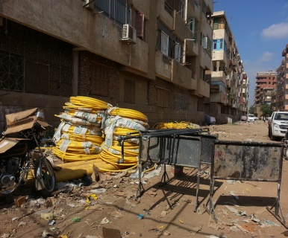 | 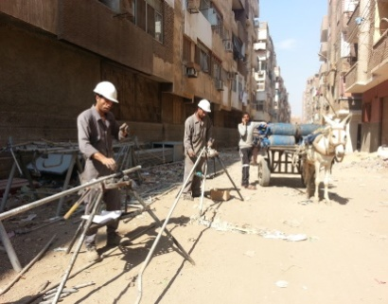 | 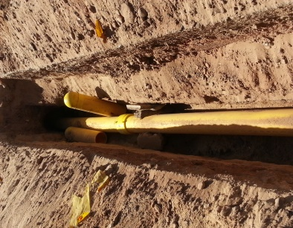
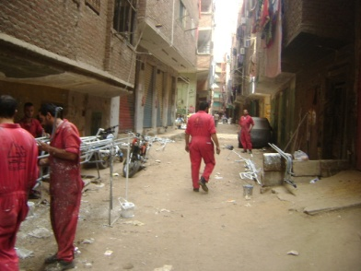 | 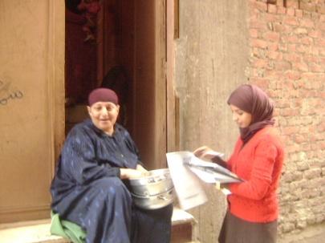 | 1.5 Million Natural Gas Connections Project in 11 Governorates  Site-Specific Environmental and Social Impact Assessment  Executive Summary  Gerga/Sohag Governorate  28 June 2016

EGAS
Egyptian Natural Gas Holding Company
Developed by
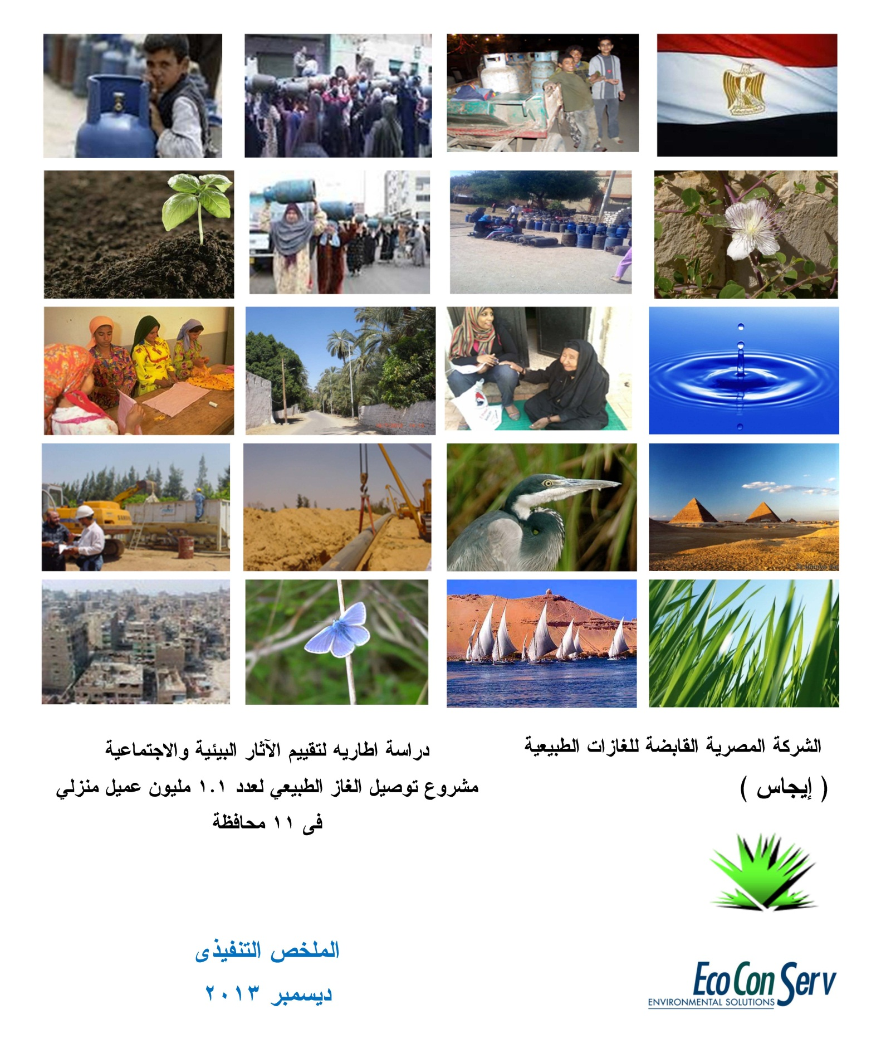 |  | 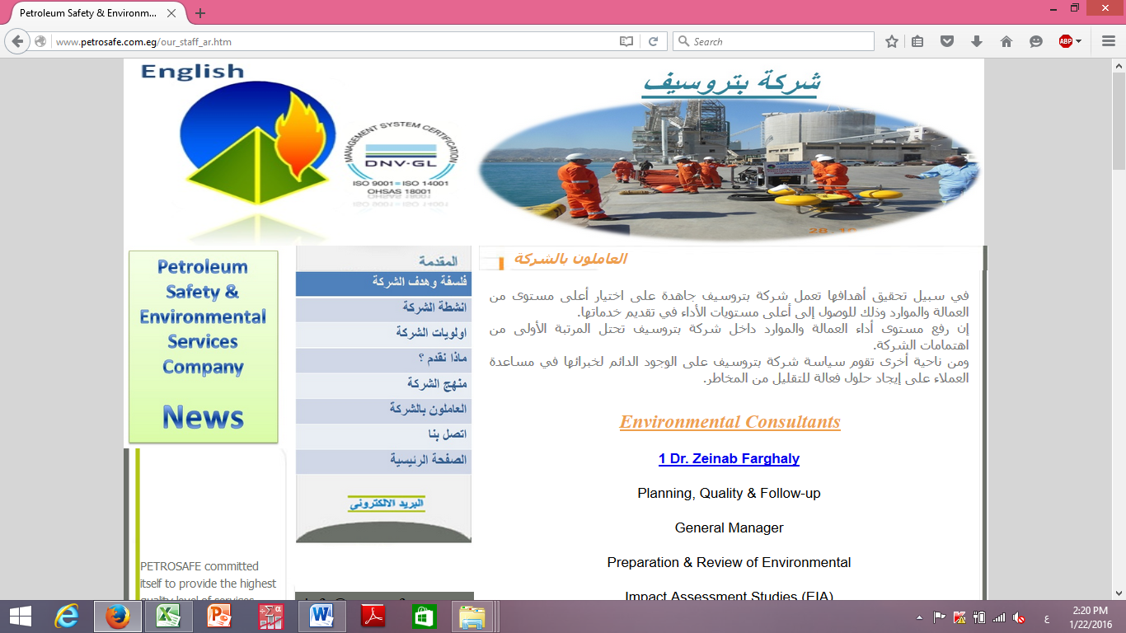
EcoConServ Environmental Solutions |  | Petrosafe  Petroleum Safety & Environmental Services Company

EXECUTIVE SUMMARY

Introduction
The Government of Egypt (GoE) has immediate priorities to increase household use of natural gas by connecting 1.2 million households/yr to the gas distribution network to replace the highly subsidized, largely imported Liquefied Petroleum Gas (LPG).
The GoE is implementing an expansion program for Domestic Natural Gas connections to an additional 1.5 Million households over the next 4 years. The project presented in this study is part of a program that involves extending the network and accompanying infrastructure to connect 1.5 million Households in 11 Governorates between 2016 and 2019 with the assistance of a World Bank Loan of up to US$500 Million and the Agence Française de Développement (French Agency for Development) financing of up to €70 Million. The program is estimated to cost US$850 Million.
The ESIA objectives are as follow:
- Describing project components and activities of relevance to the environmental and social impacts assessments
- Identifying and addressing relevant national and international legal requirements and guidelines;
- Describing baseline environmental and social conditions,
- Presenting project alternatives and no project alternative,
- Assessing potential site-specific environmental and social impacts of the project;
- Developing environmental & social management and monitoring plans in compliance with the relevant environmental laws
- Documenting and addressing environmental and social concerns raised by stakeholders and the Public in consultation events and activities
As the project involves components in various areas within the 11 governorates, the parties to the project agreed that site-specific ESIAs for each of the project sub-areas within the governorate will be prepared. Guided by the 2013 ESIAF and SSIAF, this is the site specific ESIA for the connections network and Pressure Reduction Station (PRS) planned for the Gerga city in Sohag Governorate. The project in Gerga encompasses household connections and construction of a new 10,000 m3/h PRS in Gerga District. The 31,500 households will be connected over 3 years: 12,000 in year 1, 12,960 in year 2, and 6,540 in year 3. The local distribution company responsible for project implementation in Gerga is Regional Gas Company (ReGas(

Project Description

Background
Natural Gas is processed and injected into the high pressure lines of the national Grid (70 Bar) for transmission. Upon branching from the main lines to regional distribution networks, the pressure of the NG is lowered to 7 Bar at the Pressure Reduction Stations (PRS). An odorant is added to the NG at PRSs feeding distribution networks to residential areas in order to facilitate detection. Regulators are then used to further lower the pressure to 100 mbar in the local networks, before finally lowering the pressure to 20 mbar for domestic use within the households. In addition to excavation and pipe laying, key activities of the construction phase also include installation of pipes on buildings, internal connections in households, and conversion of appliance nozzles to accommodate the switch from LPG to NG.

Project Work Packages

Off-take & Inlet connection/Pipeline “70 bar system”
In Gerga city there will be 15-m pipeline connection between off-take from the national high-pressure grid (70 bar) and PRS (Pressure Reduction Station).

Pressure Reduction Station (PRS)
PRS consists of equipment installed for automatically reducing and regulating the pressure in the downstream pipeline or main to which it is connected. Included are piping and auxiliary devices such as valves, control instruments, control lines, the enclosure, and ventilation equipment.
PRS for Gerga city has an inlet pressure range (70-18 bar) and outlet pressure 7 bar and maximum flow rate 10,000 SCMH.

Main feeding line/network “7 bar system – PE 100”
A gas distribution piping system that operates at a pressure higher than the standard service pressure delivered to the customer. In such a system, a service regulator is required to control the pressure delivered to the customer.
Main feeding lines are manly constructed from polyethylene pipes (HDPE) with maximum operating pressure (MOP) below 7 bar.

Distributions network “Regulators, PE80 Networks”
A gas distribution piping system in which the gas pressure in the mains and service lines is substantially the same as that delivered to the customer’s Meters. In such a system, a service regulator is not required on the individual service lines.
Distribution networks are mainly constructed from polyethylene pipes (MDPE) with MOP below 100 millibar.

Installations (Steel Pipes)
A gas distribution piping system consist of steel pipes which is connected from individual service line to vertical service pipe in a multistory dwelling which may have laterals connected at appropriate floor levels; in addition to service pipe connected to a riser and supplying gas to a meter and gas appliances on one floor of a building.
Internal Installation is pipe connecting the pressure reducing regulator/district Governor and meter Outlet (MOP 25 millibar) to appliances inside the customer’s premises.

Conversions
Conversions involve increasing the diameter of the nozzle of the burner of an appliance to work with natural gas as a fuel gas rather LPG or other.

Legislative and Regulatory Framework

Applicable Environmental and Social Legislation in Egypt
- Law 217/1980 for Natural Gas
- Law 4 for Year 1994 for the environmental protection , amended by Law 9/2009 and law 105 for the year 2015.Executive Regulation(ER) No 338 for Year 1995 and the amended regulation No 1741 for Year 2005, amended with ministerial decree No 1095/2011, ministerial decree No 710/2012, ministerial decree No 964/2015, and ministerial decree No 26/2016
- Law 38/1967 for General Cleanliness
- Law 93/1962 for Wastewater
- Law 117/1983 for Protection of Antiquities
- Traffic planning and diversions
  - Traffic Law 66/1973, amended by Law 121/2008 traffic planning during
  - Law 140/1956 on the utilization and blockage of public roads
  - Law 84/1968 concerning public roads
- Work environment and operational health and safety
  - Articles 43 – 45 of Law 4/1994, air quality, noise, heat stress, and worker protection
  - Law 12/2003 on Labor and Workforce Safety
  - Book V on Occupational Safety and Health (OSH)
  - Minister of Labor Decree 48/1967.
  - Minister of Labor Decree 55/1983.
  - Minister of Industry Decree 91/1985
  - Minister of Labor Decree 116/1991.

World Bank Safeguard Policies
Three policies are triggered for the project as a whole: Environmental Assessment (OP/BP 4.01), Physical Cultural Resources (OP/BP 4.11), and Involuntary Resettlement (OP/BP 4.12).
OP/BP 4.01, OP/BP 4.12 and BP 17.50 are triggered for the project. However, OP/BP 4.12 will not be applicable to the land obtained in Gerga city as the process of obtaining the land for the pressure reduction station was based on willing buyer willing seller approach. No pipelines will cross agriculture land in Gerga and accordingly no compensation will be applied.

Analysis of Alternatives

No Project Alternative
This Natural Gas Connections to Households Project is expected to yield many economic and social benefits in terms of providing a more stable, energy source, achieve savings in LPG consumption and enhance safety in utilizing energy.
The No-Project alternative is not favored as it simply deprives the Egyptian Public and Government of the social, economic, and environmental advantages detailed in section 5.1.

Energy Alternatives
- Maintain LPG use: Introduction of piped natural gas to replace LPG will help to remove subsidies and reduce imports. The proposed project would also improve the safety of gas utilization as appliance standards are strictly controlled and only qualified personnel carry out installations and respond to emergencies. In the case of LPG, installations are not carried out by trained personnel resulting in possible unsafe installations and unsafe use of LPG.

- Covert to Electricity: The second alternative is to convert all homes to use electricity for all energy supply applications. Additional power stations would be needed to cope with the additional demand created by utilization of electricity in homes, which most probably would operate also by natural gas. Power losses in transmission and distribution are also significantly higher than their natural gas equivalents which would add to the overall inefficiency.

- Use Renewables: the renewables market does not present feasible, practical, and affordable alternatives to connecting 1.5 million households at this point in time in Egypt. Biogas requires large amounts of agricultural and domestic waste, while solar panels and heaters remain in pilot phase.
Energy alternatives do not provide favorable options to the proposed NG networking

Installation costs
The average natural gas connection installation cost is about 5600 EGP and consumers contribute a part of 1700 LE because the connection is heavily subsidized by the Government. This payment can be made either upfront or in installments over a period of time. Installment schemes are available to all community people.
The government of Egypt is negotiating with the project’s financing organizations in order to secure additional subsidy to poor and marginalized groups. They also provide facilitation payments strategies through offering various installment schemes. The following are the main types of installments 138 EGP/Month for 12 months,74 EGP/Month for 24 months, 52 EGP/Month for 36 months, 42 EGP/Month for 48 months, 35 EGP/Month for 60 months, 31 EGP/Month for 72 months and 28 EGP/Month for 84 months

Environmental and Social Impacts and Mitigations
The environmental and social advantages of switching household fuel from LPG cylinders to natural gas pipelines are diverse. On the residential level, the proposed project will lead to improved safety, reduced physical/social/financial hardships, and secure home fuel supply. On the national level, it promotes the utilization of Egyptian natural resources and reduces the subsidy and import burden.
A thorough analysis of environmental and social impacts is important to detail an effective management and monitoring plan which will minimize negative impacts and maximize positives.
The assessment of impacts distinguishes between the construction phase and the operations phase.

Positive Impacts

During the construction phase

Direct job opportunities to skilled and semi-skilled laborers
The project is expected to result in the creation of job opportunities, both directly and indirectly. Based on similar projects implemented recently by EGAS and the local distribution company, the daily average number of workers during the peak time will be about 150 workers in 6 sites across Gerga. The local community of Sohag Governorate could provide a proportion of this temporary labour force dependent on skills needed and the strategies of the individual contractors in sourcing their workforce.
Additional temporary job opportunities will be provided through construction works (for 5-6 months) on the PRS site.
In order to maximize employment opportunities in the local communities it is anticipated that training will be required for currently unskilled workers. On-the-job training will also supplement opportunities for the local workforce for both temporary construction roles also for long-term operations phase position, where these are available.

During the operation phase
- As indicated in the Baseline Chapter, women are key players in the current domestic activities related to handling LPG and managing its shortage. Being the party affected most from the shortfalls of the use of LPG, the NG project is expected to be of special and major benefits to women. This includes, but is not limited to, clean and continuous sources of fuel that is safe and does not require any physical effort and is very reasonable in the price of consumption fees. Time saving is among the benefits to women. The use of a reliable source of energy will allow women to accomplish the domestic activities in less time and this will potentially open a space for better utilization for the saved time.
- Constantly available and reliable fuel for home use
- Reduced expenditure on LPG importation and subsidies. 28.457 thousand connections will be installed in Gerga City. Each household consumes 1.4 LPG monthly and one LPG for water heating. The total LPG that are predicted to be reduced are about 68296.8 thousand LPG per month for cooking and water heating purposes. The subsidy value is about 70 EGP per each LPG. Consequently, the total subsidy to be saved monthly will be about 4780776 EGP. That will result in total annually savings of 57369312 EGP. Additionally, significant savings in electricity will result due to replacing the electric water heater by NG heater.
- Significantly lower leakage and fire risk compared to LPG
- Improved safety due to low pressure (20 mBar) compared to cylinders
- Beneficiaries to benefit from good customer service and emergency response by qualified personnel/technicians
- Eliminate the hardships that special groups like physically challenged, women, and the elderly had to face in handling LPG.
- Limiting possible child labor in LPG cylinder distribution

Anticipated Negative Impacts

Impact Assessment Methodology
To assess the impacts of the project activities on environmental and social receptors, a semi-quantitative approach based on the Leopold Impact Assessment Methodology the Buroz Relevant Integrated Criteria was adopted.
Detailed assessment matrices shown in Annex 5. Following are the impact assessment scoring classification and results. The table below presents the classification of impact ratings and respective importance of impact values.
Importance of Impact | Impact rating
0-25 | None or irrelevant (no impact);
26-50 | Minor severity (minimal impact; restricted to the work site and immediate surroundings)
51-75 | Medium severity (larger scale impacts: local or regional; appropriate mitigation measures readily available);
76-300 | Major severity (Severe/long-term local/regional/global impacts; for negative impacts mitigation significant).
The following tables summarize the impacts and the corresponding mitigation measures within the management plan, in addition the monitoring plane proposed for implementation.

Environmental and Social Management Matrix during CONSTRUCTION
Table ‎0-1: Environmental and Social Management Matrix during CONSTRUCTION
Receptor | Impact | Mitigation measures | Roles and Responsibility
 |  |  | Implementation | Direct supervision | Means of supervision | Estimated Cost of mitigation / supervision
Medium severity
Local traffic and accessibility | Traffic congestion (and associated noise/air emissions) | Excavation during off-peak periods  Time limited excavation permits granted by local unit & traffic department | Excavation contractors | - LDC +  - Traffic department | Contractor has valid conditional permit + Field supervision | Contractor costs  LDC management costs
 |  | Announcements + Signage indicating location/duration of works prior to commencement of work | - LDC  - Excavation contractors | - LDC HSE  - Local Unit  - Traffic department | Ensure inclusion in contract + Field supervision
 |  | Apply Horizontal Directional Drilling under critical intersections whenever possible to avoid heavy traffic delays | Contractor | LDC HSE | Field supervision
 |  | Traffic detours and diversion | Traffic Department | Traffic Department | Field supervision for detouring efficiency  Complaints received from traffic department | Additional budget not required
 |  | Road restructuring and closing of lanes |  |  | Fluidity of traffic flow
Minor severity
Ambient air quality | Increased emissions of dust and gaseous pollutants | Controlled wetting and compaction of excavation/backfilling surrounding area | Excavation Contractor | LDC HSE | Contractual clauses + Field supervision | - Contractor costs  - LDC management costs
 |  | Isolation, covering, transportation and disposal of stockpiles |  |  | Contractual clauses + Field supervision
 |  | Compliance to legal limits of air emissions from all relevant equipment |  |  | Measure and document emissions of machinery by regular audits request emission measurements
- Ambient noise levels  - Local community  - Workers | Increased noise levels beyond WB/National permissible levels | Ear muffs, ear plugs, certified noise PPE for workers | - LDC  - Excavation Contractor | LDC HSE | Contractual clauses + Field supervision (audits) | - Contractor costs  - LDC management costs
 |  | Avoid noisy works at night whenever possible |  |  | Field supervision  Complaints receipt from local administration
- Underground utilities’ integrity  - Local community | Damage to underground utilities resulting in water/wastewater leaks, telecommunication and electricity interruptions | Coordination with departments of potable water, wastewater, electricity, and telecom authorities to obtain maps/ data on depth and alignment of underground utilities, whenever available | Excavation Contractor | LDC HSE | Official coordination proceedings signed by representatives of utility authorities  - Examination of site-specific reports and records  - Field supervision | - Contractor management costs  - LDC management costs
 |  | If maps/data are unavailable:  Perform limited trial pits or boreholes to explore and identify underground utility lines using non-intrusive radio- cable and pipe locators |  | LDC HSE Supervisor | - Contractual clauses + Field supervision
 |  | Preparation and analysis of accidental damage reports |  | LDC HSE | - Review periodic HSE reports
 |  | Repair and rehabilitation of damaged components |  | LDC HSE  Local Government Unit  Local Police | - Contractual clauses + Field supervision
- Streets (physical status)  - local community and workers (health and safety) | Hazardous waste accumulation | - Temporary storage in areas with impervious floor  - Safe handling using PPE and safety precautions  - Transfer to LDC depots for temporary storage  - Disposal at licensed Alexandria hazardous waste facilities (Nasreya or UNICO)  - Hand-over selected oils and lubricants and their containers to Petrotrade for recycling | - LDC  - Excavation Contractor | LDC HSE | Field supervision and review of certified waste handling, transportation, and disposal chain of custody | Indicative cost items included in contractor bid:  Chemical analysis of hazardous waste  Trucks from licensed handler  Pre-treatment (if needed)  Disposal cost at Nasreya  Approximate cost of the above (to be revised upon project execution): 8,000-10,000 LE per ton
 |  | - Adequate management of asbestos and any possible hazardous waste | Water Authority + contractor |  | Field supervision + review of Water Authority manifests | - Contractor costs  - LDC management costs
 |  | - Minimize fueling, lubricating and any activity onsite that would entail production of hazardous materials empty containers | - LDC  - Excavation Contractor |  | Field supervision
- Local community | Non-hazardous waste accumulation | - Designate adequate areas on-site for temporary storage of backfill and non-hazardous waste  - Segregate waste streams to the extent possible to facilitate re-use/recycling, if applicable  - Reuse non-hazardous waste to the extent possible  - Estimate size of fleet required to transport wastes.  - Transfer waste to Gerga disposal facility west of the city (near beit daoud and beit khallaf villages) | - LDC  - Excavation Contractor | LDC HSE | - Contractual clauses  - Monitoring of waste management plan  - Field supervision | - Contractor costs  - LDC management costs
Local community | Destruction of streets and pavement | - Arrange Restoration and re-pavement (رد الشئ لأصله) with local unit  - Communication with local community on excavation and restoration schedules. | - LDC | EGAS | Field supervision  Coordination with LGUs as needed | Included in re-pavement budget agreed by LDC with local units or Roads and Bridges Directorate
Occupational health and safety | Health and safety | - Full compliance to EGAS and LDC HSE requirements, manuals, and actions as per detailed manuals developed by Egypt Gas  - Ensure the provision of the appropriate personal protective Equipment and other equipment needed to ensure compliance to HSE manuals | Excavation Contractor | LDC HSE | Field supervision | - Contractor costs  - LDC management costs
Local communities and businesses | Lack of accessibility to businesses due to delay in street rehabilitation | Compliance with the Environmental management plan concerning timely implementation of the construction schedule to minimize impact on local business  - Follow up the procedure of Grievance Redress Mechanism  - Ensure transparent information sharing | During digging process  LDC  The sub-contractors | LDC  EGAS (SDO) | - Ensure the implementation of GRM  - Supervision on Contractors performance | No cost
Local community  Health and safety | Threat to Safety of users and houses (due to limited level of awareness and misconceptions) | Prepare Citizen engagement and stakeholder plan  Awareness raising campaigns should be tailored in cooperation with the community-based organizations | During the construction  LDC | LDC  EGAS (SDO) | - List of awareness activities applied  - Lists of participants  - Documentation with photos  - Awareness reports | - 2250 $ per awareness raising campaign  - 2250 $ for brochure and leaflets to be distributed (material available by EGAS-$ spent)

Environmental and Social Monitoring Matrix during CONSTRUCTION
Table ‎0-2: Environmental and Social Monitoring Matrix during CONSTRUCTION
Receptor | Impact | Monitoring indicators | Responsibility of monitoring | Frequency of monitoring | Location of monitoring | Methods of monitoring | Estimated Cost of monitoring
Local traffic and accessibility | Reduction of traffic flow and accessibility to local community | Comments and notifications from Traffic Department | LDC HSE | Monthly during construction. | Construction site | Documentation in HSE monthly reports Complaints log | LDC management costs
Ambient air quality | Increased air emissions | HC, CO% and opacity | LDC HSE | Once before construction + once every six months for each vehicle | Vehicles licensing Department | Measurements and reporting of exhaust emissions of construction activities machinery  Complaints log | LDC management costs
Ambient noise levels | Increased noise levels | Noise intensity, exposure durations and noise impacts | LDC HSE | Regularly during site inspections and once during the night in every residential area or near sensitive receptors such as hospitals | Construction site | Measurements of noise levels Complaints log | LDC management costs
 |  | Complaints from residents | LDC HSE | Monthly during construction. | Construction site | Documentation in HSE monthly reports | LDC management costs
Underground utilities | Damages to underground utilities and infrastructure | Official coordination reports with relevant authorities  Accidents documentation | LDC HSE | Monthly during construction. | Construction site | Documentation in HSE monthly reports | LDC management costs
Physical state of street | Waste generation | Observation of accumulated waste piles | LDC HSE | During construction. Monthly reports | Construction site | Observation and documentation | LDC management costs
 |  | Observation of water accumulations resulting from dewatering (if encountered) | LDC HSE | During construction. Monthly reports | Around construction site | Observation and documentation | LDC management costs
 |  | Chain-of-custody and implementation of waste management plans | LDC HSE | Zonal reports | Construction site and document examination | Site inspection and document inspection | LDC management costs
Local community | Damaging to the streets | - Streets quality after finishing digging  - Number of complaints due to street damage | LDC, EGAS | Four times per year, each three months | Site and Desk work | Checklists  and complaints log | No cost
Local community | Threat to Safety of users and houses (due to limited level of awareness and misconceptions) | - Number of awareness raising implemented  - Number of participants in information dissemination | LDC, EGAS | Quarterly monitoring | Office | Reports  Photos  Lists of participants | No cost

Environmental and Social Management Matrix during OPERATION
Table ‎0-3: Environmental and Social Management Matrix during OPERATION
Receptor | Impact | Mitigation measures | Responsibility of mitigation | Responsibility of direct supervision | Means of supervision | Estimated Cost of mitigation / supervision
- Ambient air quality  - Community health and safety | Network integrity | - Detailed review of the geotechnical and geological history of the project area  - Development of a full emergency response plan in case of rare events which exhibit multiple simultaneous impacts  - Random inspections and awareness campaigns to ensure that NG piping and components (both inside the household and outside) are not be altered, violated, or intruded upon in any way without written approval from, or implementation of the alteration by, the LDC. | LDC | - LDC HSE. | - Map and local geotechnical report review  - Site inspections  - Awareness actions  - Periodical trainings and drills | - LDC management costs
- Ambient air quality  - Community health and safety | Repairs and maintenance (network and households) | - As with construction phase activities | - LDC  - Excavation Contractor | - LDC HSE | - As relevant from construction phase | - LDC management costs
- Ambient air quality  - Occupational health and safety  - Community health and safety | Management of odorant and its containers | - Strict use of chemical-resistant suits and PPE when handling odorant barrels, tanks, or spills  - Evacuation of odorant from barrels into holding tank with utmost care and full PPE  - Covering possible odorant spills immediately with sand and treatment with sodium hypochlorite as per EGAS and LDC practices  - On-site treatment of empty containers with sodium hypochlorite and detergent as Per EGAS and LDC practice  - Ship empty containers to a certified hazardous waste facility via company depot using certified handling and transportation contractors  - Ensure full and empty (treated) odorant containers are accompanied by a trained HSE specialist during transportation to and from the depot and to/from the hazardous waste disposal facility (UNICO and/or Nasreya)  - Others measures as per QRA | PRS staff | LDC HSE | Quarterly auditing for each PRS | Cost to be included in PRS running budget:
- Ambient noise  - Occupational health and safety  - Community health and safety | Noise of PRS operation | - Locate noisy pressure reducers away from PRS borders in residential areas  - Others measures as per QRA | LDC Design Department | LDC HSE | Review of PRS layout | LDC management costs
 |  | - Build barrier walls between reducers and sensitive receptors when needed | Contractor | LDC HSE | Field supervision of PRS construction | Contractor costs
- Ambient air quality  - Occupational health and safety  - Community health and safety | Leakage and fire | - Mitigations based on Quantitative Risk Assessments | Independent consultant | LDC HSE | QRA Document review | LDC management costs & PRS cost
- Ambient air quality  - Occupational health and safety  - Community health and safety | Potential risks due to PRS Operation | - Remote actuation of isolation and slam-shut valves by LDC for PRS and pipelines. | Designer | LDC Project Dept. | PRS design Document Review | Additional budget not required
 |  | - Produce Hazardous Area Classification drawings  - Control room exit design | Designer | - Eng. / Elect. Dept.  Projects Dept. | Drawing and design Document Review | Additional budget not required
 |  | - Preventive maintenance policy and station manual | contractor + LDC | Engineering Dept. | Policy and manual review | Included in PRS cost
 |  | - Provision of self-contained breathing apparatus (2 pieces for each station) for handling odorant leaks | LDC | HSE Dept. | Inspection by operators | Included in PRS cost
 |  | - Apply jet fire rated passive fire protection system to all critical safety shutdown valves ESDVs or Solenoid valves (As applicable) | Designer | LDC Projects Dept. | Component inspection and design document review | Included in PRS cost
 |  | - Place signs in Arabic and English "Do Not Dig" and "High Pressure Pipeline Underneath" | LDC | Engineering Dept. | Signage inspection and site visits | Additional budget not required
 |  | - Install an elevated wind sock and provision of portable gas detectors | LDC | HSE Dept. | Design and implementation review | Included in PRS cost
 |  | - The design should fully comply with IGE TD/3 code requirements | Designer | Project Dept. | Design document review | LDC management costs
 |  | - Any other measures as per QRA | LDC | EGAS | As per QRA | As per QRA
Economically disadvantaged Community members | Financial burden on economically disadvantaged due to the installments | - Petro Trade should collect the installment immediately after the installation of NG  - The installments should be collected on monthly basis in order not to add burden to the poor, as it will be easier for them to pay on monthly basis  - The installment should not be high | Petro trade (Company responsible for collecting the consumption fees and the installments | EGAS | Banks loans log  Complaints raised by poor people due to the frequency of collecting the installments | No cost
Informal  LPG distributors | Loss of revenue for LPG distributors | - LPG distributors should be informed about the NG potential areas in order to enable them to find alternative areas  - They should be informed about the GRM in order to enable them to voice any hardship | Butagasco | EGAS | Information sharing activities with the LPG vendors  Grievances received from them | No cost
Community health and safety | Possibility of Gas leakage | - Information should be provided to people in order to be fully aware about safety procedures  - The hotline should be operating appropriately  - People should be informed of the Emergency Numbers | LDC | LDC | Complaints raised due to Gas leakage | No cost

Environmental and Social Monitoring Matrix during OPERATION
Table ‎0-4: Environmental and Social Monitoring Matrix during OPERATION
Impact | Monitoring indicators | Responsibility of monitoring | Monitoring Frequency | Location of monitoring | Methods of monitoring | Monitoring Estimated Cost
Network integrity | - Earthquakes or geotechnical settlements  - Emergency response time and corrective actions during emergency drills  - Reports of alteration or tampering with ANY gas components | LDC HSE | Bi-annual inspections and annual emergency response drills | Along the network and inside and outside households | - Inspection, leakage detection, running the drills | LDC management costs
Improper management of odorant during operation | - Log of spillage incidents  - Number of treated containers  - Odorant delivery forms | LDC HSE | Quarterly for each PRS | PRSs | - Compare Environmental Register with odorant delivery forms, observation of site | LDC management costs
Noise of PRS operation | - Noise intensity | LDC HSE | Quarterly for each PRS | PRSs | - Noise meter | LDC management costs
Financial burden on economically disadvantaged due to the installments | - Number of economically disadvantaged people who complained  - Number of those who can't pay the installment | LDC and Petro Trade, EGAS | Quarterly | Desk work | - Complaints log  - Bank reports  - Petro trade reports | No cost
Impact on the informal  LPG distributors | - Grievance received from the informal LPG distributors  - Information shared with them | EGAS, LDC | Quarterly | Desk work | - Complaints log | No cost
Possibility of Gas leakage | - Complaints raised by the community people  - Number of leakage accidents reported/raised | LDC, EGAS | Four times per year, each three months | Site and Desk work | Complaints log  LDC | No cost

Stakeholder Engagement and Public Consultation
The public consultation chapter aims to highlight the key consultation and community engagement activities that took place as part of the preparation of the ESIAs and their outcomes. Following are the main groups consulted during the SSESIA and the engagement tool used.

Table ‎6-1: Summary of Consultation Activities in Gerga City
Participants | Number |  | Methods | Date
During the ESIAF and RPF study | Male | Female
Government officials | 3 |  | In-depth | December 2013
Governmental and NGOs | 1 |  | In-depth
Community people | 32 | 17 | Structured questionnaire
Community people | 8 | 8 | FGD
Total | 44 | 25
During the site specific study | Male | Female
Government officials | 5 |  | In-depth | September and October 2015
Governmental and NGOs | 1 |  | In-depth
Community people | 10 | 9 | FGD
Community people | 62 | 36 | Structured questionnaire
Public hearing for the ESIA of the governorate level. Potential beneficiaries, government officials, NGO representatives, (20 people have attended from Gerga) | 89 | 33 | Public consultation | 14th of February 2016
Total | 167 | 78

Main results of consultation during the data collection phase

The majority of sample surveyed expressed very high demand on the project. They also indicted their willingness to be connected to the NG regardless to the amount of money they can afford to pay. 56.1% of them were willing to pay the installation cost in cash. This high level of enthusiasm from the local communities towards the project is attributed to the high level of awareness of the benefits of the natural gas and the current hardships that the households are facing to secure LPG.

Table ‎6-2:Sample of the main issues of discussion raised during data collection and scoping phase in Gerga
Subject | Questions and comments | Responses
Safety measures of the NG | What are the safety procedures of the NG? Is it risky to the community? What about the explosions of GAS cylinders? | It is essential to say that EGAS and the LDCs (Regas) follow and apply the maximum safety standards. They adhere to provision of instructions about safety and they provide a hotline.  The use of natural gas is much safer than LPG
Reasons for not installing some areas | Why EGAS don’t provide NG to all residents in Gerga city? | There is a set of technical and economic criteria for the selection of the locations and the buildings to be connected to natural gas. It is a top priority for the Government to get as many areas as possible connected but this is usually done based on time-bound and phased plan.
Sewage problem in Sohag and the reasons to have sewage installed prior to the NG | Almost all participants were keen to inform about the problems associated with the sewage.  Lack of proper sewage should not prohibit the installation of NG | Sewage connections is crucial to the NG. Natural gas should be the last utility as the sewage pipeline is below the NG pipeline.
Lack of connection cost | 1700 EGP is too much to be paid by the community in Gerga | Each one can pay in installment. You can pay 35 EGP as installment per month. This is equivalent to the cost of 2 LPG cylinders  EGAS try to support disadvantaged people through provision various installation schemes
Illegal constructions | Some illegal construction were built in Sohag. They closed the entrance of streets how such problem can be solved | It falls under the responsibility of the local governmental units.

Summary of consultation outcomes
Site specific consultation activities, as mentioned above, included wide range of concerned stakeholders. This included, but was not limited to, persons/households affected by the project activities, civil society organizations representing the interest of the community, or regulatory and governmental bodies who will play a role in facilitating or regulating the implementation of site-specific project activities.

The key message from the consultation events carried out for this project is that Public and government acceptance for and support to the project are very strong. Aside from limited concerns regarding the lack of sewage, the main public and governmental requirement was the speedy implementation of the project and expansion to additional areas

Because natural gas is odorless, odorants facilitate leak detection for inhabitants of residential areas.

